V. We invite you to stand as you are able.

OFFERING PRAYER
V. Let us pray,
O God, maker of heaven and earth,
your steadfast love embraces all creation.
You send rain and sunshine to nourish the earth
and bring forth its bounty.
Through these gifts of bread and wine,
draw us into the death and life of your Son,
who calls us to bear witness to his saving work.
We ask this in Jesus’ name.
C. Amen.

GREAT THANKSGIVING
V. The Lord be with you.
C. And also with you.

V. Lift up your hearts.
C. We lift them to the Lord.

V. Let us give thanks to the Lord our God.
C. It is right to give him thanks and praise.

V. It is indeed right and salutary that we should at all times and in all places offer
thanks and praise to you, O Lord, holy Father, through Christ our Lord; who rose
beyond the bounds of death and, as he promised, poured out your Spirit of life
and power upon the chosen disciples. At this the whole earth exults in boundless
joy. And so, with the Church on earth and the hosts of heaven, we praise your
name and join their unending hymn:

SANCTUS
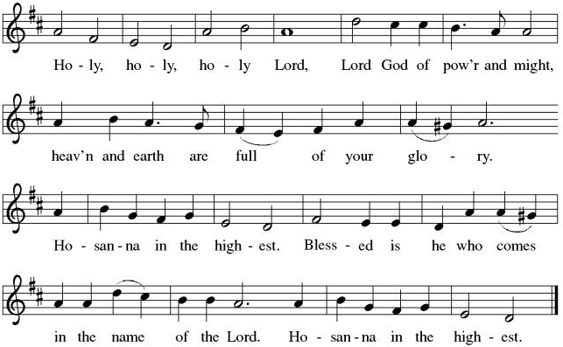

THE EUCHARISTIC PRAYER
V. Blessed are you, Lord of heaven and earth, in mercy for our fallen world you gave
your only Son, that all those who believe in Him should not perish, but have
eternal life. We give thanks to you for the salvation you have prepared for us
through Jesus Christ. Send now your Holy Spirit into our hearts that we may
receive our Lord with a living faith as He comes to us in His holy supper.
C. Amen. Come, Lord Jesus.

V. In the night in which he was betrayed our Lord Jesus took bread,
he gave thanks; broke it, and gave it to his disciples, saying:
Take and eat; this is my body, given for you.
Do this for the remembrance of me.

V. Again, after supper, He took the cup, he gave thanks,
and gave it for all to drink, saying:
This cup is the new covenant in my blood,
shed for you and for all people for the forgiveness of sin.
Do this for the remembrance of me.

THE LORD’S PRAYER
(We ring the bell throughout the Lord’s Prayer at all services to
invite those in the community to join in praying the Lord’s Prayer.)
V. May we now join with one another and pray together as Jesus has taught us.
C. Our Father, who art in heaven, hallowed be thy name, thy kingdom come,
thy will be done, on earth as it is in heaven. Give us this day our daily
bread; and forgive us our trespasses, as we forgive those who trespass
against us; and lead us not into temptation, but deliver us from evil. For
thine is the kingdom, and the power, and the glory, forever and ever.
Amen.

LAMB OF GOD

(We invite you to be seated.)

HOLY COMMUNION
V. We invite you to be seated. We extend the invitation to Communion to all who are
baptized and believe in Jesus Christ.

OFFERING SONG
(We invite you to sing along.)
Worship & Praise
156—What Have We to Offer?
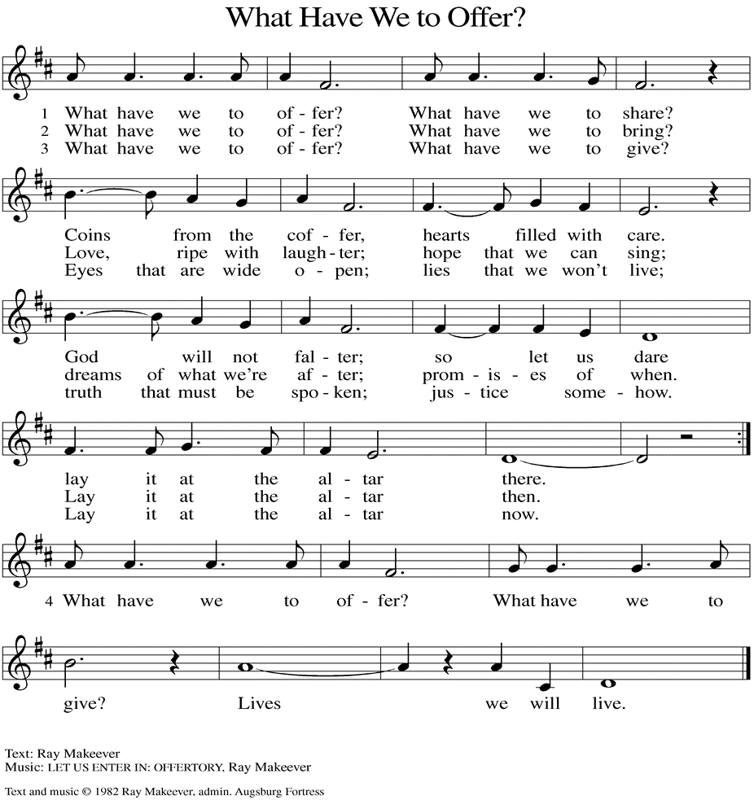
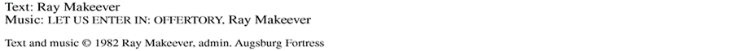

(Usher(s) brings the Tithes and Offerings up front to the Assistant.)
SHARING OF THE PEACE
V. May the peace of the Lord be with you always.
C. And also with you.
V. Now, let us share God’s Peace with one another.



(Please respect your neighbor if they desire to still only offer a peace sign or wave.)

(Following the Sharing of the Peace, we invite you to be seated.)

OFFERING
V. We now worship God with our tithes and offerings, wine and bread for use in holy
communion, and monetary gifts to support our ministry for service in God’s name.
Our Ushers will be around to your pews to pass the Offering Plates.

(Ushers come forward to get the Offering Plates from the Assistant.)

(Vicar and Assistant prepare the Altar for Communion.)

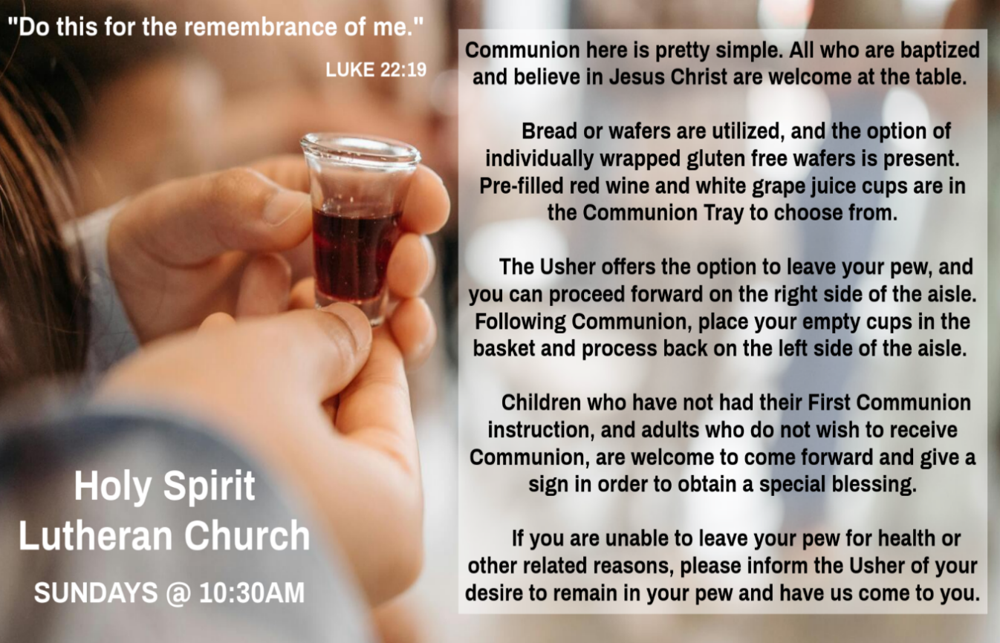

INVITATION TO COMMUNION
V. Come to the table.
Feast on God’s goodness and mercy.
C. Amen.

(Distribution of Holy Communion)

COMMUNION HYMN
(Please enjoy various music offered by our Organist during your
quiet time, prayer, and reflection following Holy Communion.)

(Vicar and Assistant remove Communion Vessels from the Altar.)

V. We invite you to stand as you are able.

POST COMMUNION BLESSING
V. May the body and blood of our Lord Jesus Christ strengthen us and keep us
always in His grace.
C. Amen.
POST COMMUNION CANTICLE
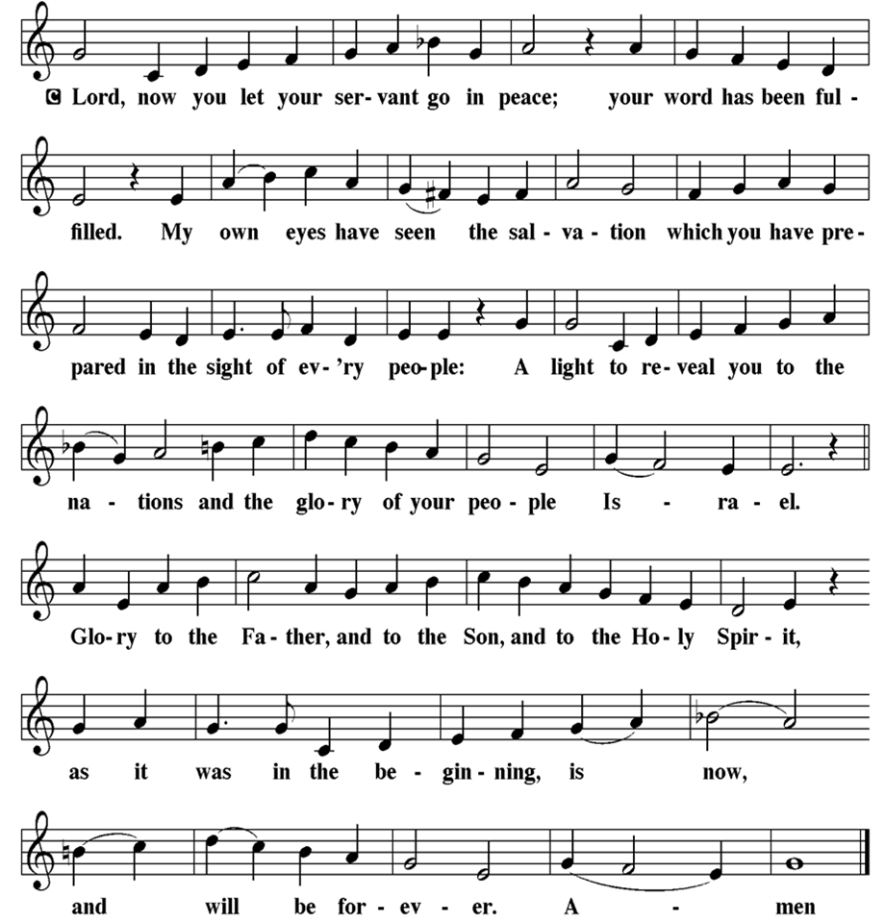

Sandy Bloomberg (Judy Brannan's Family)
Simon (Carol Amundsen's Family)
Bill Ransing & Family (Frank Ford’s Friends)
Barbara Brosius (Philomena Noak's Friend)
Barbara Schmiedel (Bob Fritsch's Family)
Cathy Bell (Ted & Diane Bell's Family)
Linda Stonelake (Kathy & Butch Poehler's Friend)
Anne Pfaff (Bonnie Millard & Vicki Rinier's Friend)
Celeste (Community Member)
Robin (Community Member)
Anna Perez (Bob Fritsch's Family)
Denise Graham (Mary Melnicoff's Friend)
Ann Duhadway (Community Member)
Louise Helmes (Wayne & Eleanor Rand's Family)
Barry & Kathy (Kathy & Butch Poehler's Friends)
Marion & Ernie Rink (Fran Green's Friends)
Paul Rand (Wayne & Eleanor Rand's Family)
Donna Oliver (Carol Amundsen's Friend)
Dr. Ed. Tinney (Bonnie & Skip Millard's Friend)
(Additional Names Added Prior to the Worship Service.)
A. Hear us, O God.
C. Your mercy is great.

A. God our friend, we praise you for the diversity of people among us. Awaken us to
share and receive the gifts we each possess, and stir up a spirit of
understanding, celebration, and welcome for all. Hear us, O God.
C. Your mercy is great.

A. God our home, we thank you for all who have died and completed their baptismal
journeys. Grant us faith to live until we too dwell in your house forever. Hear us,
O God.
C. Your mercy is great.

(Here other intercessions may be offered.)

V. Watch over all of us who are worried and suffering, and especially those whose
names we now say aloud or hold within our hearts (pause). Hear us, O God.
C. Your mercy is great.

V. Receive our prayers, O God, through Jesus Christ, our strength and salvation.
C. Amen.
Robert Chaplin (Mary Melnicoff's Friend)
Jack Wieckouski (Theresa & Kim McGinley's Family)
Carolyn Santarpio (Bob Fritsch's Friend)
Harry (Judy Brannan's Friend)
Janet K (Philomena Noak's Friend)
Michael Hart (Diana DeNote's Friend)
Rocco Leonard DeNote (Diana DeNote's Family)
Sherri Lynn (Bob Fritsch's Friend)
John Bannco (Bob Fritsch's Friend)
Nancy Pazarinie (Bob Fritsch's Family)
Jane & Paul Eiben (Rose Lang's Friend)
Joe DiMassimo (Judy Brannan & Mary Melnicoff's Friend)
Denny Papst (Rose Lang’s Friend)
Mike & Alice Rhoades (Rose Lang’s Friends)
Chris (Judy Brannan's Friend)
Helen Ehlers (Judy Brannan's Friend)
Leanne Bueth (Joan Kilcoyne's Family)
Janett MacFarlane (Carol Amundsen's Friend)
Thish Kelly (Theresa & Kim McGinley's Family)
Edward Chapleski (Allison Call's Family)
Scott Levin (Rose Lang's Friend)
Alice Ann Dennis (Diana DeNote's Family)
Nancy Taylor (Ted & Diane Bell's Family)
Santa Isabel Lutheran Church (Elizabeth, NJ)
Messiah Lutheran Church (Oakland, NJ)
Joyce Thompson (TDPWC Member)
Barbara Paynter (Leon Stitt’s Family)
Ruth (Anthony & Vincent Bruno's Family)
William T Hodgetts (Pastor William Hodgetts’ Family)
Paul Bowker (Church Member)
Bob Poole (Kathy Poehler's Family)
David Smith (Heather & Vicar Vince Piekarski’s Family)
Barbara Hoitink (Lucas & Sabrina Munson's Family)
Kathy Raynor (Philomena Noak & Mary Melnicoff’s Friend)
Jordan (Carol Amundsen's Friend)
Jeremy Pochatko (Vicar Vince Piekarski's Friend)
Ann Wieckouski (Theresa & Kim McGinley's Family)
Rich (Kim McGinley's Friend)
Amy Johnson (Ted Bell's Sister)
Jerry & Marlana (Carol Amundsen's Friend)
Theresa Dolan (Joan Kilcoyne's Family)
PRAYER AFTER COMMUNION
A. Let us pray,
God of our salvation,
we give you thanks for this meal that restores our souls,
reconciles us to you, and strengthens us for the journey.
Through the body and blood of your Son,
may we become Christ’s body in the world,
bearing witness to your love for all creation,
through Jesus Christ, our Savior and Lord.
C. Amen.

BLESSING
V. Receive the blessing of the holy Trinity:
God, who calls all things into existence,
Jesus Christ, who redeems us,
and the Holy Spirit, whose breath sustains creation,
☩ bless you now and always.
C. Amen.

SENDING HYMN
(We invite you to sing along.)
With One Voice—Blue Book
776—Be Thou My Vision

(Assistant extinguishes the Altar Candles half way through the Sending Hymn.)

(Vicar processes out once the Altar Candles have been extinguished.)

(We invite you to be seated.)

BIRTHDAYS, ANNIVERSARIES, & ANNOUNCEMENTS
(Offered by Assistant and Congregation.)

BIRTHDAYS
15th Butch Poehler
18th BettyAnn Rich-White
19th Dax Martin

ANNIVERSARY
17th Chrissy & Bob Thomas
DISMISSAL
A. Go in peace. Believe the good news.
C. Thanks be to God.

POSTLUDE
(Music offered by our Organist as we depart following our Worship Service.)
When I Survey The Wondrous Cross

LICENSES & EXPIRATION DATES
Worship Service Content is used via permission through Augsburg Fortress Liturgies Annual License #SB144368. The next Subscription Renewal Date is 2/28/2027.
Our Hymns and Worship Music are used via permission through CCLI One
License #11327166. The next Subscription Renewal Date is 1/31/2027.

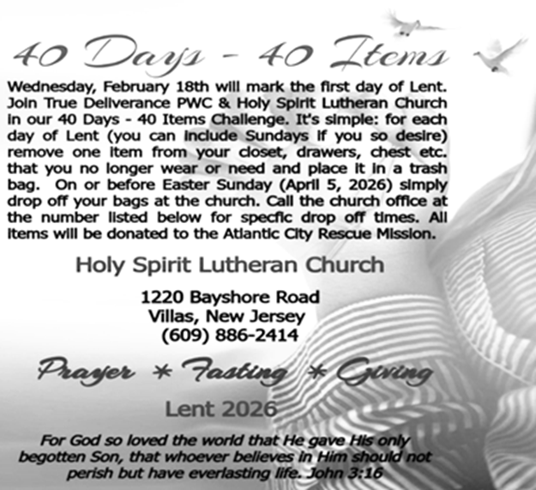

A. God our provider, we cry out for this planet and the life it holds. Rescue
endangered animals and plants, preserve threatened ecosystems, and save
creatures from natural disasters. Hear us, O God.
C. Your mercy is great.

A. God our sovereign, we plead for your peace on earth. Bring an end to war and
violence, and raise up leaders in governments, courts, businesses, schools, and
community organizations who seek goodness and mercy. Hear us, O God.
C. Your mercy is great.

A. God our healer, we call to you in our need. Uplift all who are made to feel
unimportant, and transform the hearts of all infected by bigotry and prejudice.
Care for all in special need this day; especially:
BettyAnn Rich-White (Church Member)
Chip & Marie Hand (Church Members)
Lynn Bargstadt (Church Member)
Frank Ford (Church Member)
Carol Amundsen (Church Member)
Kim McGinley (Church Member)
Anthony DeLuca (Church Member)
Frank Brunner (Church Member)
Joan Sommerman (Church Family)
Arleen Kinka (Church Family)
Rick Lang (Church Family)
Suzie Clark (Rose Lang's Friend)
Francis Clock (Dianna DeNote’s Family)
Andrew Hudak (Rose Lang’s Friend)
Viena Murtha (Bob Fritsch’s Friend)
Sharon Waicus (Skip & Bonnie Millard's Friend)
Karen O'Brien (Paul Bowker's Friend)
Dustin Irizzary (Mary Melnicoff's Family)
The Bryan Family (Wanda Bryan's Family)
Craig Brearey (Judy Brannan & Mary Melnicoff's Friend)
Sarah Dutton (Frank Ford's Family)
Christina McNasby (Fran Green’s Family)
Mark Stephen Dennis (Diana DeNote's Family)
Bill Lodge (Skip & Bonnie Millard's Friend)
Ron Anderson (Bill Kelly's Friend)
Bud Brearey (Judy Brannan & Mary Melnicoff's Friend)
Mary Skain (Kathy Poehler's Friend)

HYMN OF THE DAY
(We invite you to sing along.)
Lutheran Book of Worship—Green Book
104—In the Cross of Christ I Glory

APOSTLES’ CREED
V. God has made us his people through our Baptism into Christ. Living together in
trust and hope let us confess our faith together using the Apostles’ Creed.
C. I believe in God, the Father almighty,
creator of heaven and earth.

I believe in Jesus Christ, God’s only Son, our Lord,
who was conceived by the Holy Spirit,
born of the Virgin Mary,
suffered under Pontius Pilate,
was crucified, died, and was buried;
he descended to the dead.
On the third day he rose again;
he ascended into heaven,
he is seated at the right hand of the Father,
and he will come to judge the living and the dead.

I believe in the Holy Spirit,
the holy catholic church,
the communion of saints,
the forgiveness of sins,
the resurrection of the body
and the life everlasting.
Amen.

PRAYERS OF INTERCESSION
V. Reconciled by God’s mercy and sustained by God’s presence, let us pray for the
world and its needs.

(A brief silence.)

A. God, our shepherd, we pray that you guide the church. Lead Christians in our
community and across the globe in right paths for your name’s sake. Hear us, O
God.
C. Your mercy is great.


CONFIRMATION & SUNDAY SCHOOL
“Here We Stand” allows our young folks to go through a 2-year process focusing on the Bible and Luther’s Small Catechism. Classes are on Sundays from 9-10AM.

SPECIAL PREACHER FOLLOWING SEMINARY WEEK
Heather Piekarski is looking forward to Preaching TODAY, Sunday, March 15th, following Vicar Vince’s week of Intensive Class at Seminary. There will be Holy Communion as Vicar Vince will be back from Seminary and Leading Worship.

WORSHIP MINISTRY
The most important thing we do each week is gather together as God's people to Worship. God is the center and focus of everything we do. Participating in Worship is active, as Liturgy means the work and actions of the people gathered. Everything we do during the week to prepare for Worship, and everything we do as we Assist in leading Worship is important. We are thankful for all the wonderful work being done. If you have questions, or are interested in any position, reach out to Vicar Vince.
Sign-up sheets are located on the bulletin board between the church offices.

NEWSLETTER
Collect information, stories, pictures, and reports for our next publication. Everything needs submitted to Vicar Vince in-person or via email at vpie8282@gmail.com.
The deadline for information to be submitted for Spring is Sunday, March 15th.

CHURCH COUNCIL
Share your comments, concerns, questions, or joys with one of our Church Council Members who can bring them back to our meetings. Visitors are always welcome to attend and listen to what is going on in and around the church. Join us In- Person or on our Conference Call at our next Meeting on Tuesday, March 17th, at 6PM.

FOOD PANTRY
Open every Thursday, and the last Saturday of every month, from 10AM to 1PM. 106 people were served in February and 240 people have been served in 2026. Donations can be dropped in the outdoor drop-box, in the money jug in the back of the Church, mailed into the Church Office, or placed in the Offering Plate. Volunteers are needed. Sign-up sheets are located on the bulletin board between the church offices. If you have questions or need training see Heather, Vicar Vince, or Bonnie.
A special thank you goes out to all who donate, pray, and help in any way!

Thursday, 3/19 | Thursday, 3/26 | Saturday, 3/28
Kim, Theresa, & Garnet | Kim, Theresa, & Bob | Vicki & Bonnie

COMMUNITY FOOD DONATIONS, DELIVERIES, & MORE
North Cape May Acme provides us with Expiring, Recently Expired, and Slightly Damaged Food and Items. Kathy delivers on Saturdays in the community, brings items to church and the food pantry, and to the Branches Outreach in Rio Grande.

BULLETIN ENTRY DEADLINE
The Bulletin is printed on Thursdays during Church Office Hours. Changes need to be submitted to Vicar Vince no later than Thursday by 4PM. Thank you!

CHURCH OFFICE HOURS
Open Thursdays from 6PM to 8PM. It is open to serve the Congregation, the Community, and to handle the business of the Church. Feel free to stop in to talk, pick-up or drop off something, pray in the Sanctuary, or for whatever reason.

agreed that anyone who confessed Jesus to be the Messiah would be put out of
the synagogue. 23 Therefore his parents said, “He is of age; ask him.”

24 So for the second time they called the man who had been blind, and they said
to him, “Give glory to God! We know that this man is a sinner.” 25 He answered,
“I do not know whether he is a sinner. One thing I do know, that though I was
blind, now I see.” 26 They said to him, “What did he do to you? How did he open
your eyes?” 27 He answered them, “I have told you already, and you would not
listen. Why do you want to hear it again? Do you also want to become his
disciples?” 28 Then they reviled him, saying, “You are his disciple, but we are
disciples of Moses. 29 We know that God has spoken to Moses, but as for this
man, we do not know where he comes from.” 30 The man answered, “Here is an
astonishing thing! You do not know where he comes from, yet he opened my
eyes. 31 We know that God does not listen to sinners, but he does listen to one
who worships him and obeys his will. 32 Never since the world began has it been
heard that anyone opened the eyes of a person born blind. 33 If this man were
not from God, he could do nothing.” 34 They answered him, “You were born
entirely in sins, and are you trying to teach us?” And they drove him out.

35 Jesus heard that they had driven him out, and when he found him he said, “Do
you believe in the Son of Man?” 36 He answered, “And who is he, sir? Tell me, so
that I may believe in him.” 37 Jesus said to him, “You have seen him, and the one
speaking with you is he.” 38 He said, “Lord, I believe.” And he worshiped him.
39 Jesus said, “I came into this world for judgment, so that those who do not see
may see and those who do see may become blind.” 40 Some of the Pharisees
who were with him heard this and said to him, “Surely we are not blind, are we?”
41 Jesus said to them, “If you were blind, you would not have sin. But now that
you say, ‘We see,’ your sin remains.”

V. This is the Gospel of the Lord,
C. Praise to you, O Christ.

(We invite you to be seated.)

SERMON
(Delivered by Heather Piekarski.)

(Following the Sermon, we invite you to stand as you are able.)

GOSPEL READING
Jesus heals a man born blind, provoking a hostile reaction that he regards as
spiritual blindness to the things of God.

V. The Holy Gospel According to John (Chapter 9, Verses 1-41).
C. Glory to you, O Lord.

V. 1 As [Jesus] walked along, he saw a man blind from birth. 2 His disciples asked
him, “Rabbi, who sinned, this man or his parents, that he was born blind?”
3 Jesus answered, “Neither this man nor his parents sinned; he was born blind so
that God’s works might be revealed in him. 4 We must work the works of him who
sent me while it is day; night is coming, when no one can work. 5 As long as I am
in the world, I am the light of the world.” 6 When he had said this, he spat on the
ground and made mud with the saliva and spread the mud on the man’s eyes,
7 saying to him, “Go, wash in the pool of Siloam” (which means Sent). Then he
went and washed and came back able to see. 8 The neighbors and those who
had seen him before as a beggar began to ask, “Is this not the man who used to
sit and beg?” 9 Some were saying, “It is he.” Others were saying, “No, but it is
someone like him.” He kept saying, “I am he.” 10 But they kept asking him, “Then
how were your eyes opened?” 11 He answered, “The man called Jesus made
mud, spread it on my eyes, and said to me, ‘Go to Siloam and wash.’ Then I went
and washed and received my sight.” 12 They said to him, “Where is he?” He said,
“I do not know.”

13 They brought to the Pharisees the man who had formerly been blind. 14 Now it
was a Sabbath day when Jesus made the mud and opened his eyes. 15 Then the
Pharisees also began to ask him how he had received his sight. He said to them,
“He put mud on my eyes. Then I washed, and now I see.” 16 Some of the
Pharisees said, “This man is not from God, for he does not observe the Sabbath.”
Others said, “How can a man who is a sinner perform such signs?” And they
were divided. 17 So they said again to the blind man, “What do you say about
him? It was your eyes he opened.” He said, “He is a prophet.”

18 The Jews did not believe that he had been blind and had received his sight
until they called the parents of the man who had received his sight 19 and asked
them, “Is this your son, who you say was born blind? How then does he now
see?” 20 His parents answered, “We know that this is our son and that he was
born blind, 21 but we do not know how it is that now he sees, nor do we know
who opened his eyes. Ask him; he is of age. He will speak for himself.” 22 His
parents said this because they were afraid of the Jews, for the Jews had already

BIBLE STUDY & FAITH DISCUSSIONS
Bible Study & Faith Discussions focuses on various readings, books, Bible verses, people of faith, and other general topics. Group Members offer various points of view while being respectful and supportive of one another. Join us on Tuesdays at 6PM.
We will return Tuesday, March 24th, following our Church Council week.

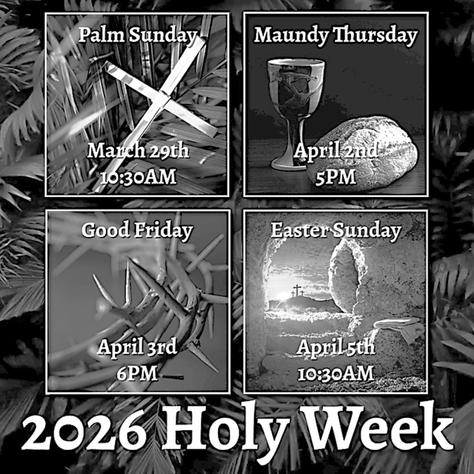

DONATION STATION
Get on the train and place all purchased items in the specified project donation bins located on the counter by the front doors. See Heather for more information.


WOMEN OF THE CHURCH
Their next meeting is on Monday, April 6th, at 6PM. New members are always invited and welcome to attend! Contact Judy for more information.

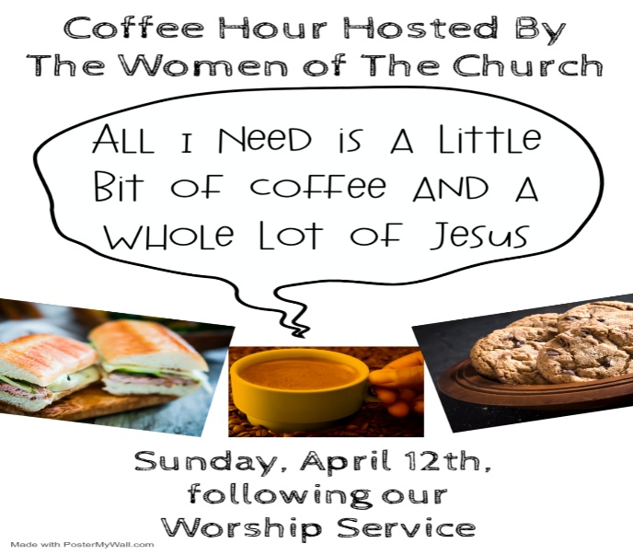

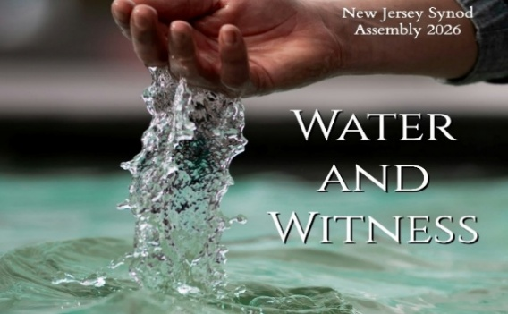
Our NJ Synod Assembly transitions back to a one-day event on Saturday,
May 30th, 2026. Wayne & Judy are considering attending with Vicar Vince.
Registration is now up and will need completed and paid for soon.


Confirmation is a journey of faith filled with new questions and answers, new discoveries, new relationships, new responsibilities, and new possibilities. Clearly confirmation is intended to be a milestone, not a destination; it is not graduation! Rather, Confirmation is a tool that equips for the life-long process of living out Christian identity. Traditionally we would be celebrating Confirmation on Pentecost Sunday. However, due to it falling on Memorial Day Weekend, and the schedules of our young folks, we will be moving it to Sunday, June 14th, during our 10:30AM Worship Service. Please come out and join Caylee Thomas and Robert Thomas on this special day and celebrate with them at the Coffee Hour afterwards.
and guide me along right pathways for your name’s sake.
4 Though I walk through the valley of the shadow of death, I shall fear no evil;
for you are with me; your rod and your staff, they comfort me.
C. You anoint my head with oil. (Ps. 23:5)

R. 5 You prepare a table before me in the presence of my enemies;
you anoint my head with oil, and my cup is running over.
6 Surely goodness and mercy shall follow me all the days of my life,
and I will dwell in the house of the Lord forever.
C. You anoint my head with oil. (Ps. 23:5)

SECOND READING
Because we now live in the divine light which is Jesus Christ, we conduct our
lives in ways that reflect the light of Christ, so that our activity is truly pleasing to
God.

R. Our Second Reading is from Ephesians (Chapter 6, Verses 8-14).

R. 8 Once you were darkness, but now in the Lord you are light. Walk as children of
light, 9 for the fruit of the light is found in all that is good and right and true. 10 Try
to find out what is pleasing to the Lord. 11 Take no part in the unfruitful works of
darkness; rather, expose them. 12 For it is shameful even to mention what such
people do secretly, 13 but everything exposed by the light becomes visible, 14 for
everything that becomes visible is light. Therefore it says,
“Sleeper, awake!
Rise from the dead,
and Christ will shine on you.”

R. This is the Word of the Lord.
C. Thanks be to God.

V. I invite you to stand as you are able, and I invite you to announce the Gospel
Acclamation with me.

GOSPEL ACCLAMATION
C. Jesus says, I am the light of the world; whoever follows me will have the
light of life. (John 8:12)

R. 1 The Lord said to Samuel, “How long will you grieve over Saul? I have rejected
him from being king over Israel. Fill your horn with oil and set out; I will send you
to Jesse the Bethlehemite, for I have provided for myself a king among his sons.”
2 Samuel said, “How can I go? If Saul hears of it, he will kill me.” And the Lord
said, “Take a heifer with you and say, ‘I have come to sacrifice to the Lord.’
3 Invite Jesse to the sacrifice, and I will show you what you shall do, and you
shall anoint for me the one whom I name to you.” 4 Samuel did what the Lord
commanded and came to Bethlehem. The elders of the city came to meet him
trembling and said, “Do you come peaceably?” 5 He said, “Peaceably. I have
come to sacrifice to the Lord; sanctify yourselves and come with me to the
sacrifice.” And he sanctified Jesse and his sons and invited them to the sacrifice.

6 When they came, he looked on Eliab and thought, “Surely his anointed is now
before the Lord.” 7 But the Lord said to Samuel, “Do not look on his appearance
or on the height of his stature, because I have rejected him, for the Lord does not
see as mortals see; they look on the outward appearance, but the Lord looks on
the heart.” 8 Then Jesse called Abinadab and made him pass before Samuel. He
said, “Neither has the Lord chosen this one.” 9 Then Jesse made Shammah pass
by. And he said, “Neither has the Lord chosen this one.” 10 Jesse made seven of
his sons pass before Samuel, and Samuel said to Jesse, “The Lord has not
chosen any of these.” 11 Samuel said to Jesse, “Are all your sons here?” And he
said, “There remains yet the youngest, but he is keeping the sheep.” And Samuel
said to Jesse, “Send and bring him, for we will not sit down until he comes here.”
12 He sent and brought him in. Now he was ruddy and had beautiful eyes and
was handsome. The Lord said, “Rise and anoint him, for this is the one.” 13 Then
Samuel took the horn of oil and anointed him in the presence of his brothers, and
the spirit of the Lord came mightily upon David from that day forward. Samuel
then set out and went to Ramah.

R. This is the Word of the Lord.
C. Thanks be to God.

PSALM
R. Our Responsorial Psalm is from the 23rd Psalm.
C. You anoint my head with oil. (Ps. 23:5)

R. 1 The Lord is my shepherd;
I shall not be in want.
2 The Lord makes me lie down in green pastures
and leads me beside still waters.
3 You restore my soul, O Lord,
CHURCH DIRECTORY
2026 Church Directories are by the Church Office on the bookshelves. We continue keeping it updated, but we undoubtedly miss a few changes or have made a few errors. Please inform the Church Office of updates or changes to keep us up to date.

FAVORITE HYMNS
Carol is willing to play some of your favorite hymns for the Prelude & Postlude each Sunday during our Worship Service. Feel free to let her know of your suggestions.

TITHES, OFFERINGS, & ENVELOPES
We worship God with our tithes and offerings. We hear in scripture, “Each of you must give as you have made up your mind, not reluctantly or under compulsion, for God loves a cheerful giver.” (2 Corinthians 9:7) Envelopes can be dropped in the offering plate, mailed to the church, or dropped in the locked mailbox. Thanks for your support in the mission of our church, its ministries, the NJ Synod, etc!

SPACE AVAILABLE
​​​​​Interested in utilizing our Fellowship Hall for a Party or Event? There is a suggested $50 refundable security deposit, and it is $250 for facility use. No alcohol or games of chance permitted due to ELCA policy. Please contact Vicar Vince for more info.

ED GREEN CAPITAL IMPROVEMENT FUND
We are seeking out a new fundraiser at this time. We also have the donation bin in the back of the church and we have our Annual Church Rummage Sale to raise funds. Thanks for your continued donations, prayers, and support!

HOME COMMUNION MINISTRY
A Minister is available if you have a loved one, or if you desire services. We look forward in sharing the Word and Holy Communion! Please inform Vicar Vince, Kathy, or the Church Office so plans can be made for visits.

PRAYER SHAWL MINISTRY
Prayer Shawls, Lap Quilts, Scarves, and other items have been made with love. Blessed items are located in the Narthex, and are free for anyone. Members of the group continue working at home on new stitches and patterns. We are blessed to be able to continue collecting new items. We have a donation station of yarn and other items located in the Narthex. You can find some new supplies for your next creation!

PRAYER LIST
Our Prayer List continues to lengthen and we realize the important need for prayers and healing. Sometimes the unfortunate result is that someone has passed away, and the words “The Family & Friends of” appear before someone’s name. However, sometimes we forget names are still on the list and their health has improved and they can be removed. Please share various stories as we continue to pray for strength and healing. Names can be added or removed from the list on the clipboard in the Narthex prior to the Worship Service, by calling the church office, or addressing it on the Conference Call. Please let us know the relation to the person(s) you listed so we can be more mindful with our prayers.

LIBRARY
New books are added to our library from time to time. Several are borrowed and read and exchanged. Who knows, you might find one particularly interesting and share that with someone as well. Reading is a great way to pass spare time, learn, and explore. You may find some fresh ideas for prayer, ways to grow more spiritually, ways to grow closer to God, or some opportunities to understand our faith more. We also have an extended library located in Vicar Vince’s office. There are Bibles of various translations, books from his personal collection, books inherited from Pastor Leah, movies, past Bible Study Curriculums, and more. Visit the library between the church offices or just ask to be able to check things out.

INTERESTED IN BECOMING A NEW MEMBER
Have you been attending our church for a while? Have you just recently returned to church after being away for a bit? Maybe you transitioned from another church,
or just started to recently attend our church. We are glad to have you, and would love to have you as a member of our Congregation. See Vicar Vince for more info.

BAPTISM
We are a church whose unity is in Jesus Christ, who gathers us around word and water, wine and bread. Baptism is a significant part of our faith journey as we come from the baptismal waters to live a new life as children of God. Our baptism sets us out on a lifelong journey that is characterized by our relationship to God, our relationship to our faith community, our relationships in our community and the wider world. Living our baptismal covenant means living a life of growth in the faith practices of discipleship. Please see Vicar Vince for more information.

KYRIE
V. In peace, let us pray to the Lord.
C. Lord, have mercy.

V. For the peace from above, and for our salvation, let us pray to the Lord.
C. Lord, have mercy.

V. For the peace of the whole world, for the well-being of the church of God,
and for the unity of all, let us pray to the Lord.
C. Lord, have mercy.

V. For this holy house, and for all who offer here their worship and praise,
let us pray to the Lord.
C. Lord, have mercy.

V. Help, save, comfort, and defend us, gracious Lord.
C. Amen.

PRAYER OF THE DAY
V. The Lord be with you.
C. And also with you.

V. Let us pray,
Bend your ear to our prayers, Lord Christ, and come among us. By your gracious
life and death for us, bring light into the darkness of our hearts, and anoint us with
your Spirit, for you live and reign with the Father and the Holy Spirit, one God,
now and forever.
C. Amen.

(We invite you to be seated for our Readings and Psalm.)

FIRST READING
Samuel anointed David even though he was the eighth-oldest son of Jesse and
did not match his brothers in height or other physical characteristics. With the
anointing came endowment with the Spirit of the Lord, designating David as the
Lord’s chosen successor to Saul.

R. Our First Reading is from 1st Samuel (Chapter 16, Verses 1-13).

V. For desiring self-reliance instead of hungering for your word:
Gracious God,
C. have mercy on us according to your steadfast love.
V. For failing to recognize your coming reign,
and for hindering the work of the Spirit:
Gracious God,
C. have mercy on us according to your steadfast love.
V. For drawing from the well of self-serving ambition,
and for disdaining the living water Christ offers:
Gracious God,
C. have mercy on us according to your steadfast love.
V. For disregarding voices from the margin,
and for distrusting signs of your healing and hope in the world:
Gracious God,
C. have mercy on us according to your steadfast love.
V. For dwelling in tombs of self-pity and discontent,
and for disregarding Christ’s call to come forth to life:
Gracious God,
C. have mercy on us according to your steadfast love.

V. God’s steadfast love, grace, and forgiveness abound.
Through faith, the free gift of God,
you have been clothed in the righteousness of Christ.
In the name of ☩ Jesus Christ, your sins are forgiven.
The Spirit of the One who raised Christ from the dead dwells in you,
pours God’s love into your hearts,
and gives you life and peace.
C. Amen.

GATHERING HYMN
(We invite you to sing along.)
Lutheran Book of Worship—Green Book
448—Amazing Grace, How Sweet the Sound

APOSTOLIC GREETING
V. May the grace of our Lord Jesus Christ, the love of God,
and the communion of the Holy Spirit be with you all.
C. And also with you.

FIRST COMMUNION
Although no particular age for first communion is prescribed by The Use of the Means of Grace, one guideline is offered. Because admission to the Sacrament is by invitation of the Lord to the baptized, "baptized children begin to commune on a regular basis at a time determined through mutual conversation that includes the pastor/vicar, the child, and the parents or sponsors involved, within the accepted practices of the congregation.” Each congregation is encouraged to ask the question of readiness for first communion, establish their own policies regarding age and practice, and accompany that practice with catechesis appropriate to the age of the communicant. If anyone has questions, please see Vicar Vince.

VICAR APPOINTMENT ON MARCH 19TH, 2023
A Memorandum of Understanding on the Matter of Pastoral Appointment
In Theological Education for Emerging Ministries (TEEM) Candidacy
TO: Congregation Council, Holy Spirit Lutheran Church, Villas
FROM: The Rev. Tracie L. Bartholomew, Bishop, New Jersey Synod

Dear Brother and Sisters in Christ,
This memorandum is in support of your discussions with Vincent Piekarski as pastor of Holy Spirit, Villas. Because this is not the usual pattern for completing the educational and candidacy requirements for ordination, it is my hope that this memorandum will both provide guidelines and engage in conversation with those who are invested in this process.

I would say at the outset that because Vincent is an outstanding candidate for the Ministry of Word and Sacrament, we will all want to do whatever is necessary to assure that his placement serves the mission of the church in the best possible fashion.

The following notes reflect my own understanding of this matter:
(1) The appointment for Vincent will begin on April 1, 2023. At this time, Vincent
will assume all responsibilities of a regularly called pastor, including presiding at
the Sacrament of Holy Communion and Baptism at Holy Spirit, Villas.
(2) A pastoral appointment in the TEEM process is an option for completing
seminary educational requirements and the steps of the candidacy process.
Upon completion of the candidacy process and seminary education, the
candidate may receive and accept a call to ordained ministry from the
congregation where the appointment is being served.

(3) This appointment is jointly supervised by the Office of the Bishop and the TEEM
pastor’s seminary. A mentoring relationship with a local pastor is required for the
length of this appointment.
(4) The synod of candidacy origin will be responsible for the approval process.
(5) Upon approval for ordination, the congregation would be expected to extend a
call to the pastoral appointee.
(6) Compensation for the TEEM pastor will be according to the guidelines of the New
Jersey Synod. All normal forms of compensation should be in place for the term
of the appointment, including stipulation that base salary and housing shall be in
accord with synod guidelines for first call at time of ordination.
(7) The ELCA Portico benefit plan for lay persons in full-time church service should
be used for the pastoral appointee up to the time of ordination, whereupon the
benefit package is to be converted to the plan for ELCA clergy.
(8) A decision for Pastoral Appointment is made with the agreement of a synod and
its candidacy committee, and the ELCA, normally represented by the regional
staff person of each in consultation with the seminary and its Director for
Contextual Education.
(9) Pastoral Appointment in a TEEM Candidacy is an option that is to serve the
mission of the Church in a particular and vital way and is not to be viewed or
used as a means to circumvent the normal candidacy process and/or first call
placement process.

In the specific case of Vincent, the New Jersey Synod remains responsible for the candidacy and approval process, and has agreed to this proposal for Appointment at Holy Spirit, Villas.

Continued blessings to both Holy Spirit and Vincent Piekarski as you embark on this journey of mutual ministry. As partners in ministry, we walk with you and rejoice in this new relationship.

VICAR VINCE’S DAY OF REST
A day of rest can have physical, mental, and spiritual benefits. “Mittwoch,” German for mid-week, or Wednesday, is the day that Vicar Vince will use to recharge and do some other things. Please do not hesitate to reach out if there is an emergency!

VICE PASTOR UPDATE
Pastor William Hodgetts continues to attend our Church Council Meetings
and provides Supervision and Support to Vicar Vince.

CONFERENCE CALL CHECK-IN, WELCOME, & ANNOUNCEMENTS
(Vicar (V), Assistant (A), Reader (R), and Congregation (C).)

INTRODUCTION
A. Baptism is sometimes called enlightenment. The gospel for this Sunday is the
story of the man born blind healed by Christ. “I was blind, now I see,” declares
the man. In baptism God opens our eyes to see the truth of who we are: God’s
beloved children. As David was anointed king of Israel, in baptism God anoints
our head with oil, and calls us to bear witness to the light of Christ in our daily
lives.

PRELUDE
(Music offered by our Organist at the start of our Worship Service.)
O Lamb of God, Pure, Spotless

CHIMES
(Music offered by our Organist at the start of our Worship Service.)
God So Loved The World

(We invite you to stand as you are able.)

CONFESSION & FORGIVENESS
(All may make the sign of the cross, the sign that is marked at baptism.)
V. Blessed be the holy Trinity, ☩ one God,
who forgives all our sin,
whose mercy endures forever.
C. Amen.

V. Let us confess our sin before God, who removes our guilt
and blots out all offenses.

(Silence is kept for reflection.)

V. Gracious God,
C. have mercy on us according to your steadfast love.
V. For seeking worldly delights that deceive us and dishonor you:
Gracious God,
C. have mercy on us according to your steadfast love.


We, the Evangelical Lutheran Church of the Holy Spirit, are People of God, who
are called by the Holy Spirit to pray, worship, joyfully proclaim Jesus Christ,
and compassionately witness and serve others in Christian Love.


We are glad that you joined us for Worship today! Thank you for enriching our time together! We would like to get to know you better, and for you to get to know us better too. Brochures, welcome gifts, prayer shawls, Bibles, and other items are available throughout the church. We would be happy to show you around and share about our ministries. Please do not hesitate to speak up and ask questions.
Also, please make sure you sign-in on our clipboard on the podium in the lobby.


Our Worship Services are conducted in coordination with our Conference Call.
Join us at 657-390-7423 or 701-802-5170, with access code 8221190#.
You may need to dial 1 first depending on your phone plan. After logging in please announce your name and feel free to talk with others until we get started.


SANCTUARY CANDLE FOR MARCH
Given to the Glory of God & In Memory of DOROFFEY KIROW
by Rose Lang, Vicar Vince & Heather Piekarski.
ALTAR CANDLES FOR MARCH
Given to the Glory of God & In Memory of DONNA GAIN
by Jean, Phil, & Bob Zimmerman.
WHAT IS THE EVANGELICAL LUTHERAN CHURCH IN AMERICA?
The ELCA was formed in 1987 by the merger of three Lutheran Church bodies –
the ALC (American Lutheran Church), the LCA (Lutheran Church in America), and the AELC (Association of Evangelical Lutheran Churches). Learn more at elca.org.

NEW JERSEY SYNOD
The New Jersey Synod is a geographical grouping of Evangelical Lutheran Church in America (ELCA) congregations that share the mission and ministry of the Church on the New Jersey territory. It is one of 65 synods in the ELCA. The NJ Synod is comprised of 143 congregations, which include over 45,000 baptized members.

JERSEY JOTTINGS
There is a weekly e-newsletter connecting our synod together with weekly prayer, upcoming events, synod and churchwide activities, mission stories, congregational activities, & more. Sign up at www.njsynod.org/stay-connected or download the app.

2026 FINANCIAL STANDING
FEBRUARY INCOME | $8,570.00
FEBRUARY SPENDING | $6,702.26
FEBRUARY GAIN OR (LOSS) | $1,867.74
2026 INCOME | $11,480.00
2026 SPENDING | $12,124.07
2026 GAIN OR (LOSS) | ($644.07)
ED GREEN CAPITAL IMPROVEMENT FUND | $2,958.55
FOOD PANTRY FUND (SOCIAL MINISTRY) | $13,515.13
CD | $26,414.45

TRUE DELIVERANCE PRAISE & WORSHIP CENTER
TDPWC utilizes our facilities from 1-4PM on Sundays. TDPWC hosts or assists with other events. TDPWC hosts a Prayer Line on Mondays, Wednesdays, & Fridays at 5PM on the Conference Call 1-657-390-7957; & Bible Study on Thursdays at 6:30PM on Zoom. See Rev. Brooks for more information.

JUST FRIENDS
The group promotes a spirit of fellowship among adults 50 years and older. Bring your own lunch, beverages and deserts are provided. Everyone is welcome. The group meets in Our Lady Star of The Sea Parish Hall on the last Wednesday of the month from 12Noon to 2PM from September through May. For information, please call Martine Simonis 609-884-5312 x 110.
ADDITIONAL OFFERINGS FROM OUR FRIENDS & NEIGHBORS
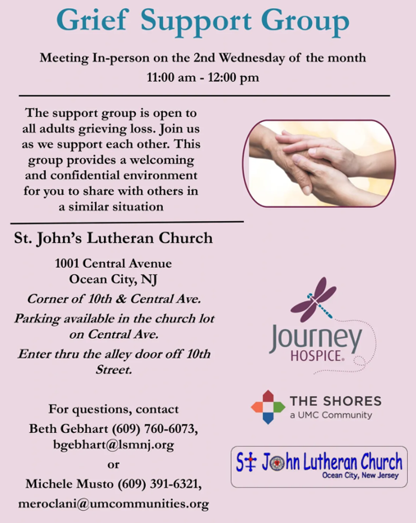

CHURCH STAFF & VOLUNTEERS
VICAR
Vicar Vince Piekarski
VICE PASTOR
Pastor William Hodgetts
ORGANIST & PIANIST
Carol Amundsen
CHURCH OFFICE, SUNDAY SCHOOL, & FOOD PANTRY
Heather Piekarski
CHURCH COUNCIL PRESIDENT & CHURCH PROPERTY
Wayne Rand
CHURCH COUNCIL VICE PRESIDENT & WOMEN OF THE CHURCH
Judy Brannan
CHURCH COUNCIL TREASURER
Bonnie Millard
CHURCH COUNCIL SECRETARY
Vicki Rinier
WELCOME TO
HOLY SPIRIT LUTHERAN CHURCH
A Member of the Evangelical Lutheran Church in America, New Jersey Synod
1220 Bayshore Rd., Villas, NJ 08251, 609-886-2414,
holyspiritlutheran@comcast.net, holyspiritvillas.com, facebook.com/holyspiritvillas
Vicar Vince Piekarski can be contacted at any time for conversation or prayer through call or text at 412-225-0287, or through email at vpie8282@gmail.com.
SUNDAY, MARCH 15TH, 2026
FOURTH SUNDAY IN LENT
10:30AM WORSHIP SERVICE WITH HOLY COMMUNION
