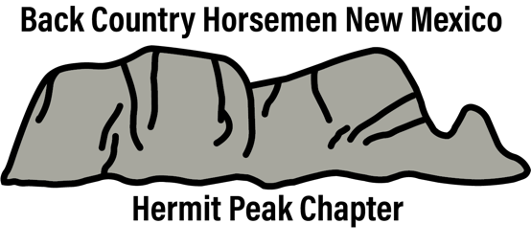 **Join Back Country Horsemen of New Mexico-Hermit Peak Chapter**

* Attend meetings to hear speakers on topics of interest to horsemen.
* Receive a quarterly newsletter from Back Country Horsemen of America.
* Inform us of issues that concern you and let us inform you of issues that have been brought to BCHNM’S attention for consideration and/or action.
* Be involved in service projects that improve areas used by backcountry riders and assist public lands agencies.



Check with us for dates and locations of our

next meeting or activity.

Hope to see you soon!!

* Educate public land users on low impact methods to preserve our wilderness areas.
* Work to maintain our heritage of pack and saddle stock use of public lands.
* Participate in scheduled work project and recreational activities.
* Member will be evaluated each December to see if they are meeting BHCA mission intent.

**Hermit Peak Chapter is a part of the Back Country Horsemen of America** The Purpose of the organization is:

* 1. To perpetuate the common sense and enjoyment of horses and mules in America’s Back Country and Wilderness.
  2. To work to ensure that public lands remain open to recreational stock use.
  3. To assist the agencies responsible for the management of public lands.
  4. To educate, encourage and solicit active participation in wise and sustaining use of the Back Country Resources by horsemen and the public, commensurate with our heritage.
  5. To foster and encourage the formation of additional Back Country Horsemen Chapters.

|  |  |  |  |  |  |
| --- | --- | --- | --- | --- | --- |
| **Name** | **Phone**  **2nd phone** | **Email address** | **Address** | **Mino**  **r**  **?** | **Skills and experience as a rider, experience in trail maintenance, camping with horses, etc.** |
|  |  |  |  |  |  |
|  |  |  |  |  |  |
|  |  |  |  |  |  |
|  |  |  |  |  |  |

Dues are $45 for an individual, and $55 for a family. Children over 18 may be included in family membership or join as an individual member.

I, under recognition that participation in horse-related activities is an inherently dangerous activity and the New Mexico Equine Liability Act #42 13-1 NMSA 1978, as amended, and any other applicable law, do hereby forever release, acquit, and discharge the Back Country Horsemen of America (BCHA) of New Mexico, Jemez Chapter, Inc., and its officers, directors, administrators, trustees, successors, and assigns of and from any and all actions, causes of action, manner of complaints, claims, damages, and demands or expenses of any kind or nature whatsoever, including attorney’s fees, which I, or if on the behalf of a minor, such minor, may hereafter have resulting from or in any way arising out of or related to my/our or such minor’s participation in this program.

It is expressly understood and agreed that this Release shall operate as a bar to any and all complaints, claims, counterclaims, demands, actions, or damages which I/we or my/our or such minor’s heirs, executors, administrators, personal representatives, successors, assigns, or anyone claiming by, though, or under them, or anyone subrogated to any of their rights, might or could assert, make, or sustain by reason of any of the matters contained in this Release. The terms of this release are contractual in nature and are not mere recitations or representations.

I/we state that I/we am/are signing on behalf of myself and I/we am/are of lawful age and that, if on behalf of a minor, I/we have the full and complete authority to sign this Release.

Signature_________________________________________________________Date___________________________ Signature_________________________________________________________Date___________________________ Signature_________________________________________________________Date___________________________ Signature_________________________________________________________Date___________________________

Send Membership/Dues by Check or Money Order to:

Back Country Horsemen of New Mexico Hermit Peak Chapter

16 NM HWY 65 Las Vegas, New Mexico, 87701