12/22/2018 The Trap is Now Being Set

Setting the Trap

The recent decision by the Commander in Chief of the Armed Forces of the United States to withdraw military support from the Middle East sets the stage for an invasion of Israel by its enemies in the region.

President Trump announced the decision to evacuate Syria and Afganistan on December 19, 2018. His top military advisors were opposed to this decision.

Link: https://www.nytimes.com/2018/12/19/us/politics/trump-syria-turkey-troop-withdrawal.html

YaHuWaH Elohim usually initially speaks directly to, and only with, the single top leader of a nation, as evidenced by prophetical dreams given to the king of ancient Babylon in the book of Daniel chapters 2 and 4. The interpretation of the dream or supernatural event is then given to YaHuWaH 's selected and anointed representative.

YaHuWaH Elohim is in complete control of the affairs of the nations. He turns the hearts of presidents and kings to accomplish His will on the earth.

Proverbs 21:1 The king’s heart is in the hand of YaHuWaH, as the rivers of water: He turneth it whithersoever He will.

The removal of troops allied with Israel from the Middle East will allow a hostile military buildup on Israel's northern border in preparation for the invasion of Israel mentioned in Ezekiel chapters 38 and 39. There is no nation who will come to Israel's aid when the invasion occurs. Israel's helper, the United States, is missing from the bible for some reason at that time. The invading armies from the north will be annihilated on the mountains of Israel by YaHuWaH Elohim as they work their way toward Jerusalem.

Zechariah chapter 14 tells us some specifics of the coming battle:

Zechariah 14:12 And this shall be the plague wherewith YaHuWaH will smite all the people that have fought against Jerusalem; Their flesh shall consume away while they stand upon their feet, and their eyes shall consume away in their holes, and their tongue shall consume away in their mouth.

The words "consume away" in the verse above means to decay and rot or putrefy and stink in the Hebrew.

After the battle mentioned above, there will be no question among the nations that there is an Elohim in Israel.

The 70th Seven

Daniel 9:24 Seventy weeks (Shabua) are determined upon thy people and upon thy holy city, to finish the transgression, and to make an end of sins, and to make reconciliation for iniquity, and to bring in everlasting righteousness, and to seal up the vision and prophecy, and to anoint the most Holy.
25 Know therefore and understand, that from the going forth of the commandment to restore and to build Jerusalem unto the Messiah the Prince shall be seven weeks, and threescore and two weeks: the street shall be built again, and the wall, even in troublous times.

Below: A graphic that shows the decree of Israel's Knesset on 4/1/1969 to rebuild Jerusalem, similar to the commandment mentioned in Daniel 9:25 above.

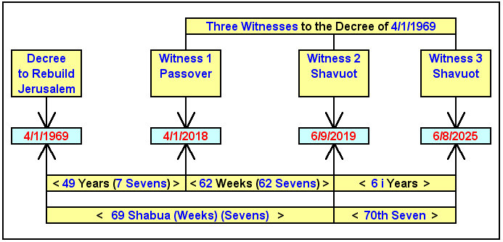

Note in the graphic above that although 62 "weeks" (sevens) from 4/1/2018 end on 6/9/2019, 62 complete and inclusive weeks end on 6/8/2019. Also be aware that the Feast of Shavuot on 6/9/2019 begins at sunset on 6/8/2019.

Note in the graphic above that this iteration of Daniel's 70th week of sevens (seven sevens) occupies exactly 6 inclusive years of history.

This iteration of Daniel's 70th week is not 7 years, as many think, but precisely 7 Shabua, seven observations of the Feast of Shavuot as indicated below.

Note that prophecy is cyclical and can have multiple fulfillments.

Below: A graphic showing an iteration of the seven Shabua of Daniel's 70th "seven" (week), completed in precisely 6 inclusive years.

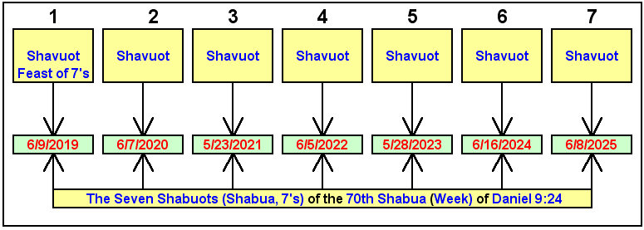

Note that YaHuWaH 's Feast of Shavuot is actually the Feast of Shabuot, spelled with a "b", the "b" being pronounced as a "v" because it's in the middle of the word. Middle b's are generally pronounced as v's, but beginning and ending b's are pronounced as b's.

Joseph's First Dream and the Tribulation Period

The Dream of the Sheaves, the Feast of Shavuot, and the Tribulum

Genesis 37:5 And Joseph dreamed a dream, and he told it his brethren: and they hated him yet the more.
6 And he said unto them, Hear, I pray you, this dream which I have dreamed:
7 For, behold, we were binding sheaves in the field, and, lo, my sheaf arose, and also stood upright; and, behold, your sheaves stood round about, and made obeisance to my sheaf.

YaHuWaH Elohim's Feast of Shavuot (Day of Pentecost) occurs at the beginning of the wheat harvest in Israel. In ancient times stalks of wheat were gathered to the threshing floor and oxen would walk over and trample the wheat with their hooves in order to separate the chaff from the grain.

The combination of chaff and wheat was then thrown into the air and the wind would carry the lighter chaff away, leaving the useful grain to fall to the floor to be gathered into storage for food.

In some instances a device called a tribulum, a device resembling a flat wooden door with sharp flint stone knives on the bottom, would be dragged over the harvested wheat in order to separate the chaff from the wheat. The word "tribulation" is derived from the ancient harvesting machine used in the wheat harvest, the tribulum.

"Tribulation" via the tribulum accompanied the wheat harvest. The later olive, fruit, and grape harvests didn't require a tribulum, or ox hooves, to process the fruit of the trees. However, the grape harvest did require a human being to tread the grapes and bring forth the wine (wine is a biblical symbol of blood).

Below: A graphic showing the time relationship between the USA total solar eclipse of 6/8/1918 and the end of the iteration of Daniel's "70th Week" mentioned further above.

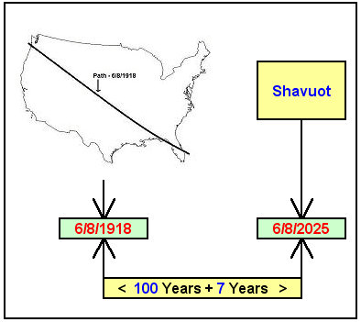

Above: In the bible, the quantity 7 denotes completeness and the quantity 100 denotes perfect completeness.

Below: A graphic that shows a curious relationship between the launch of Apollo 11, carrying the first men to walk on the moon, with the end date of the above iteration of Daniel's 70th "week".

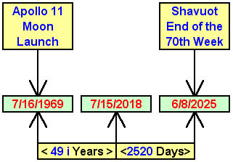
Note that in the bible, the Moon is symbolic of the nation of Israel. Israel is to reflect the light (instructions) of YaHuWaH Elohim, as the Moon reflects the light of the Sun.

The Apollo moon missions were named for Apolloyon the Destroyer Angel, Hebrew - Abaddon, the Angel of the bottomless pit.

Therefore the globally significant Apollo 11 moon mission signified Israel's first visit by Apollyon the Destroyer, the Angel who is so bad that demons want nothing to do with him.

Joseph's Second Dream and the Coming of Messiah

Genesis 37:9 And he dreamed yet another dream, and told it his brethren, and said, Behold, I have dreamed a dream more; and, behold, the sun and the moon and the eleven stars made obeisance to me.

Joseph was a type (symbol) of Israel's Messiah. Joseph's first dream was associated with the Feast of Harvest (Shavuot). Joseph's second dream involves signs in the heavens, as do several scriptures concerning the coming of Messiah.

Below: The sun, moon, and stars will give obeisance to their Creator Elohim as He approaches the earth after the binding of the sheaves during the tribulation period mentioned further above.

Mark 13:23 But take ye heed: behold, I have foretold you all things.
24 But in those days, after that tribulation, the sun shall be darkened, and the moon shall not give her light,
25 And the stars of heaven shall fall, and the powers that are in heaven shall be shaken.
26 And then shall they see the Son of man coming in the clouds with great power and glory.

Isaiah 13:9 Behold, the day of YaHuWaH cometh, cruel both with wrath and fierce anger, to lay the land desolate: and He shall destroy the sinners thereof out of it.
10 For the stars of heaven and the constellations thereof shall not give their light: the sun shall be darkened in his going forth, and the moon shall not cause her light to shine.
11 And I will punish the world for their evil, and the wicked for their iniquity; and I will cause the arrogancy of the proud to cease, and will lay low the haughtiness of the terrible.
12 I will make a man more precious than fine gold; even a man than the golden wedge of Ophir.
13 Therefore I will shake the heavens, and the earth shall remove out of her place, in the wrath of YaHuWaH of hosts, and in the day of His fierce anger.

The above verses show that a great disturbance occurs in space-time as YaHuWaH Elohim and His armies arrive and begin to approach the earth.

As a side note, the solar eclipse of 6/8/1918 mentioned in a graphic above was one of the total solar eclipses chosen by astronomers to confirm Albert Einstein’s Theory of General Relativity and the bending of light by space-time in the vicinity of matter.

The above message is not a prophecy. It's merely a representation of timely events that appear to relate with scripture. It is what it is.

We will soon know If the decree to rebuild Jerusalem by the Israeli government on 4/1/1969 is valid and of effect.

Here's another thing to consider:

Jeremiah 29:10 For thus saith YaHuWaH, That after seventy years be accomplished at Babylon I will visit you, and perform My good word toward you, in causing you to return to this place.

Modern Israel's 70 year relationship with "Babylon" ended on 5/14/2018.

May YaHuWaH Elohim have mercy on us all.

