Energy Medicine First Aid
from Awaken Your Greater Health: How Energy Medicine Opens the Way to Healing
by Heidi DuPree, RN, CTN

Energy Medicine First Aid was developed as a first response tool to become centered when experiencing sudden, strong emotions. It involves the energy of intention, touch, movement, breathing, toning, and words.

- Intention: Approach the technique in the energy of self-compassion.

- Touch: Feel your feet connecting to the ground. Now crossing one hand over the other, place your hands on your chest with your fingertips near the 4 “sore spots.” (see picture) The K-27 acupressure points are located one inch below the inside corners of each collarbone. The heart neurolymphatic points can be found by first locating the U-shaped notch at the top of the breastbone, or sternum. The points are three inches below this notch, and then three inches to the left or right. These 4 points align the entire energy system – restoring balance, enhancing focus, clarity, and energy, as well as boosting immunity and dispersing lymphatic congestion. Rubbing these points opens breathing, brings clarity to our perceptions, enhances creativity and effectiveness, and helps us to feel our connection to the universe. Rub all 4 points with the opposite fingers for 30 seconds each.

- Movement: A slight rocking motion of the body forward and backward is naturally self-soothing and has been found to relax muscles, increase circulation, stimulate endorphin release, balance biological rhythms, and induce a state of deep relaxation with heightened awareness. By closing your eyes and connecting with your natural inner rocking motion in this expanded state, heart-centered solutions to issues and conflicts can arise spontaneously.

- Breath: Slowly and deeply inhale through your nose and exhale through your mouth while focusing on the heart, imagining that you are breathing in and out of your heart.
- Toning: The human voice is the most powerful musical instrument for sound healing. Make an audible sighing “Hah” sound for the duration of each exhalation, while dropping the chin slightly toward chest and allowing the tongue to roll forward to meet the bottom lip – letting your body “go limp” to enhance relaxation.

- Words: Add a healing affirmation

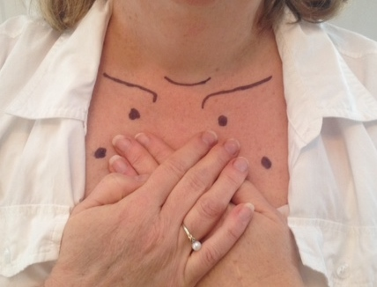

www.HeidiDuPree.com

