3/5/2017 The Birthing of Elijah

There are a couple of 500 year old events among the times that are culminating in 2017 concerning the State of Israel.

Islamic Control of Jerusalem Began 500 Years Ago

On 3/18/1517, Sultan Selim 1 took control of Jerusalem. The Islamic Caliphate had control of Jerusalem for the next 400 years, and Islamic Jordan still controls the Temple Mount area in Jerusalem today.

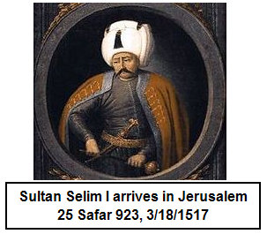

In the 401st year from 3/18/1517, on 12/11/1917 the Christian, First Viscount Edmund Allenby, walked into Jerusalem and took control during World War 1.


General Edmund Allenby was a type or symbol of YAHUSHUA the Messiah.
In Hebrew numbering, the letters Aleph and Tav are symbols of the Messiah. Note that in the book of Revelation YAHUSHUA identified Himself as the Alpha and Omega, which in Hebrew is the Aleph and the Tav, the beginning and the end, the first and last letters of the Hebrew alephbet.

In the Hebrew alephbet (alphabet), the aleph, the first letter, has the numerical value 1. The Tav, the last letter of the alephbet, has the numerical value of 400. The Hindu-Arabic number system we use today such as 1,2,3, etc. wasn't completely invented until the 7th century AD. Example - Roman numerals such as X,V,L, are letters from the Roman alphabet sometimes used as numbers today.

Aleph = 1 and Tav = 400 therefore the Aleph and the Tav = 401 = A numerical representation of Messiah YAHUSHUA

400 years under Islamic rule + 1 year = 401 = A symbol of Israel's Messiah

There were 400 years of continual Islamic rule over Jerusalem, from 1517 to early 1917. In the 401st year after the beginning of Islamic rule in early 1517, First Viscount Allenby, a symbol of YAHUSHUA the Messiah, the Aleph and the Tav, took control of Jerusalem by entering on foot through the Jaffa Gate on 12/11/1917.

However, Israel as a sovereign State, didn't exist for over 2,000 years from 63 BC to 5/14/1948. After 5/14/1948 the State of Israel didn't have complete control of the city of Jerusalem until 6/7/1967 during the Six Days War. Israel then gave control of the Temple Mount back to Jordan several days after acquiring it on 6/7/1967 in order to insure peace with the Muslims. Note that Jordan still has control of the Temple Mount area in Jerusalem today in early 2017.

The Protestant Reformation Began 500 Years Ago

The Protestant Reformation began on 10/31/1517 when Martin Luther nailed his complaints against the Roman Catholic Church to the church door.

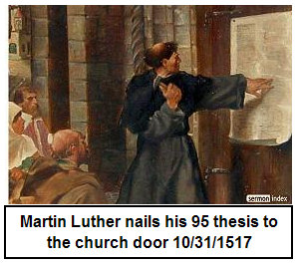

There's a one year period of time at the end of every 49th year known as the Jubilee. The Jubilee is the 50th year. It's instructions are given by YaHuWaH Elohim in Leviticus 25:8+.

Although there are no instructions from YaHuWaH Elohim regarding a 500 year period after 490 years, we might examine that 10x period of time in relation with the instructions to observe the 49th and 50th years.

Below is a graphic depicting the 500th year of the Islamic complete or partial control of the city of Jerusalem (Islam controls the Temple Mount today) and the 500th year of Christian Protestantism.

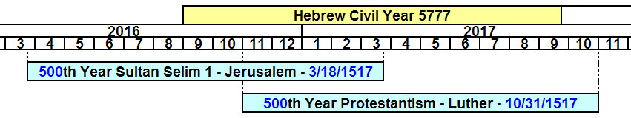

With the Jubilee of Leviticus chapter 25 as a pattern, we might consider the 10 year time period from 2007 (the 490th year from 1517) to 2017 as a 10 year Super Jubilee Period regarding Islam and Protestantism. The final 500th year for both Islam and Protestantism end in 2017. At that time, in 2017, a new 490 year count would begin, if it were applicable.

The 1582 AD Calendar Change

In October of 1582 the Roman Calendar was modified because the seasons were drifting into other months because of a lack of proper leap days. The solution decided upon was to subtract 10 whole days from the calendar in a way that wouldn't affect any Jewish or Christian holidays.

Here's the October, 1582, calendar.

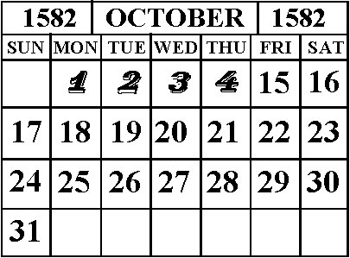

By cancelling 10 days from the calendar, the seasons were brought back on track with September 21 again being the day of the equinox, etc. An extra leap day was introduced every 400 years to keep the new calendar on track. In our modern world today, leap seconds are introduced for more precise control.

The above calendar change had to be explained so that we can better understand some of the info in the graphic below.

Sultan Selim 1 took control of Jerusalem on 3/18/1517. However, because 10 days were removed from the calendar in 1582, 3/18/1517 + 500 years does NOT equal 3/18/2017.

There are 182,621 days in 500 years (365.24219 x 500 = 182,621). Because we're figuring years from before 1582 to the present, we have to add 182,621 days on to 3/18/1517 to come up with the proper date in 2017 that is truly 500 years later.

3/18/1517 + 182,621 days (500 years) = 3/27/2017

This calculation can be verified with the calculator at this link: http://keisan.casio.com/exec/system/1247127342
The 6 Month Birth Timing Between Elijah and the Messiah

Malachi chapter 4 tells us that YaHuWaH Elohim will send Elijah the prophet before He comes to visit the world.

Luke 1:36 tells us that there was a 6 month birth relationship between John the Baptist and YAHUSHUA the Messiah.

John the Baptist was identified as being Elijah by YAHUSHUA Messiah in Matthew 17:10-13.

Therefore, we might again look for a 6 month timing relationship between the appearance of Elijah at the end of the age and the coming of Messiah. There is no guarantee that such will be the case again in our future, but it is possible.

On 9/23/2017 there will be a symbolic sign in the sky that follows the description of the Woman Clothed with the Sun that is mentioned in Revelation chapter 12. The woman is travailing in birth, giving birth to a male child who will rule the nations. That child is Israel's Messiah.

If we subtract 6 prophetic months (6 x 30 days = 180 days) from 9/23/2017, we arrive at exactly 3/27/2017. We might look for Elijah to be "birthed" sometime around 3/27/2017. Six normal months (183 days) before 9/23/2017 would be 3/24/2017.

It happens that precisely 500 years (182,621 days) from Sultan Selim 1 entering Jerusalem on 3/18/1517 expire on 3/27/2017, which is a possible date for the "birth" of Elijah, being 180 days before the birth of the man child on 9/23/2017.

Further, on 3/27/2017 at sunset the Hebrew date of Nisan 1, or Aviv 1, the 1st day of the 1st month of the new biblical year, will begin. It is significant that these times arrive precisely at Aviv 1 after 500 years.

We don't know just what the "birthing" of Elijah will be. He might be born a new born infant or he might arrive the way he went away, in a whirlwind. He might manifest as a group of many people who receive an anointing like that of Acts 2:4 on the Feast of Shavuot (Pentecost).

And of course we don't know if Elijah will arrive at all in 2017, there are just these timelines and signs and indications of Elijah's "birthing" and of the "birthing" of the man child 180 days later.

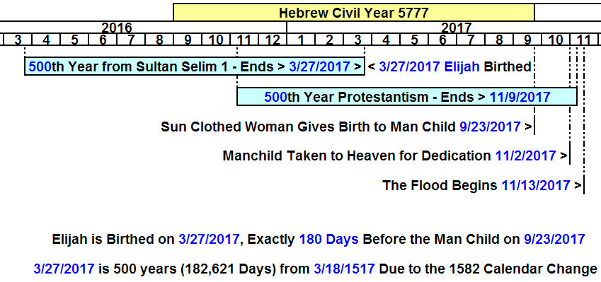

The events listed on the above graphic are the result of timeline calculations and various signs that seem to agree with scripture. There are multiple confirmations of the days listed in the graphic above that are not shown on the graphic. The flood beginning on 11/13/2017 is confirmed multiple times, and also by another researcher using a different method.

We know that we're living in times that are very different from what they were just 10 years ago. There's a lot of information available on the JoyBySurprise.com website on the Articles page concerning other timeline events that come to culmination in 2017 and 2018. When everything is considered in the light of current news events, it would be good for us to draw closer to our heavenly Father and quietly prepare for the worst. We hope, of course, that nothing bad will happen. The year will go quickly and we will see.

The members of the school of the prophets knew the day when Elijah was going to be taken alive into the heavens. It may be that we now know the day of his arrival. Watch for tornado activity and UFO activity around 3/24-28/2017 anywhere on earth, but especially in the region across the Jordan river northeast of Jerusalem, east of GilGal.

