Capability Statement  Formed in 2013, TechOne Partners is owned and operated as an independent services firm. TechOne Partners has over 20 years experience providing strategic services for its Clients.  From 2013 to today our primary business line is to recruit, screen and place highly qualified individuals in Consulting positions with Client companies for Private Industry and Government entities.  2020 allowed us to open our second business division focusing on the distribution of goods and supplies into the retail and healthcare space.  Awarded HUBZone status in January 2021 which will continue the expansion of our wholesale distribution supplies and services capabilities.  Our Current NAICS Codes are below  Primary 561320 Temporary Help Services  236118 Residential Remodelers  238160 Roofing Contractors  238220 Plumbing, Heating, and Air-Conditioning Contractors  238320 Painting and Wall Covering Contractors  238390 Other Building Finishing Contractors  423120 Motor Vehicle Supplies and New Parts Merchant Wholesalers  423320 Brick, Stone, and Related Construction Material Merchant Wholesalers  423390 Other Construction Material Merchant Wholesalers  423420 Office Equipment Merchant Wholesalers  423610 Electrical Apparatus and Equipment, Wiring Supplies, and Related Equipment Merchant Wholesalers  423620 Household Appliances, Electric Housewares, and Consumer Electronics Merchant Wholesalers  423930 Recyclable Material Merchant Wholesalers  424120 Stationery and Office Supplies Merchant Wholesalers  424950 Paint, Varnish, and Supplies Merchant Wholesalers  541519 Other Computer Related Services General $27.50m Small Business Size Standard: [Yes] Special 150 Employees Information Technology Value Added Resellers: [Yes] ⁽⁴⁾  561110 Office Administrative Services  562910 Remediation Services General $20.50m Small Business Size Standard: [Yes] Special 750 Employees Environmental Remediation Services: [Yes] ⁽⁴⁾  611420 Computer Training  811121 Automotive Body, Paint, and Interior Repair and Maintenance | HUBZone Certified (65603) by SBA on January 16, 2021  NDIA Member  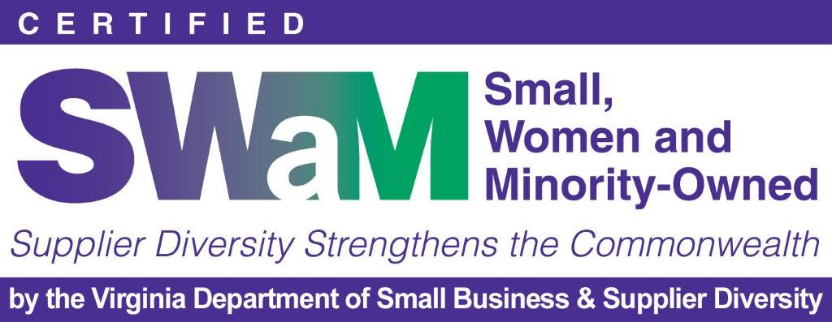  SWAM No. 722611  Cage Code: 8R2V5  JCP: 0085159  Primary NAICS: 561320  DUNS: 10-514-8103  Self-Certified Small Disadvantaged Business  Principal Office  7400 Beaufont Springs Drive  Suite 300  Richmond, VA 23225  804-672-4436  Home Office  2149 Plainview Center  Powhatan, VA 23139  Lee Burnette  President/CEO  804-350-1647  Richard King  Vice President/CFO  804-539-3239  Jaime Childrey  Office Operations  804-216-0861

