
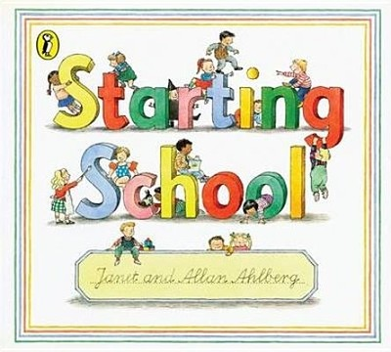


Look at the school’s website. They may have a virtual tour of their school or sessions to talk about starting school that you and your child can view. Become familiar with the look and feel of the school. If possible walk past and map your journey to school. This will help familiarise your child and make them feel secure.

If possible, get the school uniform in advance and help your child to practice wearing it – it might feel different to their other clothes
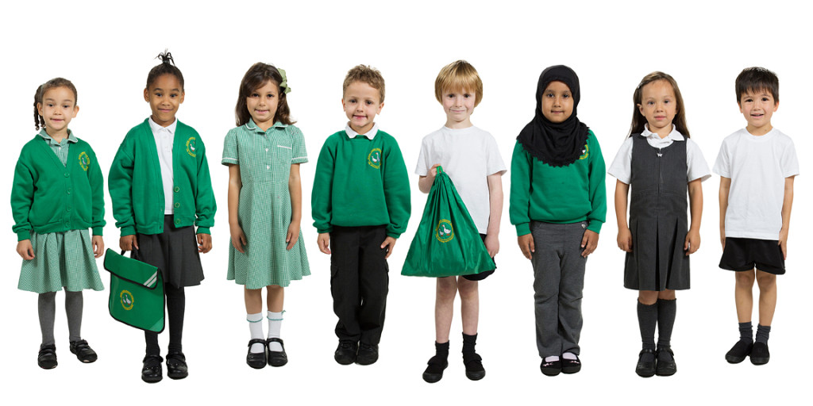

What can you do as a parent to help your child transition to Primary School?
- Spend time talking with your child about their new school
- If your child has a 'transition book' with photographs, take time to look at this regularly with your child before they start
- Find out the class teacher and teaching assistants name and use these when you talk to your child about his or her new school
- In the week before they start school, get your child used to the times they will need to get up in the mornings and go to bed.
- Talk positively to your child about starting school, as well as listening to and acknowledging any anxious feelings or fears they may have.
- Ask your child’s nursery or childminder about how they are supporting transition.
- Contact your child’s new school and ask how they are supporting transition.

