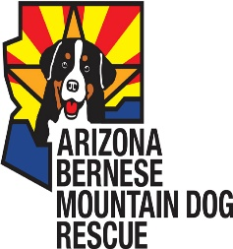

Congratulations on the adoption of your Bernese Mountain Dog named _____________
Please review and sign the terms of the adoption previously agreed upon during your application process.

Terms of Adoption
- Return Policy: If for any reason, the adoption is not found to be satisfactory for the rescue dog or the family, the ABMDR requires the dog be returned to ABMDR. The rescue dog MUST NOT be sold or given away. If the dog is returned within 14 days of adoption, a full refund of the adoption fee will be given. After 14 days, no portion of the fee will be returned. Furthermore, the ABMDR reserves the right to take back any rescue dog that is being neglected or not properly cared for.
- The rescue dog must be licensed in accordance with existing laws in your town/county/state and rabies vaccination must be kept current.
- The adopting family agrees to provide adequate shelter, food, all necessary medical care and agrees that their rescue dog will not be allowed to run free without proper supervision. Failure to do so may result in the dog being surrendered to ABMDR.
- If AKC registration papers are available for the rescue dog, they will be given to the new owner.
- I will provide for this dog a loving home and accept this dog as a member of my family. I will provide food, water, adequate exercise and safe shelter at all times.
- I will provide veterinary care, including all vaccinations and medical tests required for good health.
- I understand that ABMDR has no further responsibilities for this dog, medical or otherwise.
- I ensure that this dog will wear obvious identification at all times.
- I will accept and cooperate with the removal of this dog from my home if there should be a violation of this agreement.
- I will pay an adoption fee of $550.

Signature of Adopter Date

