(Usher(s) brings the Tithes and Offerings up front to the Assistant.)

V. We invite you to stand as you are able.

OFFERING PRAYER
V. Let us pray,
Merciful God,
accept the fruits of our labor, gathered to give you glory.
You have set a table before us, a glimpse of that great day
when we will hunger and thirst no more.
Nourish us with the body and blood of Jesus,
that goodness and mercy may follow us
and bless the world you love.
In the name of Jesus,
C. Amen.

GREAT THANKSGIVING
V. The Lord be with you.
C. And also with you.

V. Lift up your hearts.
C. We lift them to the Lord.

V. Let us give thanks to the Lord our God.
C. It is right to give him thanks and praise.

V. It is indeed right and salutary that we should at all times and in all places offer
thanks and praise to you, O Lord, holy Father, almighty and everliving God. But
chiefly we are bound to praise you for the glorious resurrection of our Lord; for he
is the true Passover Lamb who gave himself to take away our sin, who by his
death has destroyed death, and by his rising has brought us to eternal life. And
so, with Mary Magdalene and Peter and all the witnesses of the resurrection, with
earth and sea and all their creatures, and with angels and archangels, cherubim
and seraphim, we praise your name and join their unending hymn:

SANCTUS
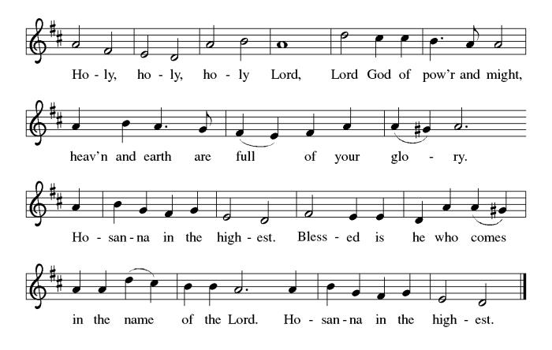

THE EUCHARISTIC PRAYER
V. Blessed are you, Lord of heaven and earth, in mercy for our fallen world you gave
your only Son, that all those who believe in Him should not perish, but have
eternal life. We give thanks to you for the salvation you have prepared for us
through Jesus Christ. Send now your Holy Spirit into our hearts that we may
receive our Lord with a living faith as He comes to us in His holy supper.
C. Amen. Come, Lord Jesus.

V. In the night in which he was betrayed our Lord Jesus took bread,
he gave thanks; broke it, and gave it to his disciples, saying:
Take and eat; this is my body, given for you.
Do this for the remembrance of me.

V. Again, after supper, He took the cup, he gave thanks,
and gave it for all to drink, saying:
This cup is the new covenant in my blood,
shed for you and for all people for the forgiveness of sin.
Do this for the remembrance of me.

THE LORD’S PRAYER
(We ring the bell throughout the Lord’s Prayer at all services to
invite those in the community to join in praying the Lord’s Prayer.)
V. May we now join with one another and pray together as Jesus has taught us.
C. Our Father, who art in heaven, hallowed be thy name, thy kingdom come,
thy will be done, on earth as it is in heaven. Give us this day our daily
bread; and forgive us our trespasses, as we forgive those who trespass
against us; and lead us not into temptation, but deliver us from evil. For
thine is the kingdom, and the power, and the glory, forever and ever.
Amen.

LAMB OF GOD

(We invite you to be seated.)

HOLY COMMUNION
V. We extend the invitation to Communion to all who are baptized and believe in
Jesus Christ.

(Ushers come forward to get the Offering Plates from the Assistant.)

(Vicar and Assistant prepare the Altar for Communion.)

OFFERING SONG
(We invite you to sing along.)
Worship & Praise
156—What Have We to Offer?
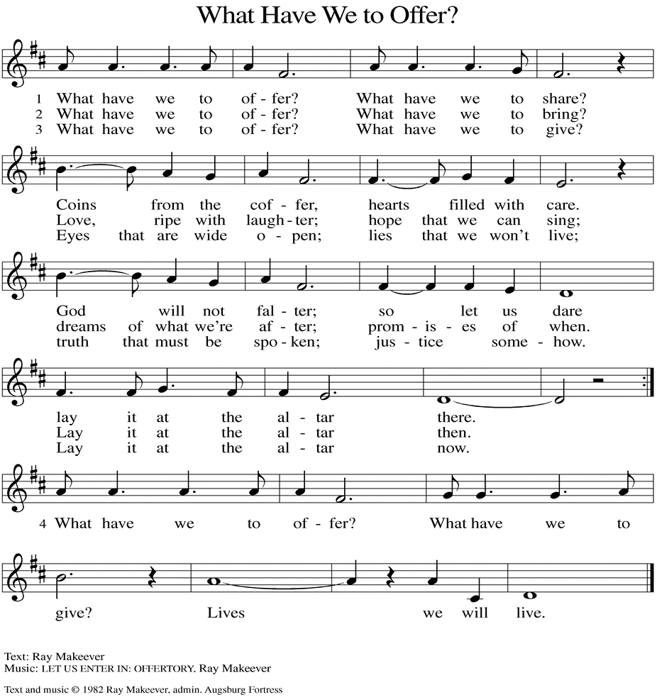
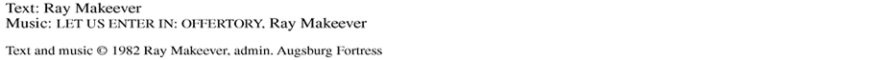
Kenzo (Philomena Noak's Friend)
(Additional Names Added Prior to the Worship Service.)
A. Strengthen the weary, give courage to the despairing, and comfort the dying.
Merciful God,
C. receive our prayer.

A. Gracious One, you have made us your own through the gift of baptism. Unite us
in genuine love for one another and uphold this community in your name. Merciful
God,
C. receive our prayer.

A. Eternal Light, we give thanks for all who have nurtured your church’s life in ages
past. Bring us at last with them to the brightness of your glorious presence.
Merciful God,
C. receive our prayer.

(Here other intercessions may be offered.)

V. Watch over all of us who are worried and suffering, and especially those whose
names we now say aloud or hold within our hearts (brief pause). Merciful God,
C. receive our prayer.

V. God of resurrection power, use us and these prayers to proclaim the good news
of new life to all the world, through Jesus Christ, our risen Savior.
C. Amen.

SHARING OF THE PEACE
V. May the peace of the Lord be with you always.
C. And also with you.
V. Now, let us share God’s Peace with one another.

(Please respect your neighbor if they desire to still only offer a peace sign or wave.)

(Following the Sharing of the Peace, we invite you to be seated.)

OFFERING
V. We now worship God with our tithes and offerings, wine and bread for use in holy
communion, and monetary gifts to support our ministry for service in God’s name.
Our Ushers will be around to your pews to pass the Offering Plates.

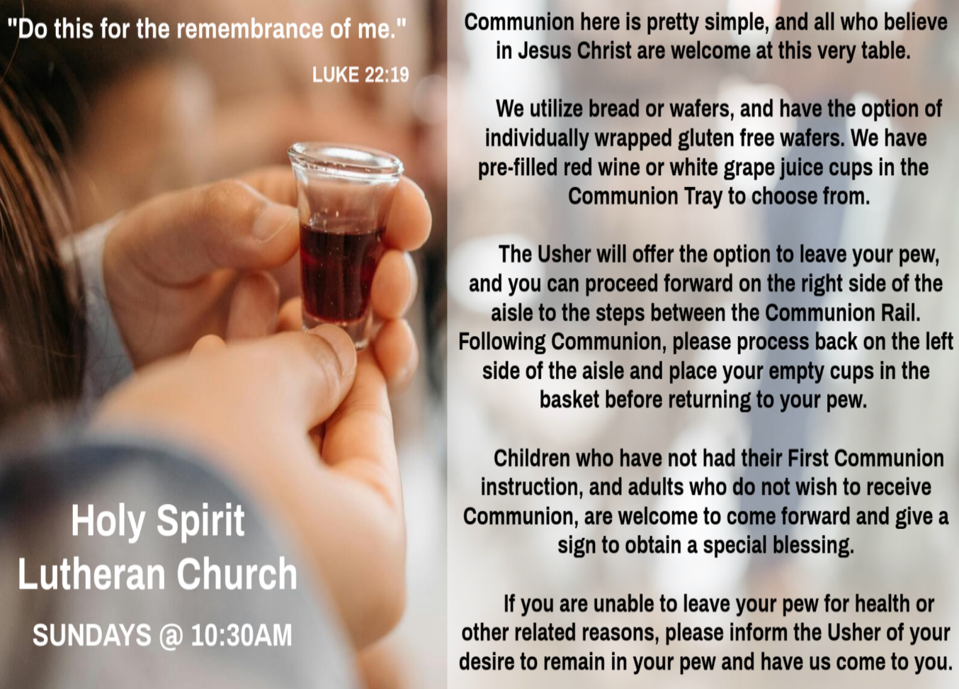

INVITATION TO COMMUNION
V. Come to the table of new life.
Receive the risen Lord.
C. Amen.

(Distribution of Holy Communion)

COMMUNION HYMN
(Please enjoy various music offered by our Organist during your
quiet time, prayer, and reflection following Holy Communion.)

(Vicar and Assistant remove Communion Vessels from the Altar.)

V. We invite you to stand as you are able.

POST COMMUNION BLESSING
V. May the body and blood of our Lord Jesus Christ strengthen us and keep us
always in His grace.
C. Amen.

POST COMMUNION CANTICLE
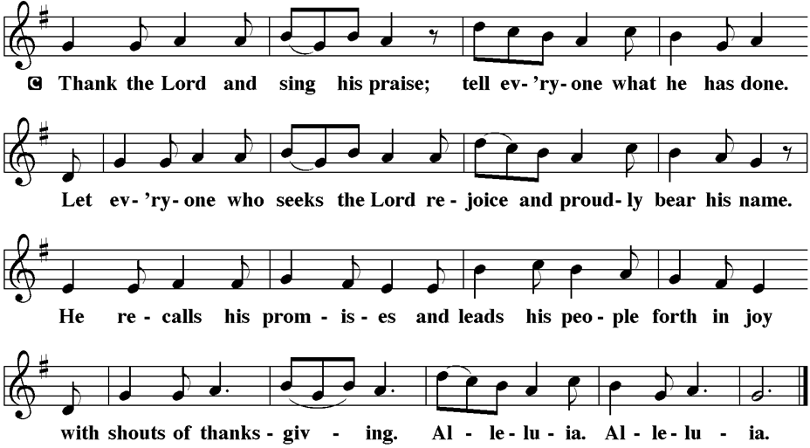

PRAYER AFTER COMMUNION
A. Let us pray,
Holy One,
through this meal you have made your home among us
and are making all things new.
Send us now to speak peace to anxious hearts,
to love our enemies,
and to bring your healing to the nations.
In the name of Jesus,
C. Amen.

Leanne Bueth (Joan Kilcoyne's Family)
Janett MacFarlane (Carol Amundsen's Friend)
Thish Kelly (Theresa & Kim McGinley's Family)
Scott Levin (Rose Lang's Friend)
Alice Ann Dennis (Diana DeNote's Family)
Nancy Taylor (Ted & Diane Bell's Family)
​​​​​ Santa Isabel Lutheran Church (Elizabeth, NJ)
Messiah Lutheran Church (Oakland, NJ)
Joyce Thompson (TDPWC Member)
Barbara Paynter (Leon Stitt’s Family)
Bob Poole (Kathy Poehler's Family)
David Smith (Heather & Vicar Vince Piekarski’s Family)
Barbara Hoitink (Lucas & Sabrina Munson's Family)
Kathy Raynor (Philomena Noak & Mary Melnicoff’s Friend)
Jordan (Carol Amundsen's Friend)
Ann Wieckouski (Theresa & Kim McGinley's Family)
Rich (Kim McGinley's Friend)
Amy Johnson (Ted Bell's Sister)
Theresa Dolan (Joan Kilcoyne's Family)
Sandy Bloomberg (Judy Brannan's Family)
Simon (Carol Amundsen's Family)
Bill Ransing & Family (Frank Ford’s Friends)
Barbara Brosius (Philomena Noak's Friend)
Barbara Schmiedel (Bob Fritsch's Family)
Cathy Bell (Ted & Diane Bell's Family)
Linda Stonelake (Kathy & Butch Poehler's Friend)
Anne Pfaff (Bonnie Millard & Vicki Rinier's Friend)
Anna Perez (Bob Fritsch's Family)
Ann Duhadway (Community Member)
Louise Helmes (Wayne & Eleanor Rand's Family)
Marion & Ernie Rink (Fran Green's Friends)
Paul Rand (Wayne & Eleanor Rand's Family)
Dr. Ed. Tinney (Bonnie & Skip Millard's Friend)
Tommy Mieluchowski (Philomena Noak's Friend)
Phyliss Mulvaney (Leon Stitt's Friend)
Ron Halbruner (Kathy & Butch Poehler's Friend)
Bill Eichorn (Wayne & Eleanor Rand's Friend)
Joe (Carol Amundsen's Friend)
Robin (Carol Amundsen's Friend)
Jeremy Pochatko (Vicar Vince Piekarski's Friend)
Olivia Holland (Bonnie & Skip Millard's Friend)
A. Healing Savior, your resurrection brings hope to a hurting world. Heal those who
are sick; especially:
BettyAnn Rich-White (Church Member)
Chip & Marie Hand (Church Members)
Lynn Bargstadt (Church Member)
Frank Ford (Church Member)
Carol Amundsen (Church Member)
Kim & Theresa McGinley (Church Member)
Anthony DeLuca (Church Member)
Frank Brunner (Church Member)
Paul Bowker (Church Member)
Joan Sommerman (Church Family)
Rick Lang (Church Family)
Suzie Clark (Rose Lang's Friend)
Francis Clock (Dianna DeNote’s Family)
Andrew Hudak (Rose Lang’s Friend)
Viena Murtha (Bob Fritsch’s Friend)
Sharon Waicus (Skip & Bonnie Millard's Friend)
Karen O'Brien (Paul Bowker's Friend)
Dustin Irizzary (Mary Melnicoff's Family)
The Bryan Family (Wanda Bryan's Family)
Sarah Dutton (Frank Ford's Family)
Christina McNasby (Fran Green’s Family)
Mark Stephen Dennis (Diana DeNote's Family)
Bill Lodge (Skip & Bonnie Millard's Friend)
Ron Anderson (Bill Kelly's Friend)
Bud Brearey (Judy Brannan & Mary Melnicoff's Friend)
Mary Skain (Kathy Poehler's Friend)
Robert Chaplin (Mary Melnicoff's Friend)
Jack Wieckouski (Theresa & Kim McGinley's Family)
Carolyn Santarpio (Bob Fritsch's Friend)
Harry (Judy Brannan's Friend)
Michael Hart (Diana DeNote's Friend)
Rocco Leonard DeNote (Diana DeNote's Family)
Sherri Lynn (Bob Fritsch's Friend)
John Bannco (Bob Fritsch's Friend)
Nancy Pazarinie (Bob Fritsch's Family)
Jane & Paul Eiben (Rose Lang's Friend)
Denny Papst (Rose Lang’s Friend)
Mike & Alice Rhoades (Rose Lang’s Friends)
Helen Ehlers (Judy Brannan's Friend)
BLESSING
V. God Almighty, who is the beginning and the end,
Jesus Christ, the firstborn of the dead,
and the Spirit, our advocate and peace,
☩ bless you now and forever.
C. Amen.

SENDING HYMN
(We invite you to sing along.)
Lutheran Book of Worship—Green Book
143—Now All the Vault of Heaven Resounds

(Assistant extinguishes only the Altar Candles half way through the Sending Hymn.)

(The Paschal Candle remains lit.)

(Vicar processes out once the Altar Candles have been extinguished.)

(We invite you to be seated.)

BIRTHDAYS, ANNIVERSARIES, & ANNOUNCEMENTS
(Offered by Assistant and Congregation.)

BIRTHDAYS & ANNIVERSARIES
None

DISMISSAL
A. Go in peace. Praise the Lord. Alleluia!
C. Thanks be to God. Alleluia!

POSTLUDE
(Music offered by our Organist as we depart following our Worship Service.)
Good Christian Friends, Rejoice and Sing

LICENSES & EXPIRATION DATES
Worship Service Content is used via permission through Augsburg Fortress Liturgies Annual License #SB144368. The next Subscription Renewal Date is 2/28/2027.
Our Hymns and Worship Music are used via permission through CCLI One
License #11327166. The next Subscription Renewal Date is 1/31/2027.


CONFIRMATION & SUNDAY SCHOOL
“Here We Stand” allows our young folks to go through a 2-year process focusing on the Bible and Luther’s Small Catechism. Classes are on Sundays from 9-10AM.

WORSHIP MINISTRY
The most important thing we do each week is gather together as God's people to Worship. God is the center and focus of everything we do. Participating in Worship is active, as Liturgy means the work and actions of the people gathered. Everything we do during the week to prepare for Worship, and everything we do as we Assist in leading Worship is important. We are thankful for all the wonderful work being done. If you have questions, or are interested in any position, reach out to Vicar Vince.
Sign-up sheets are located on the bulletin board between the church offices.

CHURCH COUNCIL
Share your comments, concerns, questions, or joys with one of our Church Council Members who can bring them back to our meetings. Visitors are always welcome to attend and listen to what is going on in and around the church. Join us In- Person or on our Conference Call at our next Meeting on Tuesday, April 21st, at 6PM.

BULLETIN ENTRY DEADLINE
The Bulletin is printed on Thursdays during Church Office Hours. Changes need to be submitted to Vicar Vince no later than Thursday by 4PM. Thank you!

C. I believe in God, the Father almighty,
creator of heaven and earth.

I believe in Jesus Christ, God’s only Son, our Lord,
who was conceived by the Holy Spirit,
born of the Virgin Mary,
suffered under Pontius Pilate,
was crucified, died, and was buried;
he descended to the dead.
On the third day he rose again;
he ascended into heaven,
he is seated at the right hand of the Father,
and he will come to judge the living and the dead.

I believe in the Holy Spirit,
the holy catholic church,
the communion of saints,
the forgiveness of sins,
the resurrection of the body,
and the life everlasting. Amen.

PRAYERS OF INTERCESSION
V. Trusting in the power of Christ’s resurrection to heal and redeem our broken
world, let us pray for the needs of all creation.

(A brief silence.)

A. Living Savior, just as you journeyed with the disciples to Emmaus, accompany us
on our journey of faith. Gather us at your table, that we recognize you in the
breaking of the bread. Merciful God,
C. receive our prayer.

A. Almighty God, you provide for the needs of all creation. Bless the fields that are
being prepared for planting, and send favorable weather so that the soil may yield
an abundant harvest. Merciful God,
C. receive our prayer.

A. God of justice, where leaders abuse power, confront them and call them to
repentance. Where there is corruption, bring integrity; where there is violence,
sow peace. Merciful God,
C. receive our prayer.
to redeem Israel. Yes, and besides all this, it is now the third day since these
things took place. 22 Moreover, some women of our group astounded us. They
were at the tomb early this morning, 23 and when they did not find his body there
they came back and told us that they had indeed seen a vision of angels who
said that he was alive. 24 Some of those who were with us went to the tomb and
found it just as the women had said, but they did not see him.” 25 Then he said to
them, “Oh, how foolish you are and how slow of heart to believe all that the
prophets have declared! 26 Was it not necessary that the Messiah should suffer
these things and then enter into his glory?” 27 Then beginning with Moses and all
the prophets, he interpreted to them the things about himself in all the scriptures.

28 As they came near the village to which they were going, he walked ahead as if
he were going on. 29 But they urged him strongly, saying, “Stay with us, because
it is almost evening and the day is now nearly over.” So he went in to stay with
them. 30 When he was at the table with them, he took bread, blessed and broke
it, and gave it to them. 31 Then their eyes were opened, and they recognized him,
and he vanished from their sight. 32 They said to each other, “Were not our
hearts burning within us while he was talking to us on the road, while he was
opening the scriptures to us?” 33 That same hour they got up and returned to
Jerusalem, and they found the eleven and their companions gathered together.
34 They were saying, “The Lord has risen indeed, and he has appeared to
Simon!” 35 Then they told what had happened on the road and how he had been
made known to them in the breaking of the bread.

V. This is the Gospel of the Lord,
C. Praise to you, O Christ.

SERMON
(Delivered by Vicar Vince Piekarski.)

(Following the Sermon, we invite you to stand as you are able.)

HYMN OF THE DAY
(We invite you to sing along.)
Lutheran Book of Worship—Green Book
263—Abide with Us, Our Savior

APOSTLES’ CREED
V. God has made us his people through our Baptism into Christ. Living together in
trust and hope let us confess our faith together using the Apostles’ Creed.
CHURCH OFFICE HOURS
Open Thursdays from 6PM to 8PM. It is open to serve the Congregation, the Community, and to handle the business of the Church. Feel free to stop in to talk, pick-up or drop off something, pray in the Sanctuary, or for whatever reason.

FOOD PANTRY
Open every Thursday, and the last Saturday of every month, from 10AM to 1PM. 88 people were served in March and 328 people have been served in 2026. Donations can be dropped in the outdoor drop-box, in the money jug in the back of the Church, mailed into the Church Office, or placed in the Offering Plate. Volunteers are needed. Sign-up sheets are located on the bulletin board between the church offices. If you have questions or need training see Heather, Vicar Vince, or Bonnie.
A special thank you goes out to all who donate, pray, and help in any way!

Thursday, 4/23 | Saturday, 4/25 | Thursday, 4/30
Skip & Bonnie | Heather & Bonnie | Theresa, Kim, & Bob

COMMUNITY FOOD DONATIONS, DELIVERIES, & MORE
North Cape May Acme provides us with Expiring, Recently Expired, and Slightly Damaged Food and Items. Kathy delivers on Saturdays in the community, brings items to church and the food pantry, and to the Branches Outreach in Rio Grande.



SPECIAL PREACHER
Chip Hand is looking forward to Preaching on Sunday, April 26th, as Vicar Vince will be back in Pittsburgh for a few days for the NFL Draft and some vacation time. Please be aware that there will not be Holy Communion this Sunday as a result.
DONATION STATION
Get on the train and place all purchased items in the specified project donation bins located on the counter by the front doors. See Heather for more information.


WOMEN OF THE CHURCH
Their next meeting is on Monday, May 4th, at 6PM. New members are always invited and welcome to attend! Contact Judy for more information.

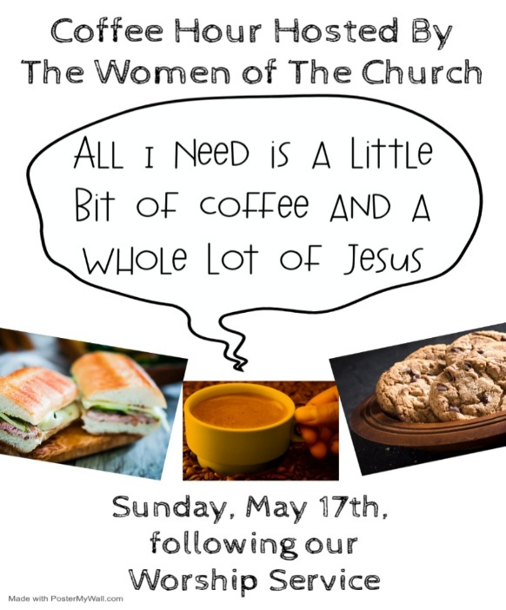


Our NJ Synod Assembly will be on Saturday, May 30th, 2026. Wayne & Judy are attending with Vicar Vince. Please keep them and the Assembly in your prayers.
were ransomed from the futile conduct inherited from your ancestors, not with
perishable things like silver or gold 19 but with the precious blood of Christ, like
that of a lamb without defect or blemish. 20 He was destined before the
foundation of the world but was revealed at the end of the ages for your sake.
21 Through him you have come to trust in God, who raised him from the dead
and gave him glory, so that your trust and hope are in God.

22 Now that you have purified your souls by your obedience to the truth so that
you have genuine mutual affection, love one another deeply from the heart.
23 You have been born anew, not of perishable but of imperishable seed, through
the living and enduring word of God.

R. This is the Word of the Lord.
C. Thanks be to God.

V. I invite you to stand as you are able, and to announce the Gospel Acclamation.

GOSPEL ACCLAMATION
C. Alleluia. Our hearts burn within us while you open to us the scriptures.
Alleluia. (Luke 24:32)
GOSPEL READING
The colorful story of Jesus’ appearance to two disciples on the road to Emmaus
answers the question of how Jesus is to be recognized among us. Here, he is
revealed through the scriptures and in the breaking of bread.

V. The Holy Gospel According to Luke (Chapter 24, Verses 13-35).
C. Glory to you, O Lord.

V. 13 Now on that same day two [disciples] were going to a village called Emmaus,
about seven miles from Jerusalem, 14 and talking with each other about all these
things that had happened. 15 While they were talking and discussing, Jesus
himself came near and went with them, 16 but their eyes were kept from
recognizing him. 17 And he said to them, “What are you discussing with each
other while you walk along?” They stood still, looking sad. 18 Then one of them,
whose name was Cleopas, answered him, “Are you the only stranger in
Jerusalem who does not know the things that have taken place there in these
days?” 19 He asked them, “What things?” They replied, “The things about Jesus
of Nazareth, who was a prophet mighty in deed and word before God and all the
people, 20 and how our chief priests and leaders handed him over to be
condemned to death and crucified him. 21 But we had hoped that he was the one
R. 1 I love the Lord, who has heard my voice,
and listened to my supplication,
2 for the Lord has given ear to me
whenever I called.
3 The cords of death entangled me; the anguish of the grave came upon me;
I came to grief and sorrow.
4 Then I called upon the name of the Lord:
“O Lord, I pray you, save my life.”
C. I will call on the name of the Lord. (Ps. 116:13)

R. 12 How shall I repay the Lord
for all the good things God has done for me?
13 I will lift the cup of salvation
and call on the name of the Lord.
14 I will fulfill my vows to the Lord
in the presence of all God’s people.
15 Precious in your sight, O Lord,
is the death of your servants.
16 O Lord, truly I am your servant;
I am your servant, the child of your handmaid;
you have freed me from my bonds.
17 I will offer you the sacrifice of thanksgiving
and call upon the name of the Lord.
C. I will call on the name of the Lord. (Ps. 116:13)

R. 18 I will fulfill my vows to the Lord
in the presence of all God’s people,
19 in the courts of the Lord’s house,
in the midst of you, O Jerusalem. Hallelujah!
C. I will call on the name of the Lord. (Ps. 116:13)

SECOND READING
The imagery of exile is used to help the readers of this letter understand that they
are strangers in a strange land. Christians no longer belong to this age. Through
the death of Christ we belong to God, so that our focus, faith, and hope are no
longer on such things as silver or gold.

R. Our Second Reading is from 1st Peter (Chapter 1, Verses 17-23).

R. 17 If you invoke as Father the one who judges impartially according to each
person’s work, live in fear during the time of your exile. 18 You know that you

Confirmation is a journey of faith filled with new questions and answers, new discoveries, new relationships, new responsibilities, and new possibilities. Clearly confirmation is intended to be a milestone, not a destination; it is not graduation! Rather, Confirmation is a tool that equips for the life-long process of living out Christian identity. Traditionally we would be celebrating Confirmation on Pentecost Sunday. However, due to it falling on Memorial Day Weekend, and the schedules of our young folks, we will be moving it to Sunday, June 14th, during our 10:30AM Worship Service. Please come out and join Caylee Thomas and Robert Thomas on this special day and celebrate with them at the Coffee Hour afterwards.


Have you been attending our church for a while? Have you just recently returned to church after being away for a bit? Maybe you transitioned from another church, or just started to recently attend our church. We are glad to have you, and would love to have you as a member of our Congregation. We are looking forward to
having new member classes in the near future. Please stay posted.
Feel free to ask Vicar Vince any questions or for more information as well.

NEWSLETTER
Collect information, stories, pictures, and reports for our next publication. Everything needs submitted to Vicar Vince in-person or via email at vpie8282@gmail.com.

CHURCH DIRECTORY
2026 Church Directories are by the Church Office on the bookshelves. We continue keeping it updated, but we undoubtedly miss a few changes or have made a few errors. Please inform the Church Office of updates or changes to keep us up to date.

TITHES, OFFERINGS, & ENVELOPES
We worship God with our tithes and offerings. We hear in scripture, “Each of you must give as you have made up your mind, not reluctantly or under compulsion, for God loves a cheerful giver.” (2 Corinthians 9:7) Envelopes can be dropped in the offering plate, mailed to the church, or dropped in the locked mailbox. Thanks for your support in the mission of our church, its ministries, the NJ Synod, etc!
SPACE AVAILABLE
​​​​​Interested in utilizing our Fellowship Hall for a Party or Event? There is a suggested $50 refundable security deposit, and it is $250 for facility use. No alcohol or games of chance permitted due to ELCA policy. Please contact Vicar Vince for more info.

ED GREEN CAPITAL IMPROVEMENT FUND
We continue to raise money for any unforeseen costs or repairs. We are currently exploring a new Annual Fundraising opportunity where we will be handing out coffee cans to raise money at home. We also have the donation bin in the back of the church. Thanks for your continued prayers, support, and donations!

NEW SPLIT UNITS INSTALLED IN THE SANCTUARY
What a blessing it was to have Pete Meehan install our new Split Air & Heat Units in the Sanctuary. We utilized money from our ED GREEN Capital Improvement Fund to pay for a portion of this cost, as it was not a budgeted expense for the year. At this time, we are looking to refund that Fund and are running at a deficit of $3,692.08. Please consider donating to help bring this budget back into the positive.

HOME COMMUNION MINISTRY
A Minister is available if you have a loved one, or if you desire services. We look forward in sharing the Word and Holy Communion! Please inform Vicar Vince, Kathy, or the Church Office so plans can be made for visits.

PRAYER SHAWL MINISTRY
Prayer Shawls, Lap Quilts, Scarves, and other items have been made with love. Blessed items are located in the Narthex, and are free for anyone. Members of the group continue working at home on new stitches and patterns. We are blessed to be able to continue collecting new items. We have a donation station of yarn and other items located in the Narthex. You can find some new supplies for your next creation!

PRAYER LIST
Our Prayer List continues to lengthen and we realize the important need for prayers and healing. Sometimes the unfortunate result is that someone has passed away, and the words “The Family & Friends of” appear before someone’s name. However, sometimes we forget names are still on the list and their health has improved and they can be removed. Please share various stories as we continue to pray for strength and healing. Names can be added or removed from the list on the clipboard in the Narthex prior to the Worship Service, by calling the church office, or addressing it on the Conference Call. Please let us know the relation to the person(s) you listed so we can be more mindful with our prayers.
PRAYER OF THE DAY
V. The Lord be with you.
C. And also with you.

V. Let us pray,
O God, your Son makes himself known to all his disciples in the breaking of
bread. Open the eyes of our faith, that we may see him in his redeeming work,
who lives and reigns with you and the Holy Spirit, one God, now and forever.
C. Amen.

(We invite you to be seated for our Readings and Psalm.)

FIRST READING
Today’s reading is the conclusion of Peter’s sermon preached following the giving
of the Holy Spirit to the apostles on the day of Pentecost. The center of his
preaching is the bold declaration that God has made the crucified Jesus both
Lord and Christ.

R. Our First Reading is from Acts (Chapter 2, Verses 14a, 36-41).

R. 14a Peter, standing with the eleven, raised his voice and addressed [the crowd]:
36 “Therefore let the entire house of Israel know with certainty that God has made
him both Lord and Messiah, this Jesus whom you crucified.”

37 Now when they heard this, they were cut to the heart and said to Peter and to
the other apostles, “Brothers, what should we do?” 38 Peter said to them,
“Repent and be baptized every one of you in the name of Jesus Christ so that
your sins may be forgiven, and you will receive the gift of the Holy Spirit. 39 For
the promise is for you, for your children, and for all who are far away, everyone
whom the Lord our God calls to him.” 40 And he testified with many other
arguments and exhorted them, saying, “Save yourselves from this corrupt
generation.” 41 So those who welcomed his message were baptized, and that
day about three thousand persons were added.

R. This is the Word of the Lord.
C. Thanks be to God.

PSALM
R. Our Responsorial Psalm is from the 116th Psalm (Verses 1-4, 12-19).
C. I will call on the name of the Lord. (Ps. 116:13)
HYMN OF PRAISE
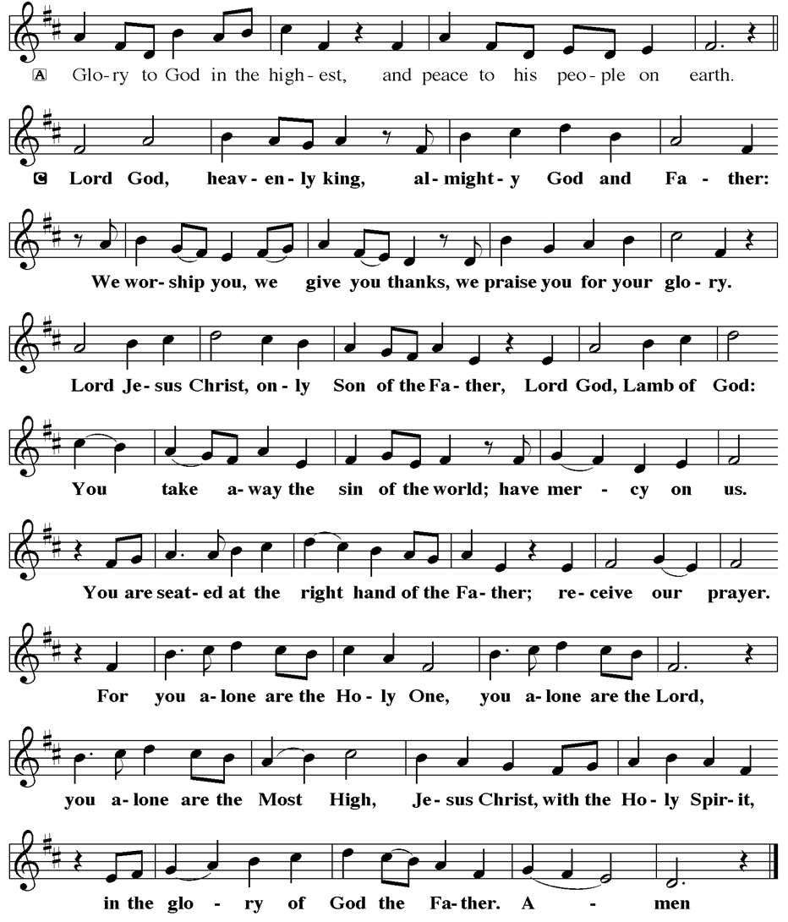
JERSEY JOTTINGS & NJ SYNOD APP
There is a weekly e-newsletter connecting our synod together with weekly prayer, upcoming events, synod and churchwide activities, mission stories, congregational activities, & more. Download the app or sign up at www.njsynod.org/stay-connected.

BAPTISM
We are a church whose unity is in Jesus Christ, who gathers us around word and water, wine and bread. Baptism is a significant part of our faith journey as we come from the baptismal waters to live a new life as children of God. Our baptism sets us out on a lifelong journey that is characterized by our relationship to God, our relationship to our faith community, our relationships in our community and the wider world. Living our baptismal covenant means living a life of growth in the faith practices of discipleship. Please see Vicar Vince for more information.

FIRST COMMUNION
Although no particular age for first communion is prescribed by The Use of the Means of Grace, one guideline is offered. Because admission to the Sacrament is by invitation of the Lord to the baptized, "baptized children begin to commune on a regular basis at a time determined through mutual conversation that includes the pastor/vicar, the child, and the parents or sponsors involved, within the accepted practices of the congregation.” Each congregation is encouraged to ask the question of readiness for first communion, establish their own policies regarding age and practice, and accompany that practice with catechesis appropriate to the age of the communicant. If anyone has questions, please see Vicar Vince.

LIBRARY
New books are added to our library from time to time. Several are borrowed and read and exchanged. Who knows, you might find one particularly interesting and share that with someone. Reading is a great way to pass spare time, learn, and explore. You may find some fresh ideas for prayer, ways to grow more spiritually, ways to grow closer to God, or some opportunities to understand our faith more. We have an extended library located in Vicar Vince’s office. There are Bibles of various translations, books from his personal collection, books inherited from Pastor Leah, movies, past Bible Study Curriculums, and more. Come check things out.

FAVORITE HYMNS
Carol is willing to play some of your favorite hymns for the Prelude & Postlude each Sunday during our Worship Service. Feel free to let her know of your suggestions.

VICAR APPOINTMENT ON MARCH 19TH, 2023
A Memorandum of Understanding on the Matter of Pastoral Appointment
In Theological Education for Emerging Ministries (TEEM) Candidacy
TO: Congregation Council, Holy Spirit Lutheran Church, Villas
FROM: The Rev. Tracie L. Bartholomew, Bishop, New Jersey Synod

Dear Brother and Sisters in Christ,
This memorandum is in support of your discussions with Vincent Piekarski as pastor of Holy Spirit, Villas. Because this is not the usual pattern for completing the educational and candidacy requirements for ordination, it is my hope that this memorandum will both provide guidelines and engage in conversation with those who are invested in this process.

I would say at the outset that because Vincent is an outstanding candidate for the Ministry of Word and Sacrament, we will all want to do whatever is necessary to assure that his placement serves the mission of the church in the best possible fashion.

The following notes reflect my own understanding of this matter:
(1) The appointment for Vincent will begin on April 1, 2023. At this time, Vincent
will assume all responsibilities of a regularly called pastor, including presiding at
the Sacrament of Holy Communion and Baptism at Holy Spirit, Villas.
(2) A pastoral appointment in the TEEM process is an option for completing
seminary educational requirements and the steps of the candidacy process.
Upon completion of the candidacy process and seminary education, the
candidate may receive and accept a call to ordained ministry from the
congregation where the appointment is being served.
(3) This appointment is jointly supervised by the Office of the Bishop and the TEEM
pastor’s seminary. A mentoring relationship with a local pastor is required for the
length of this appointment.
(4) The synod of candidacy origin will be responsible for the approval process.
(5) Upon approval for ordination, the congregation would be expected to extend a
call to the pastoral appointee.
(6) Compensation for the TEEM pastor will be according to the guidelines of the New
Jersey Synod. All normal forms of compensation should be in place for the term
of the appointment, including stipulation that base salary and housing shall be in
accord with synod guidelines for first call at time of ordination.
(7) The ELCA Portico benefit plan for lay persons in full-time church service should
be used for the pastoral appointee up to the time of ordination, whereupon the
benefit package is to be converted to the plan for ELCA clergy.

APOSTOLIC GREETING
V. May the grace of our Lord Jesus Christ, the love of God,
and the communion of the Holy Spirit be with you all.
C. And also with you.

KYRIE
V. In peace, let us pray to the Lord.
C. Lord, have mercy.

V. For the peace from above, and for our salvation, let us pray to the Lord.
C. Lord, have mercy.

V. For the peace of the whole world, for the well-being of the church of God,
and for the unity of all, let us pray to the Lord.
C. Lord, have mercy.

V. For this holy house, and for all who offer here their worship and praise,
let us pray to the Lord.
C. Lord, have mercy.

V. Help, save, comfort, and defend us, gracious Lord.
C. Amen.

V. Jesus Christ, you are the faithful witness
who accompanies us on our journeys.
We give you thanks for your life-giving death and resurrection.
We praise you for joining us in joy and sorrow.
Blessed are you.
C. You guide us to springs of the water of life.

V. Holy Spirit, you anoint our head with oil and our cup overflows.
Break down barriers that divide us.
Fill us with the breath of peace.
Blessed are you.
C. You guide us to springs of the water of life.

V. Holy One, we thank you for the gifts and grace of baptism,
and for making us a new creation.
We join with saints and angels, giving you honor and praise,
now and forever.
C. Amen.

BRIEF ORDER FOR CONFESSION AND FORGIVENESS
V. God hears us when we cry, and draws us close in Jesus Christ. Let us return to
the one who is full of compassion.

(Silence is kept for reflection.)

V. Fountain of living water,
C. pour out your mercy over us. Our sin is heavy, and we long to be free.
Rebuild what we have ruined and mend what we have torn. Wash us in your
cleansing flood. Make us alive in the Spirit to follow in the way of Jesus, as
healers and restorers of the world you so love. Amen.

V. Beloved, God’s word never fails. The promise rests on grace: by the saving love
of Jesus Christ, the wisdom and power of God, ☩ your sins are forgiven, and God
remembers them no more. Journey in the way of Jesus.
C. Amen.

GATHERING HYMN
(We invite you to sing along.)
With One Voice—Blue Book
674—Alleluia! Jesus Is Risen!
(8) A decision for Pastoral Appointment is made with the agreement of a synod and
its candidacy committee, and the ELCA, normally represented by the regional
staff person of each in consultation with the seminary and its Director for
Contextual Education.
(9) Pastoral Appointment in a TEEM Candidacy is an option that is to serve the
mission of the Church in a particular and vital way and is not to be viewed or
used as a means to circumvent the normal candidacy process and/or first call
placement process.

In the specific case of Vincent, the New Jersey Synod remains responsible for the candidacy and approval process, and has agreed to this proposal for Appointment at Holy Spirit, Villas.

Continued blessings to both Holy Spirit and Vincent Piekarski as you embark on this journey of mutual ministry. As partners in ministry, we walk with you and rejoice in this new relationship.


VICAR VINCE’S DAY OF REST
A day of rest can have physical, mental, and spiritual benefits. “Mittwoch,” German for mid-week, or Wednesday, is the day that Vicar Vince will use to recharge and do some other things. Please do not hesitate to reach out if there is an emergency!

VICE PASTOR UPDATE
Pastor William Hodgetts continues to attend our Church Council Meetings
and provides Supervision and Support to Vicar Vince.

2026 FINANCIAL STANDING
MARCH INCOME | $7,024.00
MARCH SPENDING | $8,797.52
MARCH GAIN OR (LOSS) | ($1,773.52)
2026 INCOME | $18,504.00
2026 SPENDING | $20,921.59
2026 GAIN OR (LOSS) | ($2,417.59)
ED GREEN CAPITAL IMPROVEMENT FUND | ($3,692.08)
FOOD PANTRY FUND (SOCIAL MINISTRY) | $13,381.23
CD | $26,665.08
WHAT IS THE EVANGELICAL LUTHERAN CHURCH IN AMERICA?
The ELCA was formed in 1987 by the merger of three Lutheran Church bodies –
the ALC (American Lutheran Church), the LCA (Lutheran Church in America), and the AELC (Association of Evangelical Lutheran Churches). Learn more at elca.org.


The New Jersey Synod is a geographical grouping of Evangelical Lutheran Church in America (ELCA) congregations that share the mission and ministry of the Church on the New Jersey territory. It is one of 65 synods in the ELCA. The NJ Synod is comprised of 143 congregations, which include over 45,000 baptized members.

TRUE DELIVERANCE PRAISE & WORSHIP CENTER
TDPWC utilizes our facilities from 1-4PM on Sundays. TDPWC hosts or assists with other events. TDPWC hosts a Prayer Line on Mondays, Wednesdays, & Fridays at 5PM on the Conference Call 1-657-390-7957; & Bible Study on Thursdays at 6:30PM on Zoom. See Rev. Brooks for more information.

ADDITIONAL OFFERINGS FROM OUR FRIENDS & NEIGHBORS
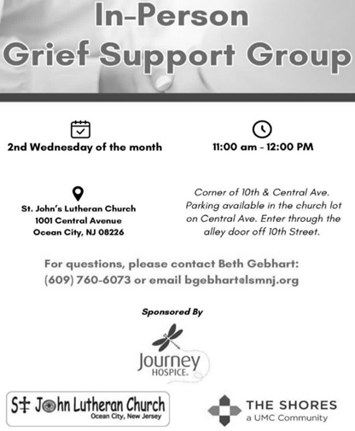
CONFERENCE CALL CHECK-IN, WELCOME, & ANNOUNCEMENTS
Vicar (V), Assistant (A), Reader (R), and Congregation (C).

INTRODUCTION
A. Today’s gospel begins with two disciples walking to Emmaus, overcome with
sadness, loss, and disappointment. They had hoped Jesus, who was crucified,
would be the one to redeem Israel! Yet the risen Christ walks with them and then
opens their eyes in the breaking of the bread. Each Sunday our hearts burn
within us as the scriptures are proclaimed and Christ appears to us as bread is
broken and wine is poured. The story of Emmaus becomes the pattern of our
worship each Lord’s day.

PRELUDE
(Music offered by our Organist at the start of our Worship Service.)
Endless Song

CHIMES
(Music offered by our Organist at the start of our Worship Service.)
Holy, Holy, Holy

(We invite you to stand as you are able.)

THANKSGIVING FOR BAPTISM
(All may make the sign of the cross, the sign that is marked at baptism.)
V. Alleluia! Christ is risen.
C. Christ is risen, indeed. Alleluia!

V. Salvation belongs to our God who is seated on the throne and to the Lamb!
C. Amen.

V. Let us give thanks for the gifts of baptism.

V. Merciful God,
you are the one who was, who is, and who is to come.
You lead us beside still waters.
We thank you for the waters of creation:
morning dew, gentle rain, roaring waves.
We thank you for the waters that nourish us.
Blessed are you.
C. You guide us to springs of the water of life.

We, the Evangelical Lutheran Church of the Holy Spirit, are People of God, who
are called by the Holy Spirit to pray, worship, joyfully proclaim Jesus Christ,
and compassionately witness and serve others in Christian Love.


We are glad that you joined us for Worship today! Thank you for enriching our time together! We would like to get to know you better, and for you to get to know us better too. Brochures, welcome gifts, prayer shawls, Bibles, and other items are available throughout the church. We would be happy to show you around and share about our ministries. Please do not hesitate to speak up and ask questions.
Also, please make sure you sign-in on our clipboard on the podium in the lobby.


Our Worship Services are conducted in coordination with our Conference Call.
Join us at 657-390-7423 or 701-802-5170, with access code 8221190#.
You may need to dial 1 first depending on your phone plan. After logging in please announce your name and feel free to talk with others until we get started.


SANCTUARY CANDLE FOR APRIL
Given to the Glory of God & In Memory of
EDWARD & LINDA SCHUBERT by Vicki, Bob, Evan Rinier.
ALTAR CANDLES FOR APRIL
Given to the Glory of God & In Memory of
JOSEPH “MAC” MCKENNA & JAMES P ROONEY by Del McKenna & Children.
JUST FRIENDS
The group promotes a spirit of fellowship among adults 50 years and older. Bring your own lunch, beverages and deserts are provided. Everyone is welcome. The group meets in Our Lady Star of The Sea Parish Hall on the last Wednesday of the month from 12Noon to 2PM from September through May. For information, please call Martine Simonis 609-884-5312 x 110.

CHURCH STAFF & VOLUNTEERS
VICAR
Vicar Vince Piekarski
VICE PASTOR
Pastor William Hodgetts
ORGANIST & PIANIST
Carol Amundsen
CHURCH OFFICE, SUNDAY SCHOOL, & FOOD PANTRY
Heather Piekarski
CHURCH COUNCIL PRESIDENT & CHURCH PROPERTY
Wayne Rand
CHURCH COUNCIL VICE PRESIDENT & WOMEN OF THE CHURCH
Judy Brannan
CHURCH COUNCIL TREASURER
Bonnie Millard
CHURCH COUNCIL SECRETARY
Vicki Rinier


WELCOME TO
HOLY SPIRIT LUTHERAN CHURCH
A Member of the Evangelical Lutheran Church in America, New Jersey Synod
1220 Bayshore Rd., Villas, NJ 08251, 609-886-2414,
holyspiritlutheran@comcast.net, holyspiritvillas.com, facebook.com/holyspiritvillas
Vicar Vince Piekarski can be contacted at any time for conversation or prayer through call or text at 412-225-0287, or through email at vpie8282@gmail.com.
SUNDAY, APRIL 19TH, 2026
THIRD SUNDAY OF EASTER
10:30AM WORSHIP SERVICE WITH HOLY COMMUNION

