Here's a small 14 year timeline concerning Babylon the Great and the world economy.

The first period is 7 year 7 days on the Hebrew calendar from 9/11/2001 to 9/29/2008.

The second period is 14 years and 14 days inclusive on the Roman calendar between 9/11/2001 and 9/24/2015.

There's also an interesting correlation revealed between 14 years and 13 Days (5126 days) and the 5125.34 years of a Mayan b'ak'tun.

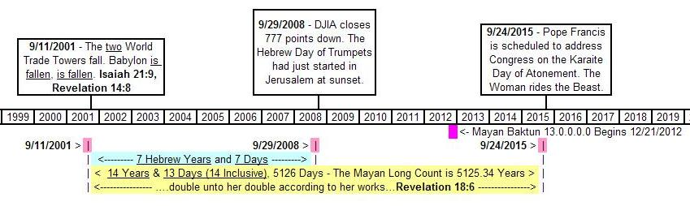

Pope Francis is scheduled to address the Congress of the United States on 9/24/2015.

It could very well be the whore of Revelation mounting the Beast, 14 years and 14 days from 9/11/2001.

