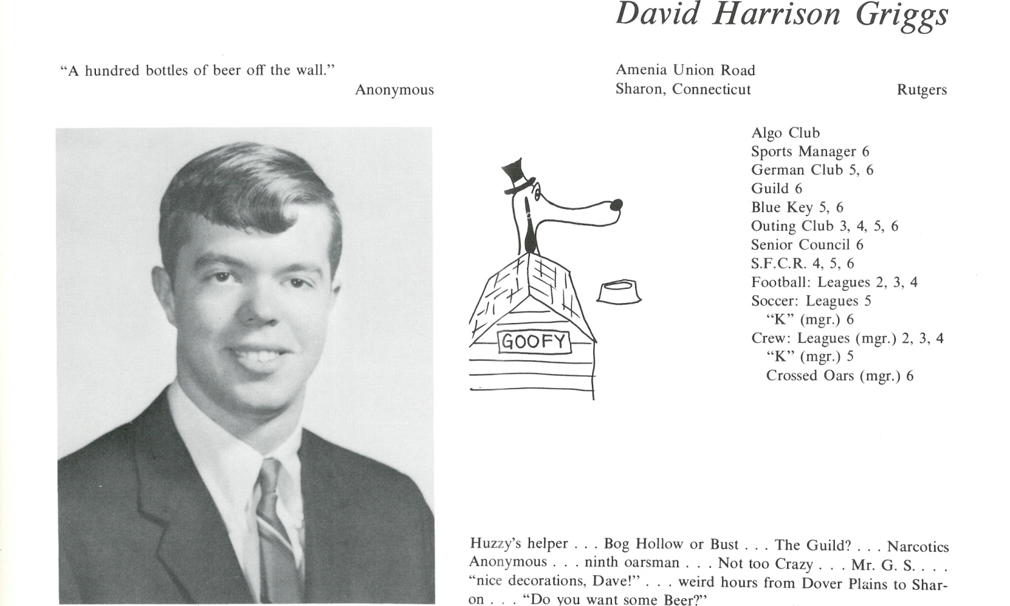

David H. Griggs

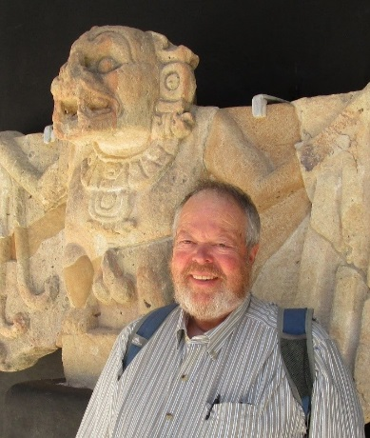Photo: *David Griggs and* Murcilago asesino (Killer bat) *in the Museum at the Copán Archaeological Park in Honduras.*

Career:

*See* “careen”, as in*, the car careened around the corner out of control.*

All in all, it’s been an interesting ride.

Marion:

*You’re not the man I knew ten years ago.*

Indiana:

*It’s not the years, honey, it’s the mileage.*

**Raiders of the Lost Ark**

**David H. Griggs, *Chaosopher***

griggs2000@hotmail.com

Panajachel, Guatemala • New Orleans, LA USA • Arcata, CA USA



______________________________________________________________

______________________________________________________________ ______________________________________________________________ ______________________________________________________________ ______________________________________________________________ ______________________________________________________________ ______________________________________________________________ ______________________________________________________________ ______________________________________________________________

Attach Picture in .jpg Format

______________________________________________________________

______________________________________________________________

___________________________________________________________________________________ _________________________________________________________________________________________________________________________________________________________________________________________________________________________________________________________________________________________________________________________________________________________________________________________________________________________________________________________________________________________________________________________________________________________________________________________________________________________________________________________________________________________________________________________________________________________________________________________________________________________________________________________________________________________________________________________________________________________________________________________________________________________________________________________________________________________________________________________________________________________________________________________________________________________________________________________________________________________________________________________________________________________________________________________________________________________________________________________________________________________________________________________________________________________________________________________________________________________________________

___________________________________________________________________________________