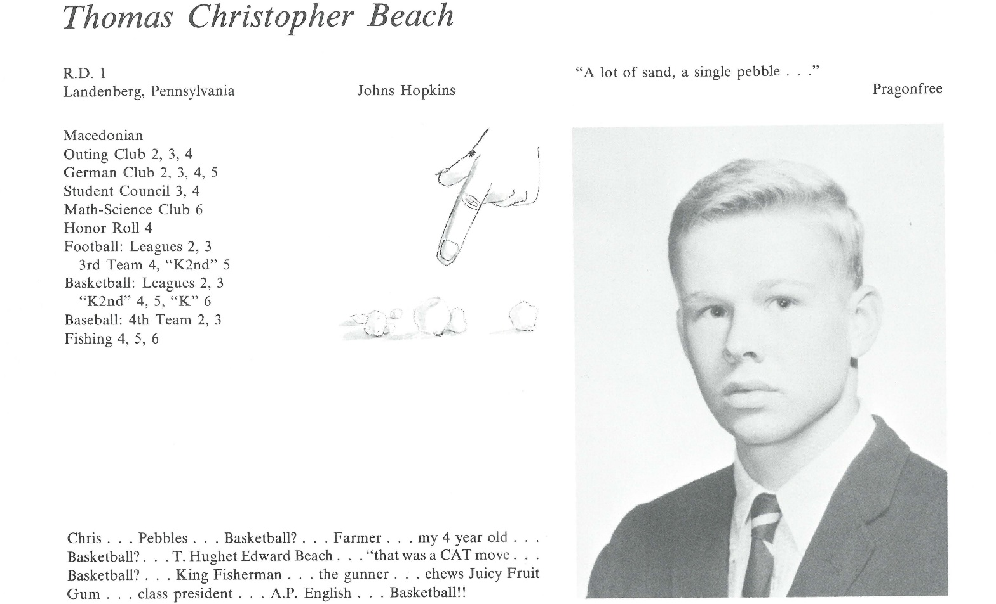

T. Christopher Beach

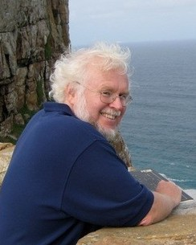BA in Humanities from JHU in 1971; played Varsity B-Ball for two years, the last under Coach “Jimmy V” Valvano. 1971 - 1973, led the JHU Tutorial Program for inner-city kids, fulfilling my conscientious objector duties.

Kathy Gleason and I married at the end of 1973 (the wisest and luckiest choice of my life; we still live and play with much joy). We “honeymooned” the next five years overseas. I utilized a Watson Fellowship to observe schools in 8 European countries for one year before teaching at, then heading, Barding Secondary School in western Kenya (just a mile from the home of Barack Obama’s father) for 4 years, the last three of which we were in Peace Corps.

In 1979, came the biggest cultural shift of our lives, as we moved from rural Kenya to Manhattan near the GW Bridge. I studied law at Columbia University for three years, then clerked for a federal trial judge in Manhattan for two years, as Kathy studied nursing and nurse-midwifery at Columbia. In 1984, we moved to Maine. I clerked for the First Circuit Court of Appeals for one year and served as a Maine Assistant Attorney General for five years, covering health care issues. Meanwhile, Kathy worked as a nurse-midwife in Portland, delivering over 3,300 babies over the next 25 years.

In 1990, I began to climb out of a difficult mid-life crisis by leaving the law and retraining to become a Jungian psychoanalyst. I studied in Zurich for four years, returning to Portland and opening a private practice in 1994. I have loved that work far more than the law, because I am more naturally inclined to help folks with their emotional and psychological concerns than with their legal problems.

Fifty years older and fifty pounds heavier, I don’t look like my 1967-self. I went through tough emotional periods in my junior year at JHU and during mid-life, but ultimately came through these feeling much better. I love Kathy and my work, still play basketball, windsurf, write poetry & articles, bike, attend Quaker meeting, and teach. We hope to bike across America next year before serving again in Peace Corps. Over the years, we have seen Peter Patch, Jack Hutchinson & Scott Baker.



______________________________________________________________

______________________________________________________________ ______________________________________________________________ ______________________________________________________________ ______________________________________________________________ ______________________________________________________________ ______________________________________________________________ ______________________________________________________________ ______________________________________________________________

Attach Picture in .jpg Format

______________________________________________________________

______________________________________________________________

___________________________________________________________________________________ _________________________________________________________________________________________________________________________________________________________________________________________________________________________________________________________________________________________________________________________________________________________________________________________________________________________________________________________________________________________________________________________________________________________________________________________________________________________________________________________________________________________________________________________________________________________________________________________________________________________________________________________________________________________________________________________________________________________________________________________________________________________________________________________________________________________________________________________________________________________________________________________________________________________________________________________________________________________________________________________________________________________________________________________________________________________________________________________________________________________________________________________________________________________________________________________________________________________________________

___________________________________________________________________________________