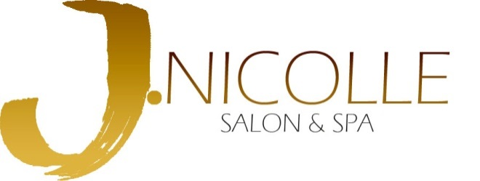
Summary of Service Charges:

Makeup Services:

Airbrush Makeup: $55-65
Takes approximately 30-45 minutes, per person.

Traditional Makeup: $45-50
Takes approximately 30-45 minutes, per person.

Posh Eye Makeup:
Full eye makeup only $25
*All makeup includes complimentary false lash application if desired.

Hair Services:

Special Occasion Hair: $45 (starts at)
Takes approximately 45 minutes-1 hour, per person. Price depends on level of stylist. A trial appointment is recommended and is an additional investment.
Bridal Design: $50 (starts at)

