BASS UNLIMITED
Toledo Bend Lake Association
P.O. Box 1031, Many, Louisiana 71449
www.toledobendlakeassociation.com
‘Dedicated to Serving Toledo Bend Lake’

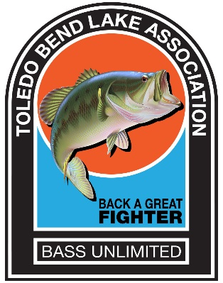

RE: Toledo Bend Lake Association Bass Unlimited Banquet/Fundraiser

Dear Sponsor,

The Toledo Bend Lake Association (TBLA) is celebrating its 19th Annual Bass Unlimited – Back A Great Fighter banquet and fundraiser (BU) on Friday, April 22, 2022. We are already gearing up for this premier event to be held at the Cypress Bend Park Pavilion, located on the shores of Toledo Bend Lake. This year will mark 52 years since TBLA was organized as a non-profit 501(c)(3) organization. TBLA has dedicated the BU funds to projects that meet our mission statement:
“Toledo Bend Lake Association is dedicated to maintaining and/or improving the quality of Toledo Bend Lake and the amenities surrounding it. TBLA shall provide financial and/or volunteer assistance to promote stewarding the environment and aquatic integrity of the Lake to perpetuate it as a world class fishery and recreational resource area.”
In 2018 & 2019 the Lake was named 4th best bass fishing lake in the central region by B.A.S.S. In 2015 and 2016 the Lake was selected as the #1 B.A.S.S. fishing lake in the United States, partly due to the projects funded and completed by the TBLA. Without the support of individuals and organizations like you, these projects would never get off the ground.

In 2017 the LA Wildlife and Fisheries awarded TBLA the Most VIP Award for Organization of the Year. TBLA members have been volunteering for over twenty years, assisting with the Sabine Parish Fishing Clinic for all fifth graders in the Parish. Additionally, TBLA provided funding for the trailer that houses and transports all the equipment for the LA Wildlife and Fisheries Educational Clinics which are conducted around the state. TBLA also funded multiple college scholarships. These are just some of the many projects funded by TBLA.

Volunteer members of TBLA are helping to secure donations and/or items for the BU raffles/auctions held during the banquet. We ask that you partner with us by donating whatever level you feel is appropriate. In return, your business name will be shown as a sponsor in our banquet program and auction guide. Securing all donations by March 1, 2022, will allow us adequate time for media coverage, as well as time to meet all printing deadlines in order to publicize your contribution. Our Federal Tax ID number is 30-0101272. Donation receipts are available upon request.

Your donation will help to contribute to making this BU event the best ever. Together we can make Toledo Bend Lake a great place to visit and enjoy with families, as well as a great place to retire. For information about TBLA’s history, projects and accomplishments, visit our website at www.toledobendlakeassociation.com or our Facebook pages at Toledo Bend Lake Association and Toledo Bend Lunker Bass Program. Should you need additional information, please contact Linda Ward at lindarhodesward@gmail.com (936-525-7409).

Thank you for your help in supporting the 19th annual Bass Unlimited Banquet – Back A Great Fighter fundraiser.

Ted Dove
Bass Unlimited – Back A Great Fighter Coordinator

Gary Moore
TBLA President

