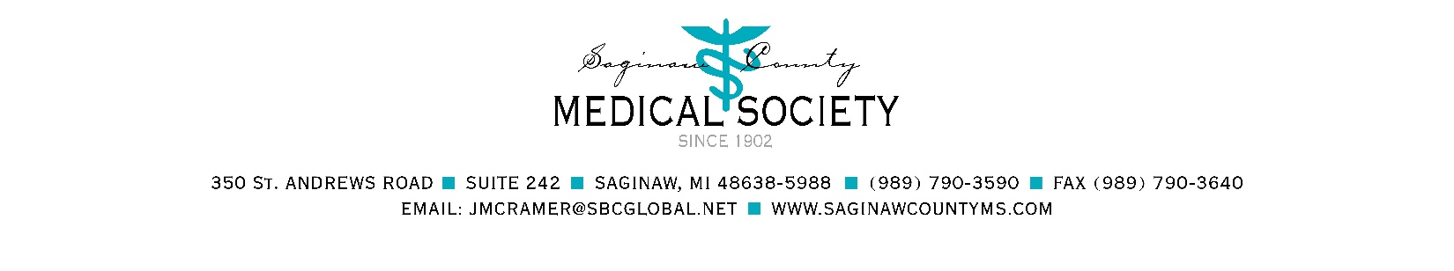

2021 Nursing Scholarship Application

TO: Nursing Scholarship Applicants

FROM: Nursing Scholarship Committee

The Saginaw County Medical Society Alliance provides $500 nursing scholarships to Saginaw County residents. Over the years, we have awarded many scholarships to help students continue their nursing education.

Requirements for consideration:
- Must be a permanent resident of Saginaw County; AND
- Currently enrolled in a RN or BSN nursing program or beginning nursing clinical core courses for award year; AND
- Overall college GPA no lower than 2.79.

The following are not eligible:
- RN/BSN to Master’s
- RN/BSN to FNP or PA
- High school seniors

Application packet MUST be complete for consideration. Incomplete applications will be denied. Applications must include:
- One-page essay describing your nursing career goals and how this scholarship would help you financially in completing your nursing degree
- Two letters of recommendation from current professors
- Current transcript
- Current resume
- Copy of driver’s license

NOTE: Prior award recipients must complete a new application packet with new letters of recommendation.

Please complete the application and return with the required documentation by March 31, 2021, to:

Saginaw County Medical Society
Nursing Scholarship Committee
350 St. Andrews Road, Suite 242
Saginaw, Michigan 48638-5988
Telephone (989) 790-3590, fax (989) 790-3640
Email: jmcramer@sbcglobal.net

IF SUBMITTING BY EMAIL, PLEASE REQUEST CONFIRMATION OF RECEIPT.

2021 NURSING SCHOLARSHIP APPLICATION

PERSONAL INFORMATION Date: _____________, 2021

Name: __________________________________________

Home Address: __________________________________________ Phone: ___________________
__________________________________________ County: ___________________

Home Email Address: _____________________________________ Cell phone: ________________

Student Address: ________________________________________
________________________________________
Student Email Address: ___________________________________

Date of Birth: ____/____/____

Marital Status: single married separated divorced widowed

If single:
- reside with parents (continue with questions 2-4) reside elsewhere (college/apartment)

- Number of siblings residing with parents _______

3. Is father employed? Yes No Occupation: ___________________________________
Place of Employment: _________________________________________________________
4. Is mother employed? Yes No Occupation: ____________________________________
Place of Employment: _________________________________________________________

If married:
1. Is spouse employed? Yes No Occupation: ____________________________________
Place of Employment: _________________________________________________________
2. List ages of children: _____________________________________________________________

List sources and amounts of financial assistance (scholarships, loans, family assistance):
Scholarship Received: $_______________ From: ________________________________ Scholarship Received: $_______________ From: ________________________________
Scholarship Received: $_______________ From: ________________________________
Do you currently have outstanding student loans? Yes No Total Outstanding Loans $___________
Current Employment History:
Employed? Yes No Type of work: ______________________________________________
Total hours worked weekly ________ Weekly salary: ___________________
Place of employment: _____________________________________________________________

EDUCATIONAL INFORMATION
Are you currently accepted in a nursing program? Yes No
High School: _______________________________ Graduation Date: ________ GPA: __________
College or University presently attending: __________________________________________________
College ID#__________________ Number of credits completed: ___________ GPA: ___________
Are you a full time or part time student?
Expected date of graduation from nursing program: _________

Have you previously received a Saginaw County Medical Society Alliance Scholarship? Yes No

When? _________________________

Application packet MUST be complete for consideration. Incomplete applications will be denied.

Applications must include:
- One-page essay describing your nursing career goals and how this scholarship would help you financially in completing your nursing degree
- Two letters of recommendation from current professors
- Current transcript
- Current resume
- Copy of driver’s license

RETURN COMPLETED APPLICATION AND REQUIRED DOCUMENTATION BY MARCH 31, 2021, TO:
Saginaw County Medical Society
Nursing Scholarship Committee
350 St. Andrews Road, Suite 242
Saginaw, Michigan 48638-5988
Telephone (989) 790-3590, fax (989) 790-3640
E-mail: jmcramer@sbcglobal.net

IF SUBMITTING BY EMAIL, PLEASE REQUEST CONFIRMATION OF RECEIPT.

