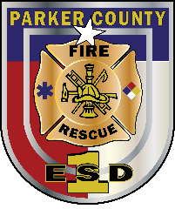
Parker County Emergency Services District No. 1
- Fleet Mechanic Job Posting -
Parker County Emergency Services District No. 1 is pleased to announce a job posting for the position of full time Fleet Technician or qualified Mechanic. The Ideal candidate for the Fleet Technician will perform preventative, routine and emergency services on Fire apparatus, command vehicles, brush trucks, as well as other fleet assets. Are you interested in steady work with great benefits?

Benefits:
- TCDRS retirement, 7% 2:1 employer match, TMRS time credit counts toward vesting and retirement
- 80% employee and family health insurance paid, (insure your family for about $200/month, co-pays, low deductibles)
- PTO benefit, longevity pay, paid continuing education/training
- Base salary range $48,000-$60,000 depending on qualifications.
- Monday – Friday normal work assignment with overtime opportunities for emergency repairs.
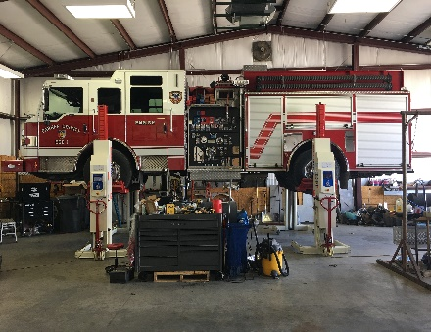
- Take home vehicle available for call out emergencies if applicant lives in/near District.
- New fleet shop in planning stages!
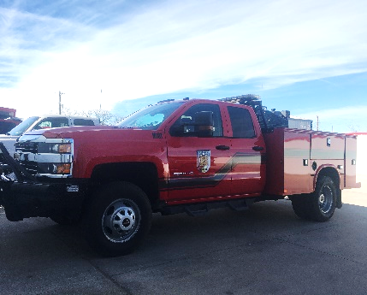
Experience & Education:
- High school diploma or equivalent
- (2) years verifiable Diesel repair experience
- (1) year of troubleshooting/repair of electrical circuits
Preferred Experience:
- ASE Heavy Truck Certification including steering, braking, and suspension certifications
- Experience with Cummins ISB, ISC, ISL, ISX motors, Detroit Engines, Caterpillar engines,
- Automotive air conditioning repairs with an EPA certification.
- Electrical ASE certification and ability to troubleshoot multi-plex systems (Fire District may send candidate to additional classes)
- EVT Certification
Job Responsibilities:
- Responsible for maintenance, repair, and servicing of assigned fire apparatus and related equipment to include structural, wildland, and command staff/support apparatus, various small engines; electrical and communications equipment, diagnose and repair problems on fire pumps and related components
- Diagnose electrical or mechanical malfunctions by utilizing electronic test equipment, including multi-plex electrical systems.
- Maintain apparatus and related equipment maintenance records in the department’s records management system (RMS)
- Log appropriate data in the RMS relating to maintenance work performed, including labor hours, parts, and parts costs
- Evaluate scope of work to be performed and determine or recommend whether to repair, rebuild, or replace various parts or assemblies
- Work with supervisor to plan and schedule maintenance and repair tasks.
- Coordinate, prioritize, and follow through with activities necessary to support the Fire Department mission
- Perform other duties as assigned
Physical Requirements/Working Environment:
- Long hours, exposure to weather and hazardous conditions
- Should possess and provide own set of mechanic’s hand tools
- Clean driving record with ability to obtain Class B driver’s license within (3) months of employment.

Qualified applicants must submit a letter of intent and resume to Kaymie DeCento, Executive Assistant, kdecento@pcesd1.com no later than 5:00PM November 6th , 2020. For additional questions contact the administrative office, Asst. Chief David Pruitt: 817-523-7598, 315 Morrow Rd, Springtown TX, 76082

