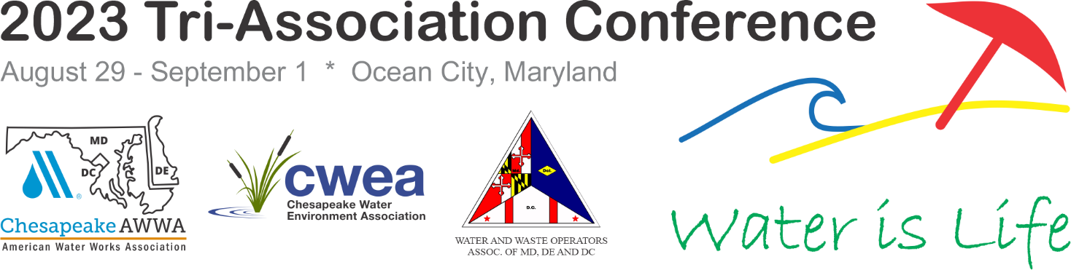

CALL FOR ABSTRACTS
Abstracts must be submitted by January 10, 2023 at 11:59 PM EST.
The Chesapeake Section, American Water Works Association, Inc. (CSAWWA), Chesapeake Water Environment Association (CWEA) and the Water & Waste Operators Association of Maryland, Delaware & the District of Columbia (WWOA) will jointly hold their annual conference and exhibition from August 29, 2023 through September 1, 2023 at the Ocean City Convention Center in Ocean City, Maryland. We are now accepting abstracts for technical presentations and technical workshops. All presentations will be 30 minutes with the exception of ethics which are required to be 1 hour long.

Categories include:

- Asset Management (Vertical)
- Asset Management (Horizontal)
- Utility Management (Regulation Management)
- Utility Management (Sustainability/Resiliency/Reuse)
- Utility Management (other)
- Wastewater Pump Stations and Collection Systems
- Wastewater Treatment (Liquids Processing)
- Wastewater Treatment (Biosolids & Residuals Treatment and Handling
- Stormwater)
- Water Pump Stations and Water Mains
- Water Storage Tanks and Reservoirs
- Water Treatment
- Engineering Ethics
- System Operations/Maintenance

Definitions of the categories are below. The submitter should review these descriptions before determining the best category for their submission.
Asset Management (vertical) – Abstracts should focus on specific strategies, practices, procedures, data, and information systems used in making asset level investment decisions with an asset management framework and used in making asset level investment and O&M decisions. Abstracts should include results and how outputs are being used to improve decision-making. These papers should be focusing on vertical assets.
Asset Management (horizontal) – Abstracts should focus on specific strategies, practices, procedures, data, and information systems used in making asset level investment decisions with an asset management framework and used in making asset level investment and O&M decisions. Abstracts should include results and how outputs are being used to improve decision-making. These papers should be focusing on horizontal assets.
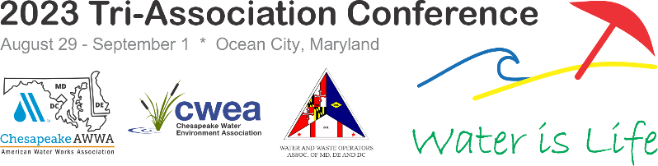
Utility Management (Regulation Management) - Abstracts should focus on how utilities are adapting and moving in the direction to meet new EPA regulations. These topics can include, but not limited to, lead and copper rule and PFAS.
Utility Management (Sustainability/Resiliency)- Abstracts should focus on planning, design, and/or operation of infrastructure that has the capability and capacity to withstand both expected and unanticipated events and to meet present needs without compromising their ability to meet future needs.
Utility Management (other) - Abstracts should focus on approach and techniques used to run or improve the benefits of a utility. These topics can include, but are not limited to project management, emergency response, mentoring, and alternative project delivery.
Wastewater Pump Stations and Collection Systems – Abstracts should focus on horizontal or “outside the fence” assets including sewer pipelines, force mains, wastewater pumping stations, septic systems, and holding tanks. Topics from study through construction will be considered such as, but not limited to: rehabilitation, new analysis techniques or approaches, new and/or innovative product applications, inflow and infiltration studies, combined sewer system, hydraulic modeling, regulatory compliance and regulations, and design & construction challenges.
Wastewater Treatment- Liquids Processing - Abstracts should focus on the liquid processing aspects of wastewater treatment including treatment processes, new technologies, and pilot studies.
Wastewater Treatment: Biosolids & Residuals Treatment and Handling – Abstracts should focus on the solids aspects of wastewater treatment including treatment processes, new technologies, pilot studies, solids handling facilities, and beneficial reuse of biosolids
Stormwater – Abstracts should focus on stormwater capture, treatment, and/or permit compliance.
Water Pump Stations and Water Distribution System - Abstracts should focus on assessment, planning, design, new construction, renewal, or operations of water pump stations and water transmission mains.
Water Storage Tanks and Reservoirs - Abstracts should focus on assessment, planning, design, new construction, renewal, or operations of reservoirs, elevated storage tanks, ground, or underground storage tanks.
Water Treatment – Abstracts should focus on the planning, new construction, or upgrades of water treatment systems including process selection, optimization, regulatory compliance, chemical addition, residuals handling, and pilot/bench studies.
Engineering Ethics – Abstracts should cover 1 hour presentations discussing general engineering ethics and specific case studies. The presenter should have suitable credential for this presentation.
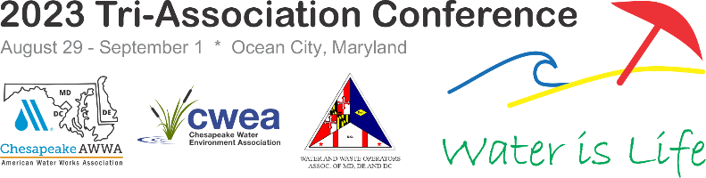
System Operations/Maintenance - Abstracts should focus on system operation and system maintenance.
Abstracts should be no more than 500 words and should include sufficient information to enable a knowledgeable program review committee to evaluate the material you wish to present. No figures or graphics are permitted. A short (3- to 4-sentence) biography of the presenter will be required. Abstracts should convey the goals of the presentation and communicate the benefits of the presentation to the attendees.

ABSTRACT PUBLICATION: Selected abstracts and speaker information will be posted to the conference website so that attendees can review them before the conference. Please make sure that your final presentation matches your abstract.

The abstract submission link (shown below) is available on the Tri-Association Conference webpage: www.ChesapeakeTricon.org

- Please use Proper sentences when entering information
- Do not use all caps when entering information or it will show up in all conference material that way
- Please do not include bullets or extra spaced in the abstract or they will not show up properly.

All speakers are responsible for their travel, lodging, and registration costs associated with the event. Speakers agree to register and pay the one-day or full conference registration fees, or the speaker will not be allowed to present. Presentation requirements will be provided if your presentation is selected.

Click here to link to the online submission portal Call for Proposals | 2023 Tri-Con or visit our website to get started www.ChesapeakeTricon.org.

If you have questions please contact Sophia Liskovich at sliskovich@gfnet.com

