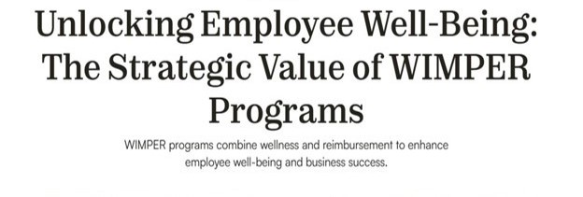



**WIMPER** stands for: **W**ellness **I**ntegrated **M**edical **P**lan **E**xpense **R**eimbursement

**WIMPER KEY POINTS**

* Savings of approximately $600 per employee per year.
* Outstanding “government subsidized” [through the ACA] wellness benefits to offer your employees.
* Used by approximately 46% of the Fortune 500. **Now becoming available to smaller companies.** The ROI on wellness programs for employees is well documented.
* Completely optional for your employees. We get 80% to 90% employee participation.
* Ultimately lowers health insurance costs. 50% fewer Urgent care visits and 40% fewer Emergency Room visits.
* Our **WIMPER** Program was crafted by tax and insurance professionals to comply with all IRS memos, the Affordable Care Act (ACA), and related public lawwith audit protection.
* **100% - IRS, ACA, ADA, ERISA, and HIPAA Compliant**
* Keep your: Current Health Insurance; CPA; Attorney. Keep all current professional relationships in place. WIMPER does not replace any of them but is something ADDITIONAL you offer your employees, most of whom will engage with and appreciate.
* **100% Confidentiality!** We will be working in the sensitive area of employee payroll. We will honor your confidence in our firm. **Zero information** will EVER be shared with others, even including the fact that you are our client.
* Reduces:
  + **Turnover** – The Work Institute’s Retention Report shows that the total replacement cost is over $15,000 per employee for a person earning a median salary of $50,000/year.
  + **Absenteeism** – The Center for Disease Control (CDC) estimates that absenteeism costs US employers an average of $1,685 in sick pay and lost productivity each year.
  + **Improves Recruiting and Retention** – A Voya Financial Survey found that wellness benefits play a crucial role in employment choices, with 78% of employees stating that their decision to work for and remain with their employer was influenced by such benefits.
* In the event that the economy “tightens” savings become even more meaningful.
* Timing is everything: The ACA “could be” repealed. **Peter A. Karl III. JD, CPA**, is a partner with the law firm of Karl, Green & DeBella, LLP in Utica, N.Y., and a professor of law and taxation at the SUNY Polytechnic Institute. He is a member of **The CPA Journal Editorial Advisory Board.**
  + *“The potential implication of a repeal of the ACA would depend upon the type of wellness plan that is being used.* ***An ACA repeal would not impact participatory wellness plans associated with a WIMPER program.”***

**Contact Don Freda**

**856-243-2785**

**df@StriveCorp.com**