9/14/2016 Mene Mene Tekel Peres and the Process of Dividing

The afternoon of 9/13/2016 former Israeli president Shimon Peres suffered a massive stroke. http://www.timesofisrael.com/doctors-family-cautiously-optimistic-as-peres-shows-signs-of-improvement/?utm_source=The+Times+of+Israel+Daily+Edition&utm_campaign=99520529ae-2016_09_14&utm_medium=email&utm_term=0_adb46cec92-99520529ae-55467209

The previous day, 9/12/2016, was the 10th day of the 7th Hebrew month and the Day of Atonement according to Karaite early aviv barley reckoning.The Day of Atonement is the only day of the year set apart by YaHuWaH Elohim for His people to afflict their souls through fasting. Few people are following the early aviv barley calendar timing this year. Most Jews, including the Karaites, are following the Hebrew Hillel calendar that was calculated centuries ago, counting this month of September, 2016, as the 6th month of Elul.

The Dividing of the 7th Month

The massive stroke suffered by president Shimon Peres occurred on the 11th day of the 7th Karaite early aviv month. That event happening to a man whose Hebrew name, "Peres", itself means "divide", divided the 22 day sequence of 7th month autumn harvest days set apart by YaHuWaH Elohim in half. The sequence of the special set apart (holy) days of the 7th month begin with the Day of Trumpets on the 1st day and end with the Last Great Day on the 22nd day of the 7th month (9/24/2016).

Dividing the 50th Prophetic Year

On 6/7/1967 the Israeli army acquired Jerusalem from Jordan in the Six Days War that began 6/5/1967. Rare twin comets passed near the earth on 3/21-22/2016, dividing the 50th prophetic year from 6/7/1967 in half. Because of their parallel trajectories, those twin comets, comet 252P/LINEAR and comet 2016 BA14, are believed by scientists to have originated from a single larger comet that had divided previously.

First the graphic depicting the time from 6/7/1967:

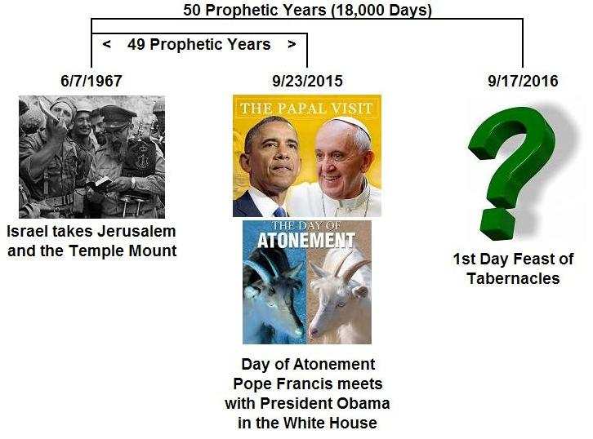

Then the graphic depicting only the 50th prophetic year divided in half by twin comets that themselves had been divided previously:

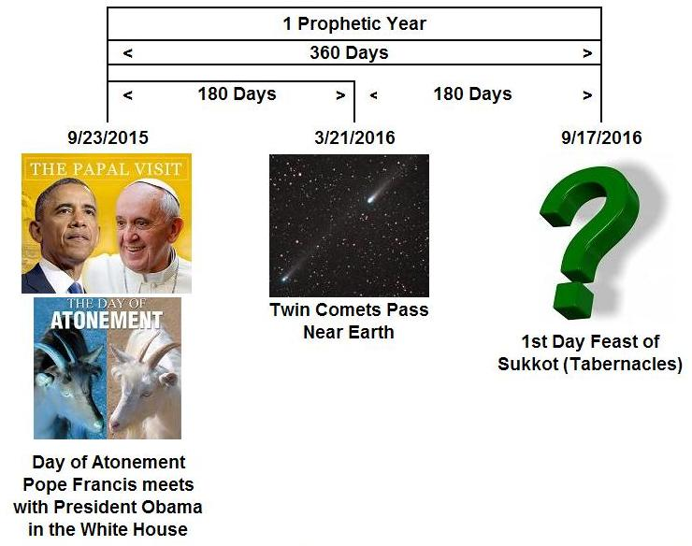

We should also know that on the Day of Atonement there was to be a dividing of sacrificial goats. One goat was to be slaughtered and its blood sprinkled on the Ark of the Covenant in the most holy place. The other goat, the scapegoat, was to be sent away alive to carry the sins of the nation of Israel into the wilderness to Azazel.

Dividing the Numeric Value Encoded into the Handwriting on the Wall

We should be aware that the Hebrew word "peres", meaning to divide or to break into two pieces, was included in the cryptic "handwriting on the wall" that the prophet Daniel deciphered and read to King Belshazzar, the king of Babylon, in Daniel 5:25-28.

Encoded into the "handwriting on the wall" was the numeric monetary value of 126 shekels, which reduces to 2520 gerahs. If we divide 2520 in half, we have two 1260 day sections. A 1260 day period at the end of the age is mentioned twice in Revelation 11:2-3.

The Dividing of the Promised Land by the United Nations

The 69th anniversary of the dividing of the Promised Land into Arab and Jewish sections by the United Nations will occur later this year on 11/29/2016.

That date, 11/29/2016, is precisely the date that is emphasized by our Creator Elohim by these special solar eclipses that place ancient Hebrew "Tavs" on Islamic regions of the earth. The "Tav" or "X" is the last letter in the ancient Hebrew pictorial aleph-bet from 3000 years ago, and it literally means "the end".

The 11/29/2016 date is also the central focus of the total lunar eclipses of 9/28/2015 and 1/31/2018.

Both solar and lunar eclipses ordained by our Creator Elohim at the creation of heaven and earth and pointing to 11/29/2016 are indicated in the graphic below:

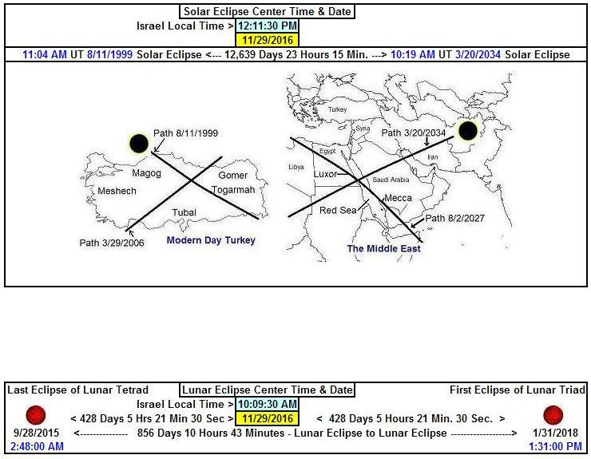

The 69th anniversary, November 29, 2016, is actually the very first day of the 70th year from the dividing of the Promised Land by the UN into Arab and Jewish sections on 11/29/1947.

Our Creator has warned us in the bible (Genesis 28:10-15, Zechariah 12:3), and then doubly emphasized to us through timely lunar and solar eclipses, the grave importance of not partitioning the land allotted by YaHuWaH Elohim entirely to Israel (Jacob) over 3500 years ago.

Genesis 28:13 - And, behold, YaHuWaH stood above it, and said, I am YaHuWaH Elohim of Abraham thy father, and the Elohim of Isaac: the land whereon thou liest, to thee will I give it, and to thy seed;
14 - And thy seed shall be as the dust of the earth, and thou shalt spread abroad to the west, and to the east, and to the north, and to the south: and in thee and in thy seed shall all the families of the earth be blessed.
The Dividing of the People Who Divide Jerusalem

Zechariah 12:3 - And in that day will I make Jerusalem a burdensome stone for all people: all that burden themselves with it shall be cut in pieces, though all the people of the earth be gathered together against it.

