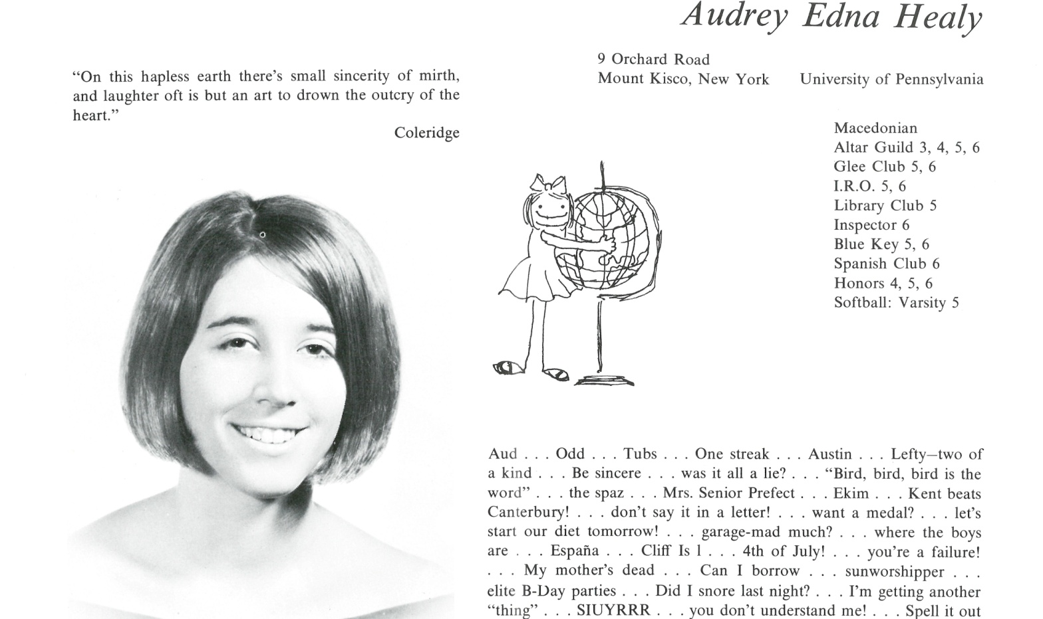

Audrey E. Healy Hiller

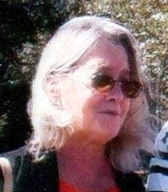

Five years ago we moved to John’s Island, South Carolina, which is right outside of Charleston. We love it here! I am working part-time as a psycho-therapist and problems are the same anywhere, though the pace makes things different from New York.



______________________________________________________________

______________________________________________________________ ______________________________________________________________ ______________________________________________________________ ______________________________________________________________ ______________________________________________________________ ______________________________________________________________ ______________________________________________________________ ______________________________________________________________

Attach Picture in .jpg Format

______________________________________________________________

______________________________________________________________

___________________________________________________________________________________ _________________________________________________________________________________________________________________________________________________________________________________________________________________________________________________________________________________________________________________________________________________________________________________________________________________________________________________________________________________________________________________________________________________________________________________________________________________________________________________________________________________________________________________________________________________________________________________________________________________________________________________________________________________________________________________________________________________________________________________________________________________________________________________________________________________________________________________________________________________________________________________________________________________________________________________________________________________________________________________________________________________________________________________________________________________________________________________________________________________________________________________________________________________________________________________________________________________________________________

___________________________________________________________________________________