GEN-3255H (5500W-38.4kW-60Hz-16yr) Hybrid 120V-240V | Geneforce Emergency Power System
Product Features
Silent operation. Safe for indoors. No gas or emissions.
No Installation; No Maintenance; No Permits required
Arrives fully charged and ready to work.
Automatic & one-touch start. | 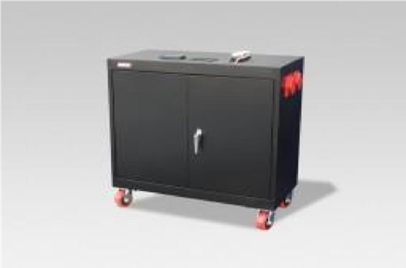
System Control Panel with Graphical 128 x 64-pixel, backlit LCD displays power reserves, amp hours consumed, fault conditions, solar panel output, charging, power consumption.
Overheat Temperature Sensor & Automatic Shutdown feature.
Built-in voltage regulation system for sensitive electronics.
Built-in 30A solar charge controller for solar panel charging.
Electrical Specifications | GEN-3255H (120V-240V)
Output power (continuous) at 25°C | 5,500 W
Overload 30 min/60 sec at 25°C | 7,000 W / 9,500 W
Output power (continuous) at 40°C | 4,500 W
Maximum output current 60 seconds (rms) | 82 A (120 V); 41 A (240 V)
Output frequency | 50 / 60 Hz selectable
Output voltage | 120 / 240 Vac
Output wave form | True sine wave
Input DC voltage range | 42 to 60 V (48 V nominal)
AC connections | Single / Split phase
Charger
Maximum output charge current | 110 A
Output charge voltage range | 40 – 64 V (48 V nominal)
Charge control | Three stage, two stage, boost, custom
Charge temperature compensation | Battery temperature sensor included
AC input frequency range (bypass/charge mode) | 55 – 65 Hz (default) 52 – 68 Hz (allowable)
AC input voltage limits (bypass/charge mode) | L-N: 78 - 140 V (120 V nominal); L-L: 160 - 270 V (240 V nominal)
AC input voltage requirements | 240V default *phase between L (1) and L (2) must be 180° to qualify AC
AC input 1 | One 60 Amp, 125/250 Volt, NEMA 14-60P, 3P, 4W, Plug and 8 ft. cord
AC output 1 | Four (20A/125V) NEMA 5-20R isolated ground receptacles
AC output 2 | One 60 Amp, 125/250 Volt, NEMA 14-60R, 3P, 4W, flush receptacle
Grid sell current range on AC1 (selectable limit) | 0 to 40 A (120 V) / 0 to 20 A (240 V)
Battery bank reserve power | 38.4 kW (38,400 Watts)
Battery service life | 12-16 years on float
Solar charge controller | 30A/12V (~360 W per hour/sunlight) *(60A/12V-24V) optional
General Specifications
Automatic transfer relay rating/typical transfer time | 60 A/8 ms
Optimal operating temperature range | -20°C to 60°C (-4°F to 140°F)
Ingress protection rating | Indoor only, IP20
Regulatory approval
Safety | Components are UL1741, CSA 107.1
EMC directive | FCC and Industry Canada Class B
General Specifications
Product Dimensions (H x D x W) and weight | (51" x 24" x 46”) & (2363 Lbs.) 1074 kg.
Shipping Dimensions (H x W x L) and weight | Custom Pallet 60” x 36” x 60” (2463 lbs.) 1120 kg.
Construction | Strong Steel, Four Casters, Color-Black or Charcoal
Warranty | 5-year warranty on components; up to 4-years on batteries
Part Number | GEN-3255H-120240-5500-16
Price | $20,479
Geneforce Incorporated www.geneforcepower.com Tel: (305) 215-5443 email: sales@geneforcepower.com

