Saturday/Sunday,
March 15 & 16, 2025
Second Sunday In Lent
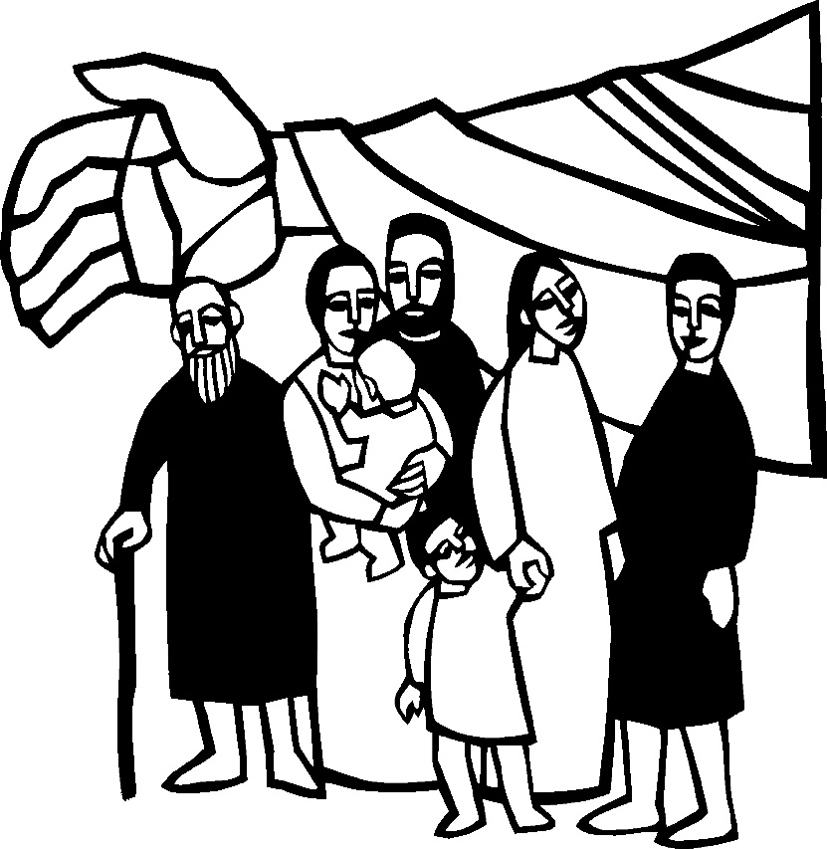
Christ Lutheran Church
“A Place Where You are Always Welcome”
Services: Saturday 5:30 pm and Sunday 10:00 am
Sunday School: 9:00 am (September- May)
600 North Main Street, Stockton, IL 61085 Office: 815-947-2033
Email:christlutheranchurch70@gmail.com http://www.christlutheranstockton.com
Ministers: ALL members of the congregation
Pastor: Rev. Chrissy Salser chrissytherev@att.net 815-988-9450
From Sundays and Seasons.com. Copyright 2017 Augsburg Fortress. All rights reserved. Reprinted by permission under Augsburg Fortress Liturgies Annual License #40643.New Revised Standard Version Bible, copyright 1989, Division of Christian Education of the National Council of the Churches of Christ in the United States of America. Used by permission. All rights reserved.
WELCOME: Thank you for joining us for worship today. We are glad you are with us. Communion will be served in the aisle or in your pew. All are welcome to share this meal. Jesus is our host and invites everyone. Those who would like to come forward, bread and wine will also be available in the front. When directed by the usher, come forward down the center aisle, Pr Chrissy will give you bread (she will be masked and wearing cloves) and then you will take a cup of wine (grape juice) from the tray. After taking communion, you will return to your seat by the side aisle. For those who are unable to come forward, communion elements can be found as you entered worship. At that part of the service, you are invited to take the bread and wine (or grape juice) when Pr. Chrissy leads. On Saturdays offering is collected as you enter or leave worship. On Sunday we will pass the plate as a response to God’s grace. Online giving is available. Please see QR code on back of bulletin or visit our website.

Introduction:

Though we sometimes doubt and often resist God’s desire to protect and save us, our God persists. In holy baptism, God’s people have been called and gathered into a God-initiated relationship that will endure. Lent provides the church with a time and a tradition in which to seek God’s face again. Lent provides another occasion to behold the God of our salvation in the face of the Blessed One who “comes in the name of the Lord.”
Gathering: The Holy Spirit calls us together as the people of God.
PRELUDE
WELCOME AND ANNOUNCEMENTS
All may make the sign of the cross, the sign that is marked at baptism, as the presiding minister begins.
P: Blessed be the holy Trinity, ☩ one God, who forgives all our sin, whose mercy endures forever. Amen.
Let us return to God, confessing our sin in the assurance of God’s abiding love.
P: Compassionate One,
C: you are slow to anger and abounding in steadfast love, but our lives do not always reflect you and your love for the world. We do not show others the tender compassion you have shown to us. We do not welcome others with the radical hospitality you grant to all people. We oppress others, even though you have set us free again and again. We squander the abundant gifts of the earth. Transform our lives and guide us again in the way of the cross. Amen.
P: Beloved in Christ, God’s arms are always stretched open wide to welcome the wandering ones home. In ☩ Christ your sins are forgiven. You have a place in God’s house forever.
C: Amen.
GATHERING HYMN My Hope is Built on Nothing Less ELW 596
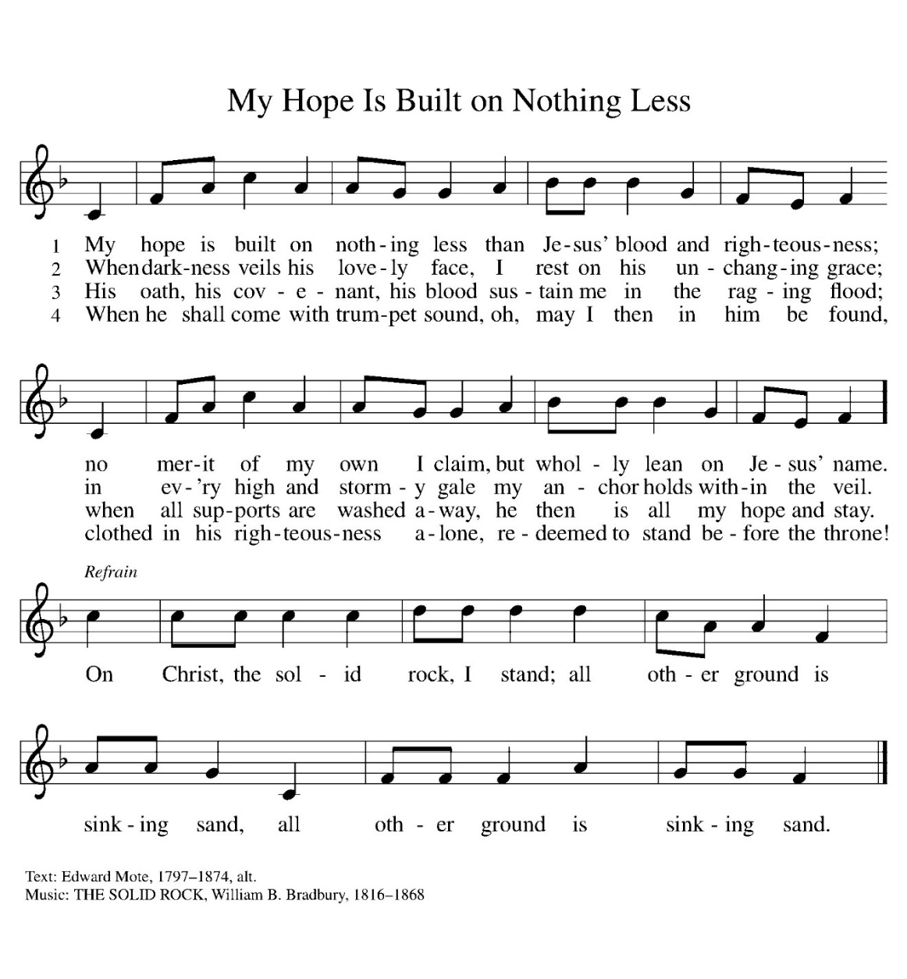
Greeting:
P: The grace of our Lord Jesus Christ, the love of God, and the communion of the Holy Spirit be with you all. C. And also with you.
PRAYER OF THE DAY
P: God of the covenant, C: in the mystery of the cross you promise everlasting life to the world. Gather all peoples into your arms, and shelter us with your mercy, that we may rejoice in the life we share in your Son, Jesus Christ, our Savior and Lord, who lives and reigns with you and the Holy Spirit, one God, now and forever.
Amen.
Word: God speaks to us in scripture reading, preaching, and song.
First Reading: Genesis 15:1-12 17-18
God promises a childless and doubting Abram that he will have a child, that his descendants will be as numerous as the stars, and that the land of Canaan will be their inheritance. Abram’s trust in God is sealed with a covenant-making ceremony, a sign of God’s promise.
¹ After these things the word of the Lord came to Abram in a vision, “Do not be afraid, Abram, I am your shield; your reward shall be very great.” ² But Abram said, “O Lord God, what will you give me, for I continue childless, and the heir of my house is Eliezer of Damascus?” ³ And Abram said, “You have given me no offspring, and so a slave born in my house is to be my heir.” ⁴ But the word of the Lord came to him, “This man shall not be your heir; no one but your very own issue shall be your heir.” ⁵ He brought him outside and said, “Look toward heaven and count the stars, if you are able to count them.” Then he said to him, “So shall your descendants be.” ⁶ And he believed the Lord; and the Lord reckoned it to him as righteousness. ⁷ Then he said to him, “I am the Lord who brought you from Ur of the Chaldeans, to give you this land to possess.” ⁸ But he said, “O Lord God, how am I to know that I shall possess it?” ⁹ He said to him, “Bring me a heifer three years old, a female goat three years old, a ram three years old, a turtledove, and a young pigeon.” ¹⁰ He brought him all these and cut them in two, laying each half over against the other; but he did not cut the birds in two. ¹¹ And when birds of prey came down on the carcasses, Abram drove them away.
¹² As the sun was going down, a deep sleep fell upon Abram, and a deep and terrifying darkness descended upon him.¹⁷ When the sun had gone down and it was dark, a smoking fire pot and a flaming torch passed between these pieces. ¹⁸ On that day the Lord made a covenant with Abram, saying, “To your descendants I give this land, from the river of Egypt to the great river, the river Euphrates.”
L: The word the Lord C. Thanks be to God.

Psalm: Psalm 27

¹ The Lord is my light and my salvation; whom then shall I fear?
The Lord is the stronghold of my life; of whom shall I be afraid?
² When evildoers close in against me to devour my flesh,
they, my foes and my enemies, will stumble and fall.
³ Though an army encamp against me, my heart will not fear.
Though war rise up against me, my trust will not be shaken.
⁴ One thing I ask of the Lord; one thing I seek; that I may dwell in the house of the Lord all the days of my life; to gaze upon the beauty of the Lord and to seek God in the temple.
⁵ For in the day of trouble God will give me shelter,
hide me in the hidden places of the sanctuary, and raise me high upon a rock.
⁶ Even now my head is lifted up above my enemies who surround me. Therefore I will offer sacrifice in the sanctuary, sacrifices of rejoicing; I will sing and make music to the Lord.
⁷ Hear my voice, O Lord, when I call; have mercy on me and answer me.
⁸ My heart speaks your message— “Seek my face.” Your face, O Lord, I will seek.
⁹ Hide not your face from me, turn not away from your servant in anger. Cast me not away—you have been my helper; forsake me not, O God of my salvation.
¹⁰ Though my father and my mother forsake me, the Lord will take me in.
¹¹ Teach me your way, O Lord; lead me on a level path, because of my oppressors.
¹² Subject me not to the will of my foes,
for they rise up against me, false witnesses breathing violence.
¹³ This I believe—that I will see the goodness of the Lord in the land of the living!
¹⁴ Wait for the Lord and be strong. Take heart and wait for the Lord!

Second Reading: Philippians 3: 17-4:1
Although Paul’s devotion to Christ has caused him to be persecuted, he does not regret the course he has taken. Writing from prison, he expresses confidence in a glorious future and encourages other Christians to follow in his footsteps.
¹⁷ Brothers and sisters, join in imitating me, and observe those who live according to the example you have in us. ¹⁸ For many live as enemies of the cross of Christ; I have often told you of them, and now I tell you even with tears. ¹⁹ Their end is destruction; their god is the belly; and their glory is in their shame; their minds are set on earthly things. ²⁰ But our citizenship is in heaven, and it is from there that we are expecting a Savior, the Lord Jesus Christ. ²¹ He will transform the body of our humiliation that it may be conformed to the body of his glory, by the power that also enables him to make all things subject to himself. ^{4:1} Therefore, my brothers and sisters, whom I love and long for, my joy and crown, stand firm in the Lord in this way, my beloved.
L: The word the Lord C. Thanks be to God.

GOSPEL ACCLAMATION Restore Us, O God ELW 328
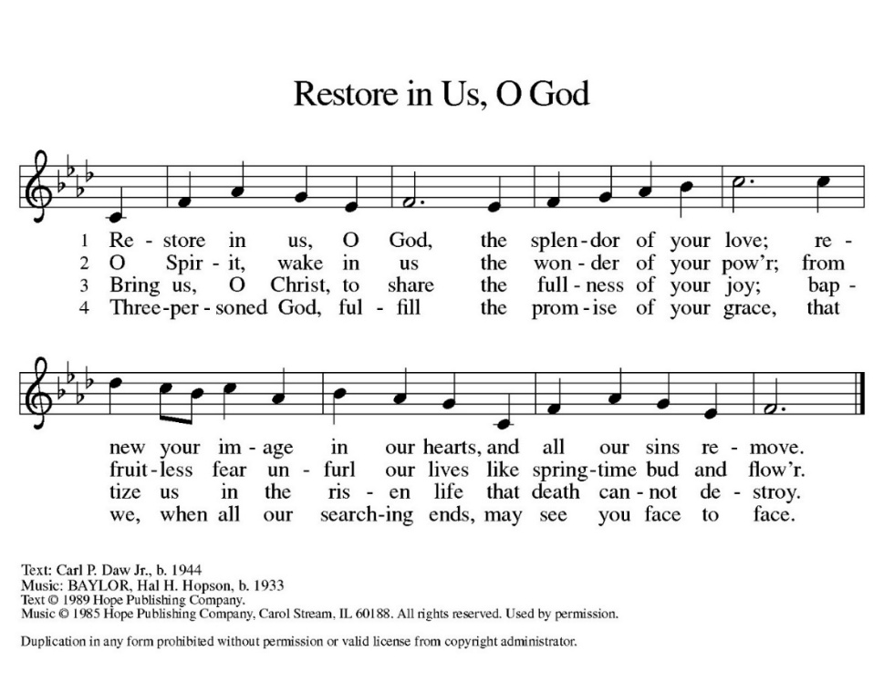

Gospel: Luke 13:31-35

P: The holy Gospel According to Luke C: Glory to you, O Lord
Neither Herod’s plotting nor Jerusalem’s resistance to maternal love will deter Jesus from his sacrificial mission.
³¹ At that very hour some Pharisees came and said to [Jesus,] “Get away from here, for Herod wants to kill you.” ³² He said to them, “Go and tell that fox for me, ‘Listen, I am casting out demons and performing cures today and tomorrow, and on the third day I finish my work. ³³ Yet today, tomorrow, and the next day I must be on my way, because it is impossible for a prophet to be killed outside of Jerusalem.’ ³⁴ Jerusalem, Jerusalem, the city that kills the prophets and stones those who are sent to it! How often have I desired to gather your children together as a hen gathers her brood under her wings, and you were not willing! ³⁵ See, your house is left to you. And I tell you, you will not see me until the time comes when you say, ‘Blessed is the one who comes in the name of the Lord.’ ”
P: The Gospel of Our Lord. C. Praise to you, O Christ.
CHILDREN’S MESSAGE
MESSAGE
HYMN OF THE DAY: God of Grace and God Glory ELW 705 (Next page)
APOSTLES’ CREED:
I believe in God, the Father almighty, creator of heaven and earth.
I believe in Jesus Christ, God’s only Son, our Lord, who was conceived by the Holy Spirit, born of the virgin Mary, suffered under Pontius Pilate, was crucified, died, and was buried; he descended to the dead. On the third day he rose again; he ascended into heaven, he is seated at the right hand of the Father, and he will come to judge the living and the dead.
I believe in the Holy Spirit, the holy catholic church, the communion of saints, the forgiveness of sins, the resurrection of the body, and the life everlasting. Amen.
PRAYERS OF INTERCESSION:
P. God, in your mercy, C: receive our prayer.

PEACE
P: The peace of Christ be with you always. C. And also with you.
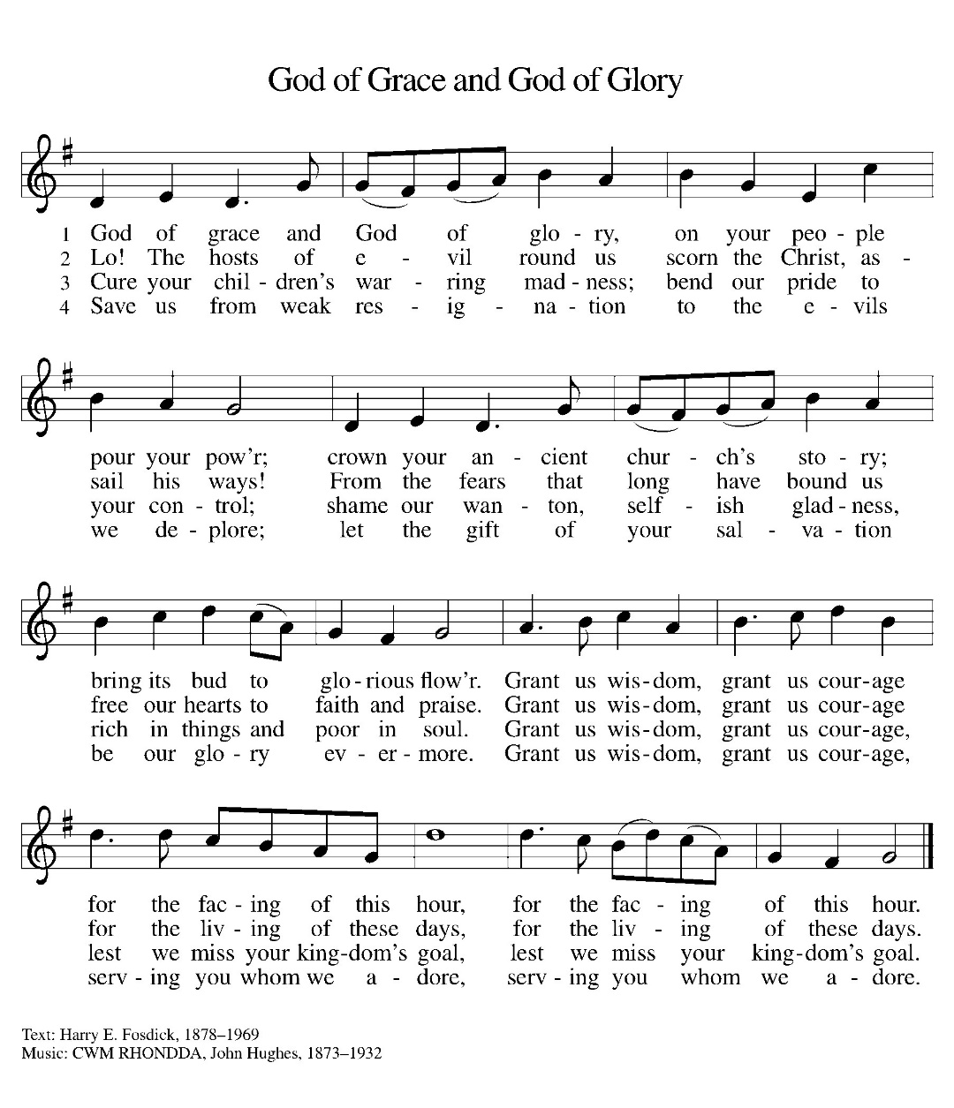

OFFERING: Our offering is a significant act of worship; we worship God through our giving. The ministry of this congregation is completely dependent upon your partnership and generosity. Offering is collected as you enter worship on Saturday. We will pass the offering plate on Sundays. Online giving is available.

OFFERING HYMN: Create In Me ELW 186
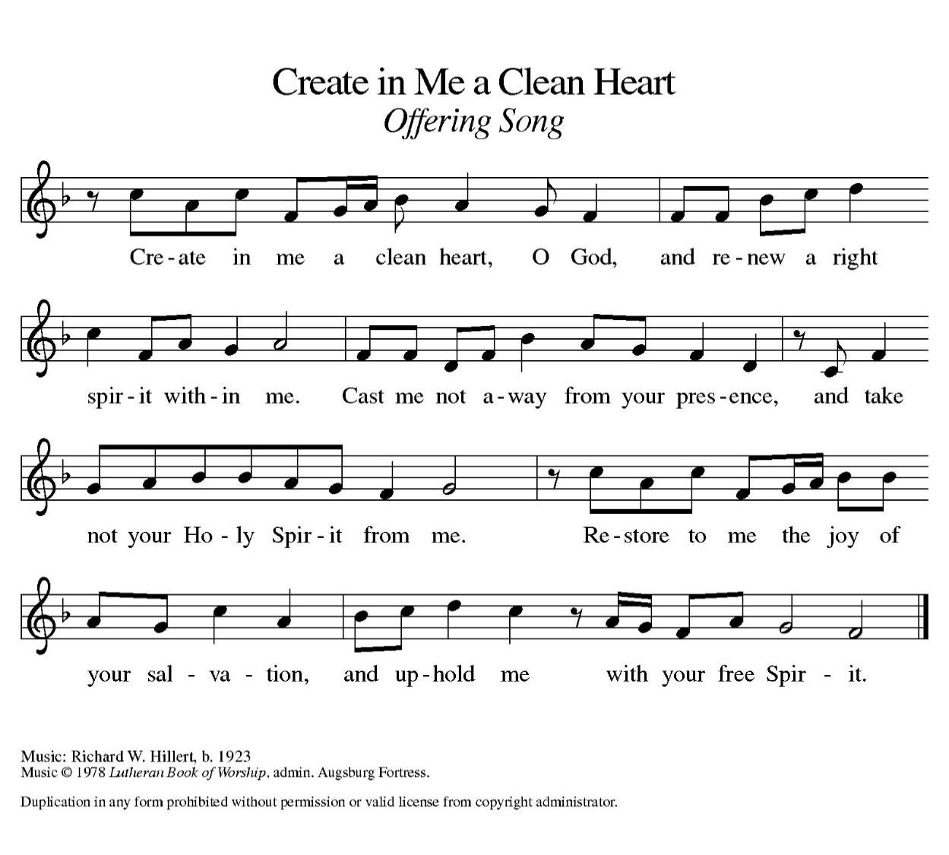
OFFERING PRAYER:
P: Gracious Provider, C: you set your immense treasures among us, opening your heart to the world. As we prepare to feast on your bountiful love, deepen our commitment to sharing those treasures with others, through our Savior, Jesus Christ. Amen.

COMMUNION LITURGY:
In the night in which he was betrayed, our Lord Jesus took bread, and gave thanks, broke it and gave it to his disciples, saying: take and eat; this is my body, given for you. Do this for the remembrance of me. Again, after supper, he took the cup, gave thanks and gave it for all the drink, saying: this cup is the new covenant in my blood, shed for you and for all people for the forgiveness of sin. Do this for the remembrance of me.
THE LORD’S PRAYER:
Our Father, who art in heaven, hallowed be thy name, thy kingdom come, thy will be done on earth as it is in heaven. Give us this day our daily bread; and forgive us our trespasses, as we forgive those who trespass against us; and lead us not into temptation but deliver us from evil. For thine is the kingdom, and power, and the glory, forever and ever. Amen

INVITATION TO COMMUNION:
P: The joy of the Lord is our strength. Come, eat this meal of gladness.
Please come down the center aisle, take the bread, then receive a cup (wine is dark, juice is light, return to your seats via side aisle.) Those who prefer to take communion in your pews, we will take all together after all is served.
DISTRIBUTION OF COMMUNION
P: This is the body of Christ given for you. (All take bread).
P: This is the blood of Christ shed for you. (All take the wine).
COMMUNION HYMN Awake, O Sleeper, Rise from Death ELW 452
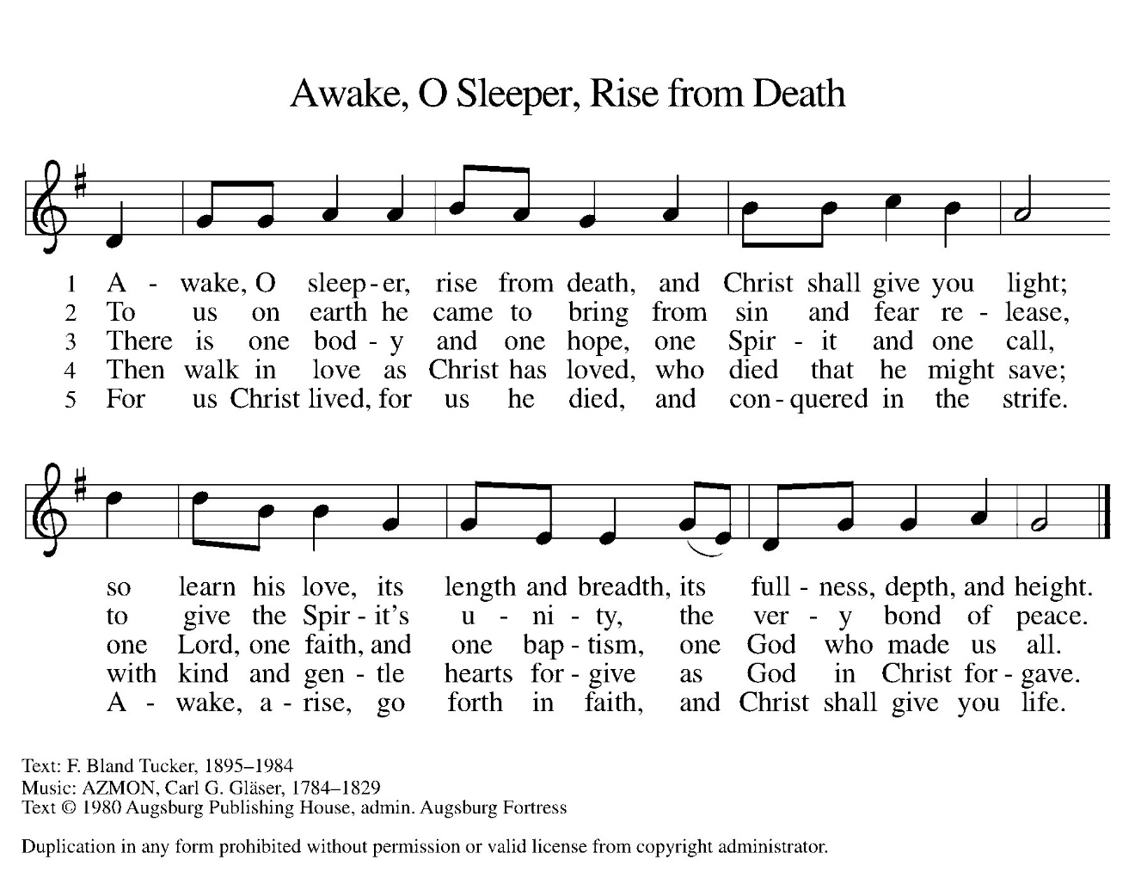
TABLE BLESSING:
P. May the body and blood of our Lord Jesus Christ strengthen you and keep you in his grace. C. Amen.

PRAYER AFTER COMMUNION:
P: Let Generous Host, C: you have shared your feast with us and made us new. Send us now to set tables of love and grace in our communities, that your liberating love might nourish the world into freedom, in the name of the crucified one, Jesus Christ our Lord. Amen.

SENDING: God blesses us and sends us in mission to the world.
BLESSING: P: God our tender parent, God the crucified one, God the reconciling Spirit,
☩ bless you now and forever.
C: Amen.

SENDING HYMN Lead Me, Guide Me ELW 768
Refrain: Lead me, guide me, along the way; for if you lead me, I cannot stray.
Lord, let me walk each day with thee. Lead me, O Lord, lead me.

1. I am weak and I need thy strength and pow’r to help me over my weakest
hour. Help me through the darkness thy face to see. Lead me, O Lord, Lead me. refrain

2. Help me tread in the paths of righteousness, be my aid when Satan and sin
oppress. I am putting all my trust in thee. Lead me, O Lord, Lead me. refrain

3. I am lost if you take your hand from me, I am blind without thy light to see.
Lord, just always let me thy servants be. Lead me, O Lord, Lead me. refrain

DISMISSAL:
P. Go in peace. Live in hope. C: Thanks be to God.
POSTLUDE
IN OUR PRAYERS TODAY: Darlene and Walt Steffes, Bob Schreck, Delores Wampfler, Marge Arnold, Josie Bonjour, Elaine Schlichting, Steve Wulff, Dan bonnet, Don and Judy Brudi, James Dieter, Christine Happ, Kay Hesselbacher, Mary Lou Bunker, Lillian Sefford, Judy Wilson, Jody Dascher, Russ Synder, family and friends of Aleta Lawfer, Emilee Wolf Schiling, Esther Wand To add someone to the prayer list please contact Pastor Chrissy
Updated addresses: Elaine Schlichting Josie Bonjour
(cell number 815-656-1153) Room 316
Oakly Courts Room 132 Manor Court at Liberty Village
3117 Kunkle Blvd 2170 W. Navajo Drive
Freeport, IL 61032 Freeport, IL 61032
CELEBRATING BIRTHDAYS / ANNIVERSARIES: Tony Jones, Rachel Cook, Colin Dvorak, Tim Larson, Jeremiah Luke, Randy Menzemer, Emily Curtiss, Amy Kuo

ANNOUNCEMENTS
Thanks be to God for your gifts for the ministry of  Christ Lutheran Church *these numbers do not reflect online giving- only offering in worship |  |  |  | Offering/ Attendance  March 8 & 9
Current Expense | $2,811.00 | Building Fund | $30.00 | March 8 | 14
Benevolence | $135.00 | Lent | $11.00 | March 9 | 50
 |  | Total | $2,987.00 | Sunday School | 20
 |  | March 5 total: | $136.00 | Ash Wednesday | 20

February Totals: As a way to improve communication around finances, we are sharing the following information: *these numbers reflect online giving contribution
2025
 | February | Year to date
Offerings: | $6,716 | $15,734
Expenses: | $10,285 | $20,512
Overall Gain / Loss | ($3,569) | ($4,778)

ONLINE GIVING: Your gift has a big impact on our ministries and those we serve. Scan this code or visit our website to give online today.

DISHES: we are cleaning the kitchen and found lots of serving dishes and containers that belong to you from helping with funeral luncheons. Items are in the narthex, please take your home with you. There are dishes downstairs as well that you are welcome to take home, as we have cleaned out the kitchen.

DONATIONS NEEDED FOR SOUP SUPPER: a sign up sheet has been placed in the narthex of items needed for dessert. Items need to be in the kitchen by Friday, March 21st by noon.
AMAZON WISH LIST: did you know that everyday items used at the church are items you could contribute? Find our list here or on our Facebook page. Thank you! https://www.amazon.com/hz/wishlist/ls/TWP5U0RAGGAY?ref_=wl_share

COWORKERS IN THE GOSPEL: Consider being apart of one our leadership teams. As of this month, three teams will be helping connect council and congregation as we work together to do ministry together. Three teams have formed; Worship Team, Building Team and Education Team. If you are interested in being apart of one of the teams, please see Pr Chrissy or someone on the team.
- Worship team leader is Janet Haas -anyone who is interested in serving in any area of worship, especially baking communion bread, communion set up, serving or clean up.
- The building team will access and address issues related to the building. Please see a Cory Haas, team leader, if you would like to help out with the building. We are also looking for people interested in helping with the mowing the lawn come spring.
- The Education Team over sees Confirmation, Sunday School and Vacation Bible School. Vacation Bible School is going to happen June 2-6. from 9-11:30. If you would like to be apart of the education team please see Leisa Hubb (team leader) VBS Planning team meeting Sunday, April 6 at 11 am.
Upcoming Events
- March 15- 8 am Break bread together at Stella’s
- March 15- 5:30 pm Worship
- March 16- 9 am Sunday School
- March 16- worship with Assistant to Bishop preaching and conversation after worship
- March 19- 9 am Bible Study
- March 19- 7 pm worship
- March 19- 7:40 pm church council
- March 22- Congregational Resourcing Event- Sauk Valley College
- March 22- 9 am- baking for soup supper
- March 22- 5:30 am worship (no communion)
- March 23- 9 am Sunday school
- March 23- 10 am Worship
- March 23- 1 pm Aleta Lawfer Funeral
- March 24- WELCA Soup Supper
- April 6- 11 am VBS planning meeting
- April 17-7pm Maundy Thursday Worship
- April 18- 7 pm Good Friday Worship
- April 19- 5:30 pm- Easter Vigil
- April 20- EASTER
- May 4- 10 am Confirmation Sunday
- May 25- LSSI Good Shepherd Sunday
- June 2-6 Vacation Bible School

