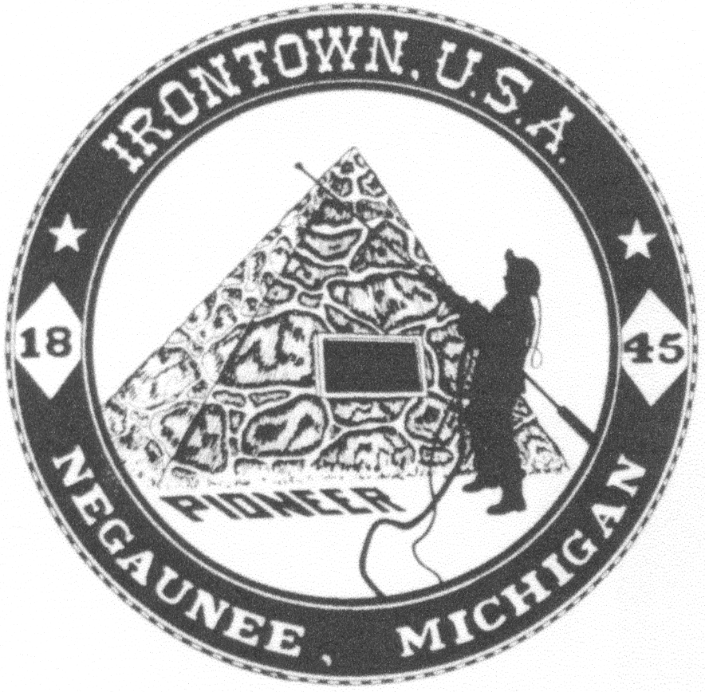
Negaunee Irontown Association

P.O. Box 128 Negaunee, MI 49866
www.negauneeirontown.com

2025 Parade Information Sheet
The Negaunee Irontown Association invites you and/or your organization to participate in this year’s Pioneer Days parade. Any type of entry, large or small, is welcome. To participate, please complete the registration form and return it by Monday, June 30th.

PARADE: Saturday, July 12, 2025
10:30 a.m. line-up time
11:30 a.m. parade starts

The staging area will be posted on Negaunee Irontown’s Facebook and Website.
Please report to any Negaunee Twp. Fireman along the side streets to receive your line-up assignment.

ROUTE: Start at the corner of Iron and Tobin streets Head east on Iron to Pioneer Avenue; North on Pioneer to Main Street; East on Main Street to Brown Avenue; Brown Avenue north to Mitchell Street, where the parade will dissipate.

- NO water guns, water balloons or buckets.
- NO alcoholic beverages
- NO fireworks
- Animal entries MUST provide clean-up.
- Performance should not stop flow of the parade
- Late entries will proceed to the end of parade.
- We cannot guarantee parade placement.

Political candidates have an entry fee of $50.

The parade committee reserves the right to effectively manage the number of entries permitted and to accept or reject any entry it deems unsuitable or not representative of the parade’s purpose and/or theme.

Please complete the attached form and return it by June 30,2025 to:
Negaunee Irontown Association; P.O. Box 128; Negaunee, MI 49866.

Please save this sheet for your reference.
Miss the Deadline? No problem! Late entries are to arrive at 10:30am.
Please see Negaunee Township Fireman for placement.

Negaunee Irontown Association

P.O. Box 128 Negaunee, MI 49866
www.negauneeirontown.com

July 12, 2025, Parade Entry Form

Please provide us with your contact information.

Contact person’s name__ ___________________________

Organization name______________________________

Address_______________________________________

City, State, Zip_____________________________

Phone number_______________E-mail____________________________

Type of Entry—Please circle all that apply.

Truck Truck w/trailer Float Car Multiple cars

Marching Unit Fire truck Multiple fire trucks Walkers

Scooters/bikes Horses/animals Political ($50 charge) Other________

Will you have music playing from your entry, either instruments or radio/speakers?

____________________________________________________________________________

Please return this completed form by June 30, 2025, to
Negaunee Irontown Association; P.O. Box 128; Negaunee, MI 49866

Miss the Deadline? No problem! Late entries are to arrive at 10:30am.
Please see Negaunee Township Fireman for placement.

