09/19/2016 The 5th Tav

On 9/4/2016 my wife was working in the garage and I was working in the yard when she called to me. I came running and found that she was concerned about the large bird that had wandered into the open garage.

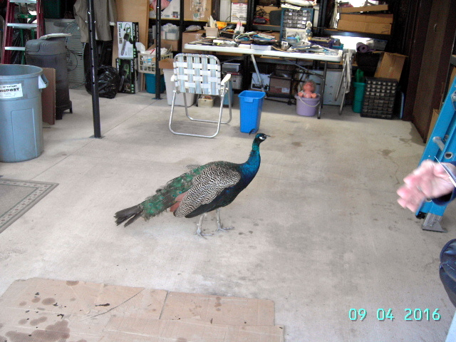

We live in the Huron National Forest in Northern Michigan. I thought the large bird was a Peacock, but reasoned that it couldn't be a Peacock because Peacock's don't live in the wild here. The beautiful bird wasn't afraid of us or disturbed by our presence. It spent about 20 minutes quietly walking around in our garage and then left. The next day a lady stopped by, looking for George her pet Peacock. She eventually found George resting on the top of a 5th wheel camper in the neighborhood.

The whole experience was a little odd. What are the odds that a beautiful Peacock will walk into your garage and visit comfortably with you for 20 minutes?

I've been pondering about something for almost 2 years now, mentioning it to only one or two people, because I don't know how to explain it. The unusual visitation event, with George the Peacock eventually being found on the top of a 5th wheel camper, spurs me to release this information concerning a 5th Tav that I've been "resting on" for quite some time now.

The Tav Eclipses

The "Tav" eclipses are total solar eclipses that began in 1999. Each Tav inscribes an "X" on the earth.

The first solar eclipse of each Tav occurs in August when the sun is in a part of the sky near the constellation of Leo and the King Star Regulus. The constellation Leo signifies the "Lion of Judah", Israel's Messiah. The King Star Regulus also signifies the Great King, the Messiah of Israel. During the approximately 2 minute period of totality in first total solar eclipse of each Tav, the constellation Leo and the star Regulus suddenly become visible as the sky goes black in the middle of the day. The purpose of the eclipse is to point to Israel's Messiah.

The second total solar eclipse of the Tav occurs precisely at the conjunction of the sun and the moon that mark the 1st day of the biblical Hebrew year, 1st Aviv. The second eclipse of the Tav always occurs 2422 days after the first eclipse in the sequence.

These two eclipse events, pointing first to Israel's Messiah, and then to the very first day of the Hebrew Year Aviv (Nissan) 1, were programmed into the orbital mechanics of the earth-moon system when the heaven and earth were created.

The 5th Tav

Here's the inscription of the 5th, and final, "Tav" that I've known about. It's knowledge that I've "resting on" and haven't mentioned thus far:
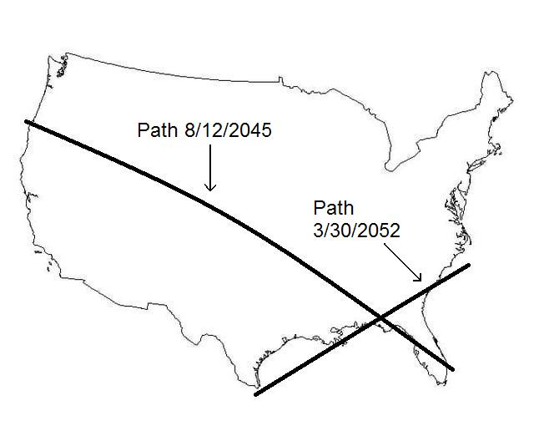

As you can see it's about 30 years in the future from 2016.

But how does it relate with the other 4 Tavs?

The Promised Land & the Tavs

Let's first look at Tavs #1 and #4 and the region of the earth that they portion off. This particular discovery concerning the region partitioned off by Tavs #1 & #4 was made by author Daniel Matson as I was in communication with him concerning the four Tavs. As you can see, the land promised to Israel is marked off by our Creator Elohim using the solar eclipses. Link to Daniel Matson's site: http://watchfortheday.org/godspartitionplan.html

Link to a video that Daniel Matson produced concerning Tavs #1 and #4: https://www.youtube.com/watch?v=lnR90TWiyc0&feature=youtu.be

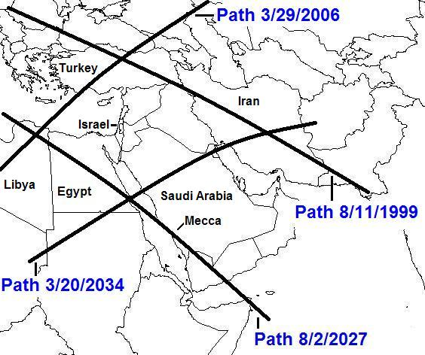
The graphic above shows the eclipses marking out the land portioned out to the descendants of Abraham (Isaac and Ishmael), with that portion allotted only to Jacob being in the center.

It's interesting that the center date of the first eclipse on 8/11/1999 and the final eclipse on 3/20/2034 is 11/29/2016. November 29, 2016 is the 69th anniversary of the UN partitioning of the Promised Land into Arab and Jewish sections. Actually, 69 full years are completed on 11/28/2016 and the 70th year begins 11/29/2016. The number 70 in scripture denotes a fullness, or completion, 7 x 10, with 7 indicating completeness and 10 indicating perfect completeness.

Not only do our Creator Elohim graphically point to boundaries of the Land promised to Jacob and his descendants using solar eclipse sequences, our Creator Elohim also point to the beginning of the 70th year of the partitioning of that land. Man has been warned in scripture by his Creator, YaHuWaH Elohim, not to divide the land allotted to Israel.
The Land Partitioned by Tavs #3 & #5:

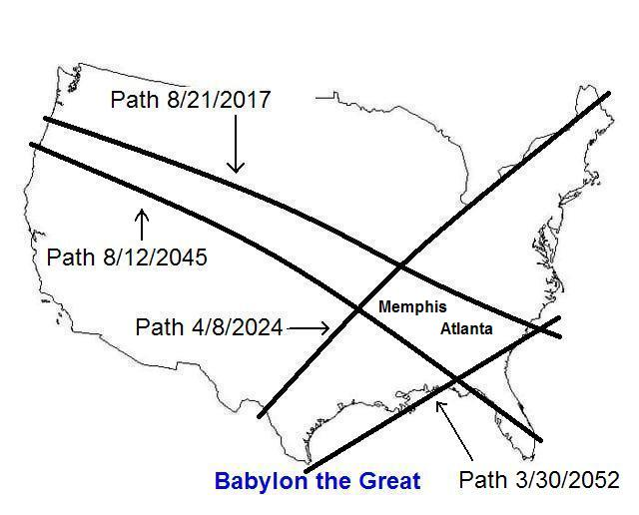

The part of the earth sectioned off by our Creator Elohim by Tavs #3 & #5 is a part of the "bible belt" of the United States.

If we recognized paganized Christianity as being truly "antichrist" in nature, then we might see the region in the Middle East as the "promised land" (Israel) and the other region in the United States as perhaps "anti-Israel" or "another Israel". Or we might recognize harlot paganized Christianity as the "Rahab" of Jericho. The whore Rahab hid the two spies sent by Yehoshua to spy out the land, and because of her help, she and her family were saved alive, being removed to a place of safety by Yehoshua when Jericho was attacked and everyone else killed.

Although Christians would not count themselves the enemy of Israel's God, they unwittingly are. Ezekiel chapters 8 and 9 reveal that a sword begins slaying in the Temple in Jerusalem and then moves outward. The Islamic sword began slaying in Israel and is now moving into the entire world. The command given by YaHuWaH Elohim was to slay everyone, men, women, and children, who practiced idolatry, the worship of the sun, and weeping for Tammuz. These pagan practices are inherent in Christianity today. YaHuWaH Elohim has not changed. Christianity has changed from what it was in the 1st century. It no longer observes the instructions (Torah) of YaHuWaH Elohim. Ishmael will live by his sword, and be used by YaHuWaH Elohim in judgment on all peoples, including paganized Christianity and Judaism. Please read Ezekiel chapters 8 & 9.

As far as I know, the 5th Tav is the final and last in the sequence which began in 1999.

Those two regions of the earth, the Promised Land in the Middle East and the region in the southeastern United States, are the only two regions on earth partitioned off by the Tav eclipses.

The central date of all 5 Tav eclipses is December 5, 2025.

