RSAI 2023 Legislative Priority:
Rural School Staff Shortage and Educator Quality

Background: Although rural Iowa schools are full of excellent teachers dedicated to student success, conditions in rural Iowa are making it difficult to attract and retain great teachers, including school employees in many different job roles, and it’s getting worse.
Many content areas are experiencing a shortage, especially at the secondary level. The Iowa DE compiles a list of areas with staff shortages annually. The list for 2022-23 includes the following, with new content areas this year underlined: deaf or hard of hearing impaired, visually impaired, special education (both II BD/LD and ID and I mild/moderate K-8 and 5-12), family consumer sciences 5-12, all world language, industrial technology, agriculture (5-12), all science (5-12), business (5-12), school counselor (K-8 and 5-12), mathematics (5-12), physical education, teacher librarian (K-8, 5-12 and K-12), early childhood education, earth science, physics (5-12), English language arts, music, art and all social studies. https://educateiowa.gov/pk-12/educator-quality/practitioner-preparation/teacher-shortage-areas. Almost all districts in Iowa are struggling to find bus drivers, paraprofessionals, office staff, and food service workers.
When there are shortages, the market tends to draw teachers away from rural areas that may lack social or entertainment amenities to higher-paying urban and suburban districts. Fewer qualified candidates are applying to fill vacant and mandated positions, and sometimes no candidates at all. Private-sector competition is also compelling. Iowa’s employers are looking for a strong work ethic, communication skills, and the ability to get to work on time. The Future Ready Workforce list of High-Demand Jobs includes educators. Iowa was facing a teacher shortage before 2020; however, the effects of the global pandemic have amplified the shortage with staff retiring earlier than planned, retired teachers more reluctant to return as substitutes, increased needs for qualified staff to cover when teachers are sick, combined with increased educational and mental health needs of students.

Teacher Shortage Data:
- The gap between Iowa Average Teacher Salary and the National Average, as reported in the 2021 Iowa Condition of Education Report, in 2020 was $5,949 (in 1988, the gap was $3,182). The estimated gap for 2021-22 places Iowa’s average teacher pay at $7,135 below the national average. Higher pay for teacher leaders, paid as much as $10,000 more for additional work through TLC plans, has helped to improve our average pay ranking since 2015. Iowa ranked #22 in 2018, however, Iowa slipped to #24 by 2021. From the 2021 Iowa Condition of Education Report: “Iowa’s average regular teacher salary increased slightly to $58,771 in 2020-2021 compared to $58,110 in 2019-2020. Iowa’s average salary is 24th in national rankings and 6th when compared to other Midwestern states in the 2019-2020 school year.” RSAI’s concern is that the gap continues to widen, with the Iowa teacher pay gap now 49% more behind the national average than in 2018-19.
- With significant teacher shortages across the nation, beginning teacher pay is critical in keeping Iowa graduates in Iowa and attracting graduates from other states. Iowa is in the second to lowest quintile and has slipped 8 places in recent years, now ranking 38th in starting teacher pay. Source: Understanding Teacher Compensation: A State-by-State Analysis

- Fewer teacher preparation candidates are graduating from colleges and universities of education, as reported in Teacher Retention and Recruitment: Shortages in Iowa/Nation, 50-state Comparison of Strategies, Education Commission of the States. In the Midwest states alone, between 2008-2017, there were 8,183 fewer graduates, for a loss of 17%. The following chart, compiled by Iowa School Finance Information Services, shows the nationwide data, which is even more drastic and predates COVID pandemic stressors on teacher supply.
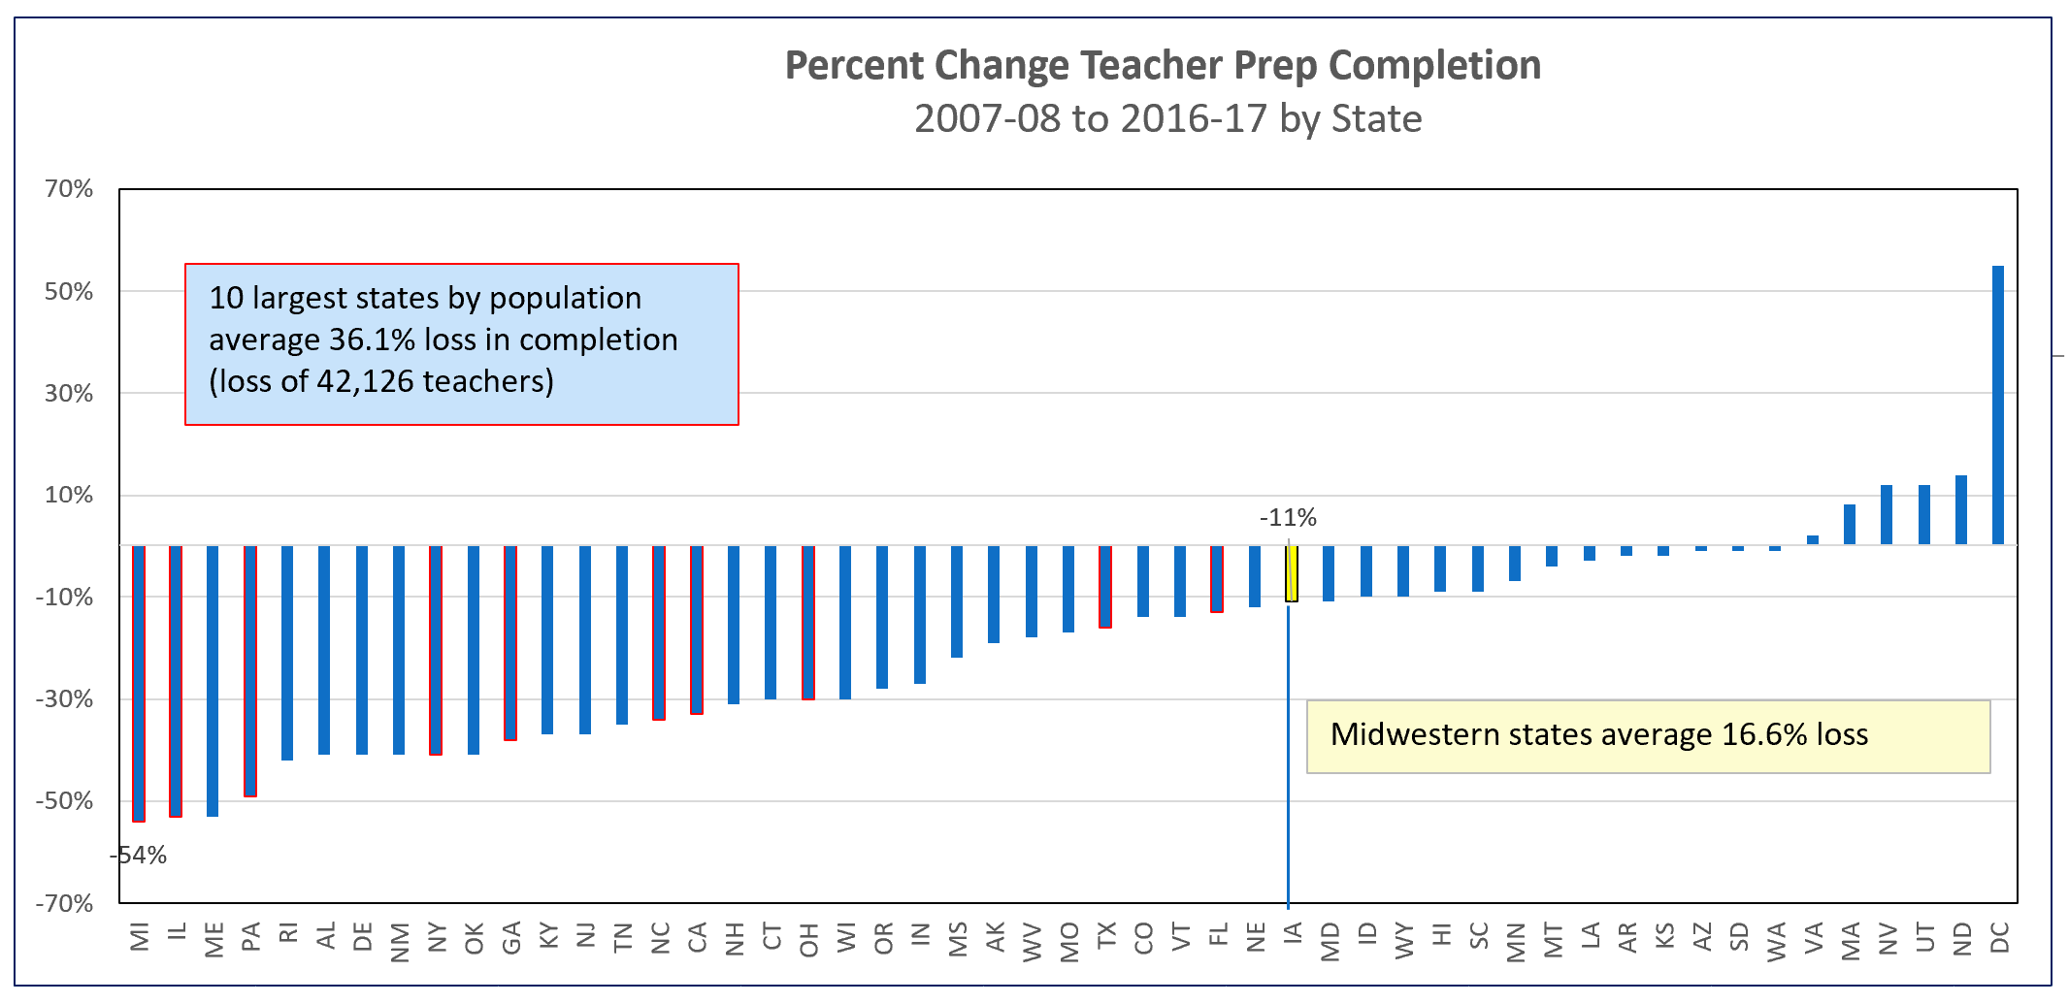

Current Reality: The qualified worker challenge is more difficult in rural Iowa:
- The implementation of the teacher leadership and compensation system increased the demand for teachers to fill vacant positions to replace teacher leaders. TLC may also have slowed the pipeline of individuals willing to take on the work of school administration.
- Some rural schools have been able to help a willing and capable teacher obtain certification in a shortage area of content, but the rules limit provisional licensure status to two years. Access to fewer colleges and universities within a short distance adds to this burden. Tuition and costs of coursework may be unaffordable for lower-paid rural teachers and nearly unattainable for new teachers, given the level of starting pay in a rural area and ongoing college loan payments. RSAI is excited to be participating in Gov. Reynolds Teacher and Paraeducator Registered Apprenticeship Program, with a consortium through which 40 school districts are accessing federal pandemic funds to help participants become certificated or degreed over the next 2-3 years. State appropriation may be necessary to keep this program going.
- Some community members, dedicated to the rural area in which they live, may be willing to teach in areas of their expertise but can’t afford to quit working for two years to become certified in teaching. Some programs in CTE areas have provided avenues to on-the-job training, a good model which could be expanded. Other teacher-intern models would be helpful but must include student teaching and ongoing mentoring and support.
- Beginning January 1, 2022, educators new to Iowa receive licensure reciprocity for their valid teaching, administrator or coaching license from any other state. Additional authority and a funding stream for recruitment programs, such as loan forgiveness, is critical to help address the teacher shortage.

Education Staff Shortage: In addition to sufficient SSA, strategies to rebuild Iowa’s education workforce must address two areas during an unprecedented staff shortage:
- Recruitment: to rebuild the pipeline of interest into education, the Legislature, BOEE and DE must provide additional flexibility for school districts to provide hiring incentives, ongoing investment in CTE programs for high school students to study and experience work in education, provide resources for grow-your-own educators and appropriate certifications, provide means-tested tuition assistance and minimize the economic costs of unpaid student teaching, provide more loan forgiveness, and change the culture of political speech to restore education to a respected profession.
- Retention: to slow the out-migration of staff from schools to other professions or retirement, the Legislature, BOEE and DE must provide maximum flexibility to hire staff to deliver great instruction; additional flexibility for retention incentives, flexibility to meet offer and teach requirements, opportunities for teaching expanded courses within existing and/or competency-based licensure, institute a special education generalist credential, allow districts to hire retirees without a negative IPERS impact, and maintain the commitment to resources for mentoring, training and supporting staff.
- In both the short and long term, legislation, policy, and public support will not only provide improved compensation for educators but must also foster the respect for the education profession that is well deserved. Only when we are able to do this will Iowa be able to have adequate numbers of quality individuals educating our children.

