**Annual Meeting - April 10th at 6 PM**

The annual meeting for the Farm at Creekside HOA will be held on Wednesday, April 10 at 6pm.

Topics will include but are not limited to: replacement board members, hiring a bookkeeper to manage the books, social events, and financials. Please see the website (<http://www.fachoa.org/>) for a proxy form if you are unable to make. You can give the form to any of your neighbors coming or any one of the board members. Email [hoa@fachoa.org](mailto:hoa@fachoa.org) with any questions.

**Pictures of Christmas Holiday Yard of the Month**

The pictures accidentally got left out of the newsletter last time. Please enjoy the lovely photos of the winning yard from Dwayne and Gloria Strong. Apologies for the oversight.

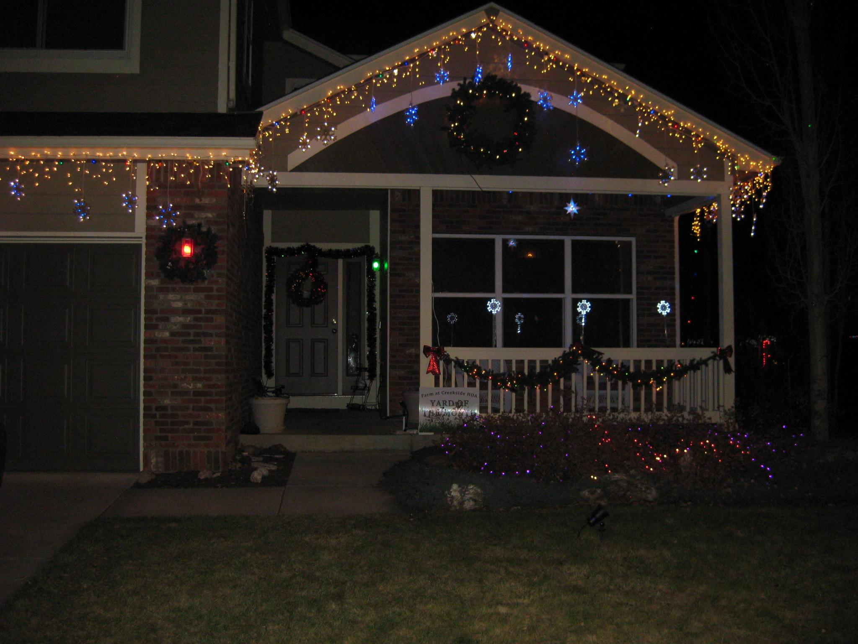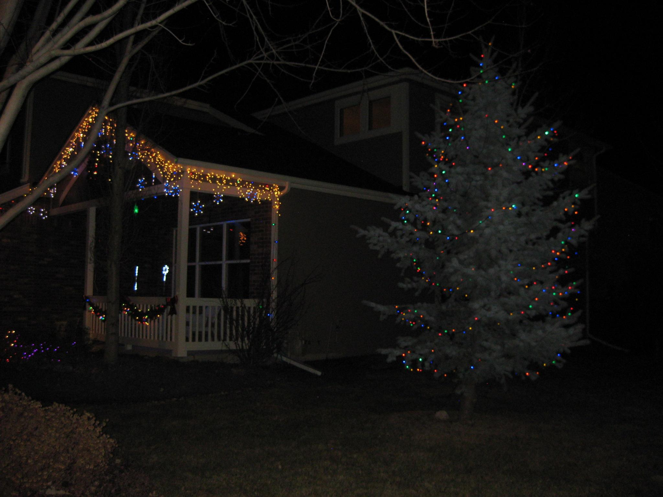

**OktoberFest Winner - Brewer for a Day**

Back in 2018, we announced that Tim Wawrzynczak had won the first prize of guest brewer at Großen Bart Brewery. He was able to brew with the head brewer there at the end of January and soon his baltic porter will be available, possibly within the next 2 to 3 weeks. Go check it out and let him know how it is.

**Easter Egg Hunt - April 20th**

The annual Easter Egg hunt will be held Saturday, April 20th at 10 am. Please come join your neighbors for the traditional hunt, snacks and drinks, crafts and fun!

If you are available to help with any setup, cleanup or filling eggs, email soc@fachoa.org

**Upcoming Vacant Board Positions**

The board is currently planning on holding the next annual meeting around the March timeframe, as we have in the past. There will be 2 vacant positions. The terms for Vann, our current treasurer, and Adam, our current president, are expiring and we will need to find 2 additional board members to replacement them on the board. New members will not immediately take over those positions, the board will vote on new positions after the annual meeting. Email [hoa@fachoa.org](mailto:hoa@fachoa.org) if you are interested in learning anything more or pay attention to the newsletter for more information about the annual meeting.

**Neighborhood Car Break-ins**

There have been more reports of thieves breaking into unlocked cars at night. Please take care to secure your cars and garages, especially overnight. Please report any suspicious activity to the Longmont Police department.