On 11/6/17 through 11/10/17 I went to a number of sites in the Mojave Desert area to locate new places to go on field trips. I consulted other rock club website, old magazine articles and general internet research. I found about a dozen likely prospects. I decided to start out on the eastern edge of the Mojave and work my back to my base in Barstow.
Clouds on the first day during a traffic jam on the I-215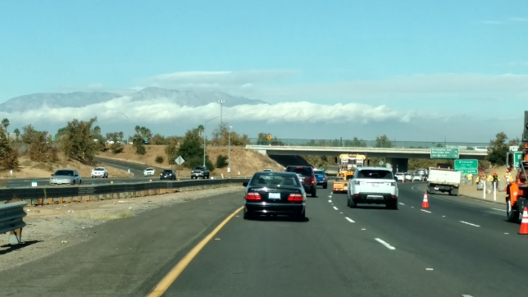
November 6th was a travel day, but I thought I would squeeze in a quick trip to the area around Calico Ghost Town and check out the plain below the hills along Mule Canyon Rd. I did not find much, but I did find one nice piece of my favorite yellow and moss agate. This piece was collected about 2 miles from the hill where it comes from.
Calico red and yellow moss agate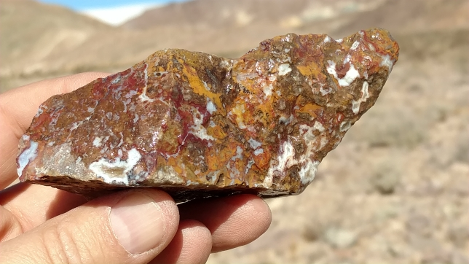
November 7th saw me hitting the road to the Lake Havasu area. I happened to drive by a BLM field office and stopped in for some advice. They gave me some nice maps of the area and said nice agates could be found in the Sawtooth Mountains just down the road. The scenery was nice, but I didn’t find anything, so I went on to the Lake Havasu area.
Sawtooth Mountains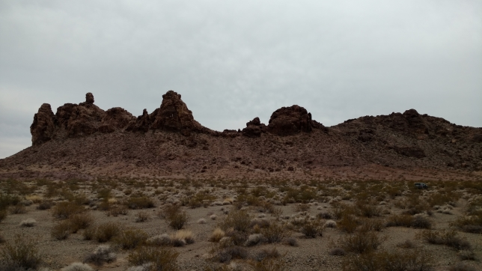
Lake Havasu opalite hill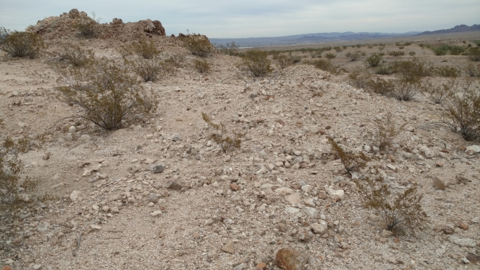
Some internet research revealed a site for opalite by Lake Havasu. This was precisely where it said it would be. The white hill stood out from the other hills along the dirt road, so I went in to investigate. It did not take long to find opalite (opal cemented together with agate).
Lake Havasu opalite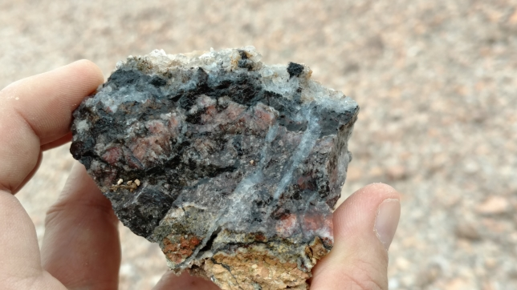
Lake Havasu opalite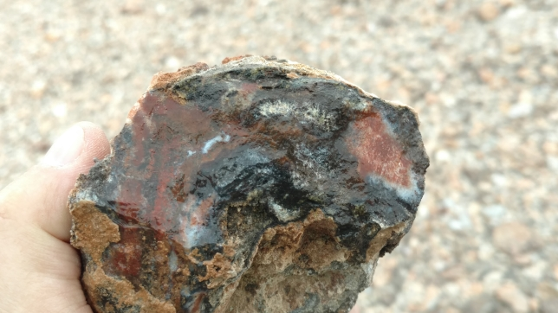
Lake Havasu opalite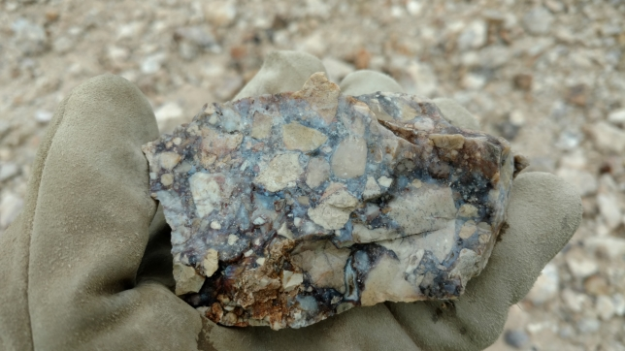

Barrel cactuses on opalite hill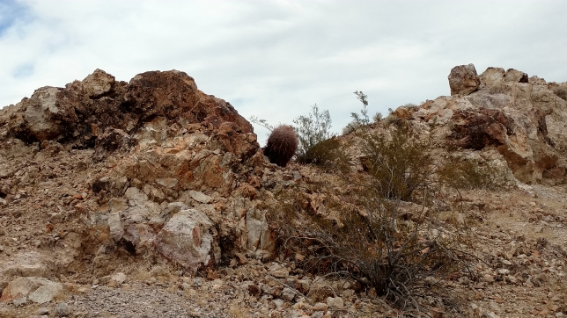
The prettiest material I found on this hill was white and cream pieces of opalite cemented together with a wine read agate. I am still working on my first test cabs of this material. So far, I can say this material is very hard and looks like it will take a mirror polish.
Lake Havasu in the distance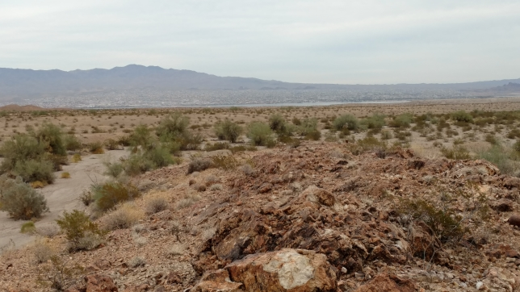

November 8th started out searching for pink seam agate. This involved traveling a long distance on remote dirt roads with unknown cell service. Looking back, it was not my best idea to go to such a remote location alone. At one point I was traveling along an active railroad and I saw an older former railroad off to one side.
Former railroad bed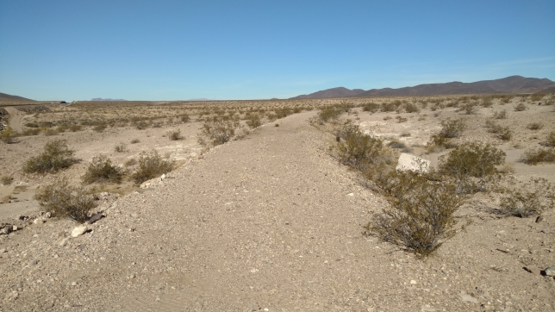
Tunnel under former railroad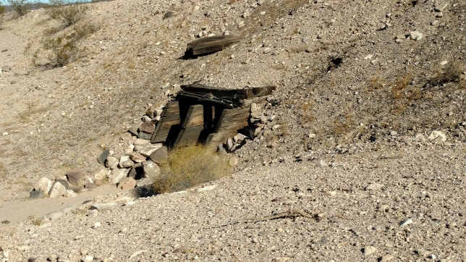
Tunnel under former railroad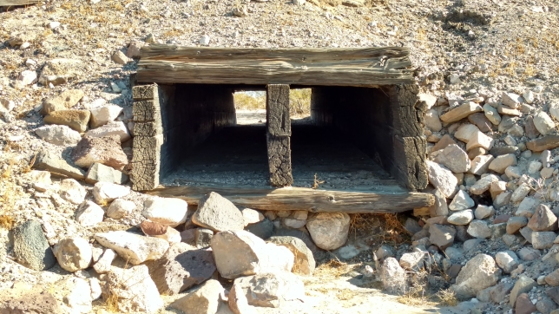
Nuts and bolts beside the railroad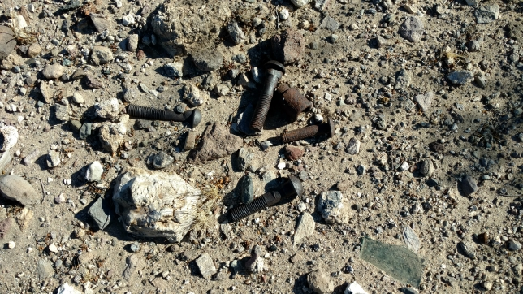
One of the limitations of trip reports is that they usually only talk about the road that takes you to where the cool rocks are. They don’t talk about all of the other roads in the area that go to different places. This was the case heading to the pink seam agate site. There was no shortage of unmarked dirt roads in the area and it was a challenge to find the right one. Sometimes I had to engage the 4-wheel drive to travel down a sandy wash. In the end I found what I was looking for, but there were some tense times.
Seam agate on the side of the road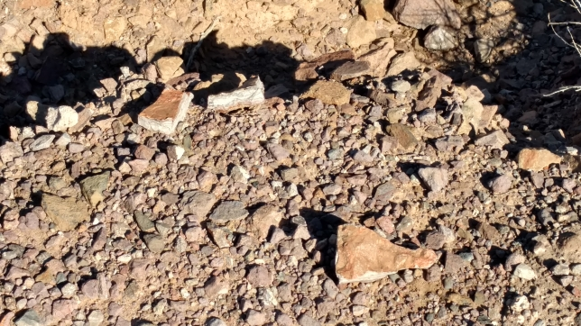
Yummy pink seam agate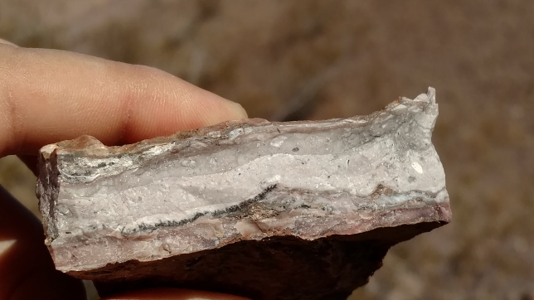
It was an easy climb up a small hill to where the pink seam agate was weathering out of the hill.

Pink seam agate hill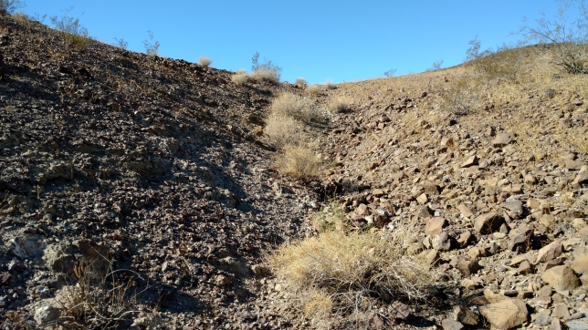
Chunks of seam agate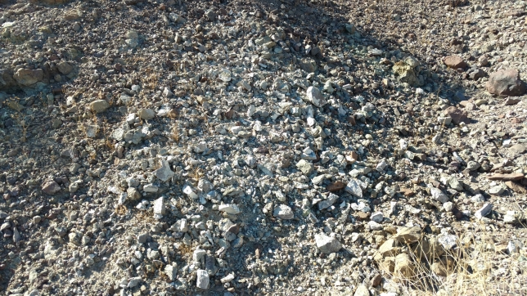
After getting my fill of the seam agate I drove to the next site to the east, the crater at Amboy. Amboy was a stop on the rail line and the town there is nearly dead.

Cinder cone on the way to Amboy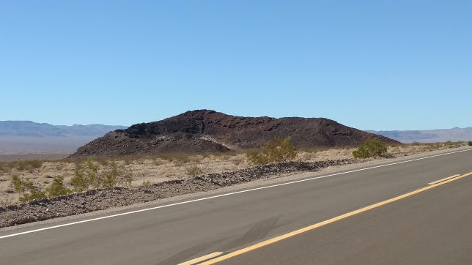
Another cinder cone by Amboy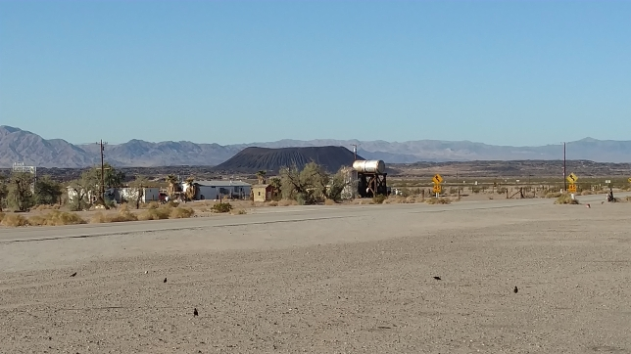
Amboy’s single café, gas station and hotel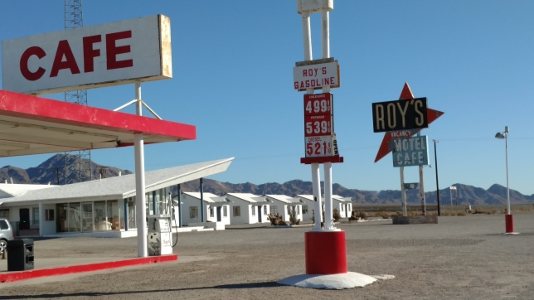
Amboy’s closed school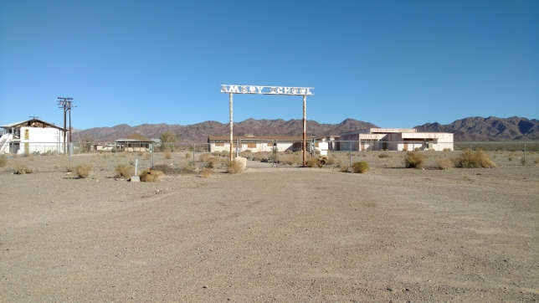
A few miles outside of Amboy is a cinder cone that is the site of a former cinder mine. This is the gasy lava you see in bar-b-ques. Somehow they did not pay much attention to the small peridot crystals in rocks on the same volcano.
Peridot area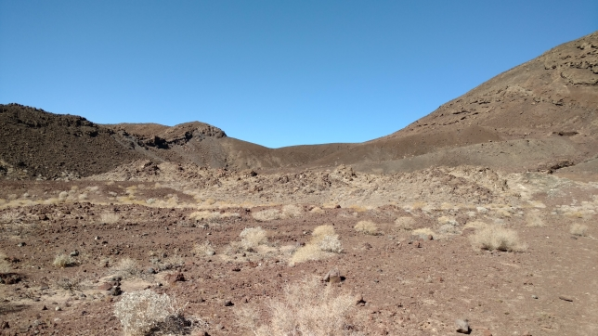
Collapsed mine works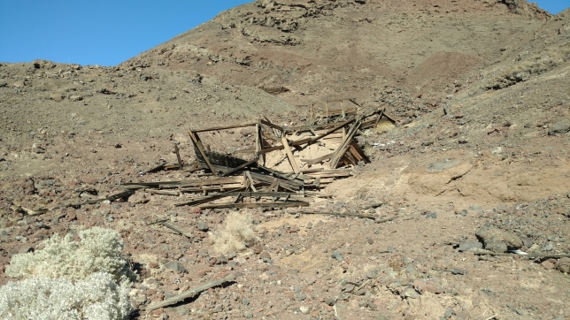
Collapsed mine works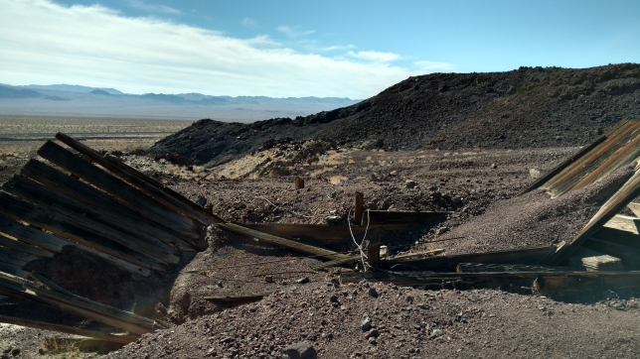
The peridot crystals form in clusters in pockets in the volcanic rocks. An hour’s work filled my back pack. I found a friendly man who was checking the passing railroad cars for fires. He decided to walk up the hill and collect peridot with me. He was amazed that he had driven by this site for years and did not know anything about it. The peridot may be cab-able if stabilized. I think it would really pretty if you could make a cab with all those small crystals.
View from peridot area to my car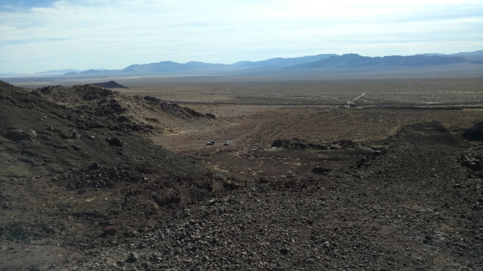
Peridot crystals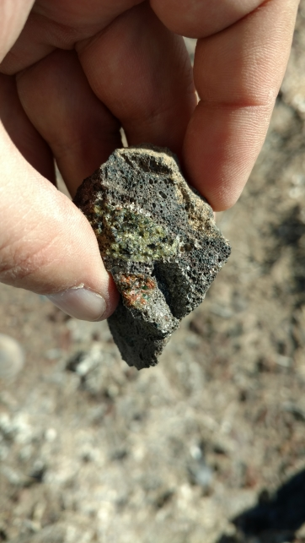
The End

