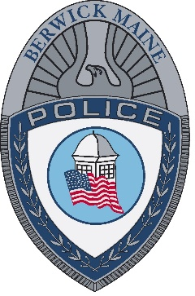
Our Mission

The mission of the Berwick Police Department is to safeguard the lives and property of the people of our community while upholding the United States Constitution, the Constitution of Maine and the Ordinances of Berwick. We will continually strive to enhance the quality of life by reducing the incidence of fear and crime while partnering with the citizenry to pursue this goal.

