5/16/2017 The Anointed One

YaHuWaH Elohim continues to reveal interesting timing relationships concerning His people Israel and world leaders.

President Donald Trump is scheduled to soon make his first official international tour. The timeline below reveals several interesting facts that will probably go unnoticed by many. Most Jews and Messianic believers follow the Hebrew Hillel calendar. There are few believers who will use the ancient method of actually sighting the new moon from Israel in order to determine the 1st day of the new month. The ancient practice of seeing the new moon is called the Karaite method of determining the new month.

The graphic below indicates days using the ancient Karaite method. The Hillel calendar in 5/2017 is one day off from the Karaite day count. What most Jews count as 28 Iyyar, the 28th day of the 2nd month, is 27 Iyyar using the Karaite method.

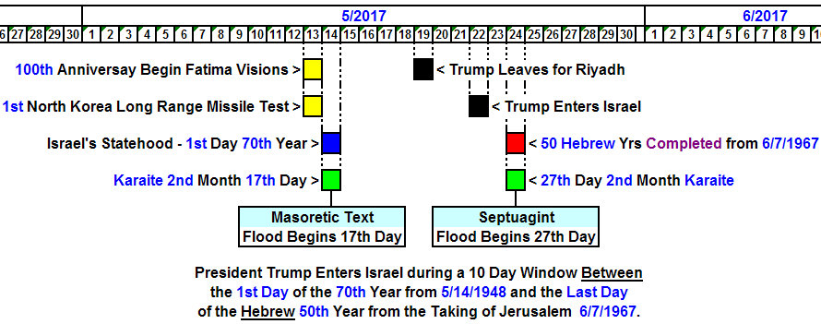

The Yellow Blocks in the Graphic Hint at Nuclear Destruction

We will first examine the events indicated by the yellow blocks in the graphic above, a day prior to Israel's 69th anniversary as a sovereign nation (according to the Roman Calendar, not the Hebrew Hillel calendar). Actually, 5/13/2017 at midnight was the complete filling up of 69 inclusive Roman calendar years from 5/14/1948 when Israel announced its sovereign Statehood.

5/13/2017 was the 100th anniversary of the beginning of a series of monthly visions given to 3 shepherd children in Fatima, Portugal, in 1917. The final vision, known as the Miracle of the Sun, occurred on 10/13/1917, 153 days after the first vision. The colors radiated during the miracle of the sun on 10/13/1917 were similar to those colors of yellow, red, and purple, described by observers of the test of the 1st atomic device, called the Trinity Test, on 7/16/1945.

Both the sun itself, being a continually ongoing nuclear reaction, and the colors involved in the Fatima miracle hint at nuclear destruction. The very first atomic weapons used in combat were used against Japan, the "land of the rising sun".

Cyrus was the King of the Persians who conquered ancient Babylon in 539 BC. The ancient Persians are now modern Iran. The name "Cyrus" means "like the sun", and his Hebrew name Koresh, is the surname taken by Vernon Howell (David Koresh) who was burned alive with members of his congregation by agents of modern Babylon on 4/19/1993 as a sign of things to come from YaHuWaH Elohim.

On 5/13/2017 North Korea launched it's very first long range missile. North Korea has threatened the United States with nuclear destruction many times through the years, and the missile test of 5/13/2017 was of great concern to government officials.

The above mentioned missile launching event occurring on the very eve of the 1st day of Israel's 70th year indicate the ominous events to come for Babylon the great. YaHuWaH Elohim declares the end from the beginning.

Isaiah 46:9 Remember the former things of old: for I am Elohim, and there is none else; I am Elohim, and there is none like Me,
10 Declaring the end from the beginning, and from ancient times the things that are not yet done, saying, My counsel shall stand, and I will do all My pleasure:

The Blue Block in the Graphic Above

The blue block in the graphic above indicates the 69th anniversary of the announcement of modern Israeli Statehood on 5/14/1948, and the very 1st Day of Israel's 70th year as a modern sovereign nation.

The 70th year of Israeli Statehood should concern us because YaHuWaH Elohim says in Jeremiah 29:10 that after 70 years of Babylon's involvement with Israel, He will visit Babylon and cause Israel to leave.

We're told in the book of Revelation chapter 18 that Babylon will be destroyed by fire in one hour, while those witnessing the destruction from ships will stay far away for fear of the destruction.

Notice that one of the green blocks in the graphic above indicates that 5/14/2017 also happens to be the 17th day of the 2nd biblical month according to the ancient Karaite method of determining the beginning of the Hebrew month.

According to the Masoretic Text used by most modern bibles, it was on the 17th day of the 2nd month in Noah's day that the flood waters began to cover the earth. The position of the 1st month was changed from the autumn to the springtime by YaHuWaH Elohim at the time of the Exodus from Egypt about 3460 years ago. It may be significant that the 17th Karaite day of the 2nd Hebrew month in 2017 just happens to fall directly on the 1st day of the 70th year of modern Israel's existence.

The Red Block in the Graphic Above

The red block in the above graphic indicates the complete filling up of 50 Hebrew years from 6/7/1967 when Israel took Jerusalem from Jordan in the Six Days War. The 50th year after Israel entered the land was known as a Jubilee year.

The day 6/7/1967 was the Hebrew Hillel calendar and Karaite date 28 Iyyar. 5/24/2017 is 28 Iyyar on the Hillel calendar, but is 27th Iyyar according to the Karaite actual sighting of the new moon by witnesses. Karaite 28 Iyyar would be 5/25/2017 and the 50th anniversary of 28 Iyyar 1967 (Roman 6/7/1967). However, 50 complete Hebrew Karaite years are filled up on Karaite 27 Iyyar 2017, 5/24/2017.

Note that 5/24/2017 also happens to be the 27th day of the 2nd month according to Karaite reckoning. The Septuagint, about 1000 years older than the Masoretic Text, records that Noah's flood began on the 27th day of the 2nd month.

It may be significant that the 27th day of the 2nd month in 2017 falls directly on 5/24/2017, the very day that fills to the full exactly 50 complete Hebrew years from 6/7/1967.

The Anointed One Arrives in a Jubilee Year

Many people expect the Messiah to arrive in a Jubilee year.

We must now refer to the black blocks in the graphic above that indicate that Donald Trump will enter Israel less than 72 hours before the expiration of the Hebrew 50th, "Jubilee", year from 6/7/1967.

President Trump is entering Israel during a 10 day window between the 1st day of the 70th year from 5/14/1948 and the expiration of the 50th Hebrew year from 6/7/1967.

Note that the Hebrew word "moshiach", messiah, means "anointed one". According to the Hebrew text, Moses' brother Aaron was a moshiach, an anointed one.

Please watch the video at this link, courtesy Thomas Tanner, for an explanation of an anointed leader, a Moshiach Nagiyd, mentioned in the book of Daniel.

Video Link: https://www.youtube.com/watch?v=u5fvf8CkPqU&feature=youtu.be

Compare the hounding of David by King Saul with the same sort of experience that President Donald Trump continues to experience daily. An anointed one will survive, not by his own power, but by the power of YaHuWaH 's Spirit. Just as the idolatrous King Cyrus was anointed of YaHuWaH Elohim to deliver Israel, so might others also be anointed by YaHuWaH Elohim to accomplish His will on the earth. It might be that President Donald Trump has been anointed, whether for good or for bad, to accomplish the will of YaHuWaH Elohim toward Israel at this time.

Keep in mind that his conception date appears to be on or around the Day of Trumpets 1945, his name is Trump, and he was placed in the Presidency by YaHuWaH Elohim to the great amazement of his opponents.

We need to walk with YaHuWaH Elohim and to watch.

Summary

We're probably about to soon witness some very extraordinary end time events, considering that we've entered Israel's 70th year, but most people probably won't notice much happening.

