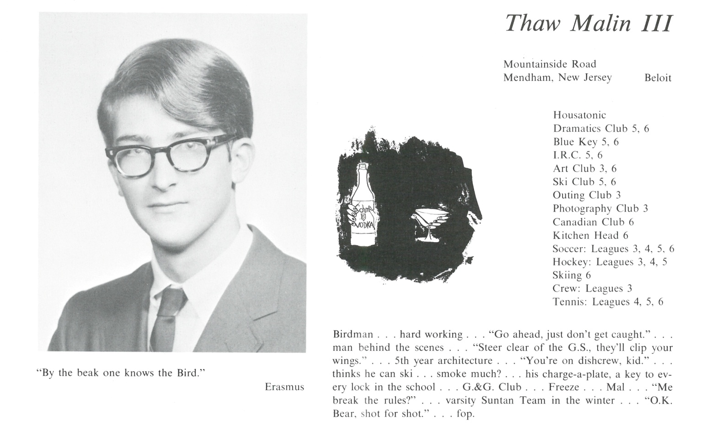

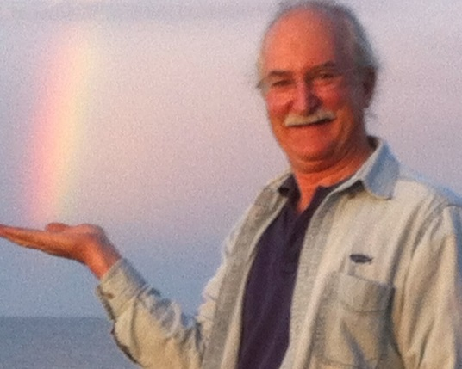Beloit College, BA ’71, Univ. of Georgia, MFA ’74.

Moved to Martha’s Vineyard 1974. Supported myself painting since graduation. First exhibition as a watercolor artist, 1975. Privately taught watercolors for 20 years. Survived one semester as a high school art teacher.

Built my own solar envelope house, 1979. Married, 1986. Divorced, 1990. 1995 got bifocals, switched to oil painting. Remarried, 2002. To spend more time with my parents in their last years, divided the year between Martha’s Vineyard and a ranch outside Fort Worth, Texas from 2005-2010.

Reinvented myself as a painting-a-day painter. Divorced. Posted every day online and sold most of my small oil paintings through eBay, Facebook, Twitter and ThawMalinArt.com from 2006 until 2014.

At the end of 2013, met the woman of my dreams. Since then have been on sabbatical from painting, building our own private Giverny and life together. We have co-created a swimmable natural pond, two acres of landscaped ornamental and edible gardens, and the interior design completing an addition and a new barn in West Tisbury on Martha’s Vineyard. The mutual goal is to be back painting full time – but no longer a painting a day, and together – by midsummer’s eve …

Thaw Malin III, 19 Skiffs Lane, West Tisbury, MA 02568-7517; Mobile (508) 560-4437.



______________________________________________________________

______________________________________________________________ ______________________________________________________________ ______________________________________________________________ ______________________________________________________________ ______________________________________________________________ ______________________________________________________________ ______________________________________________________________ ______________________________________________________________

Attach Picture in .jpg Format

______________________________________________________________

______________________________________________________________

___________________________________________________________________________________ _________________________________________________________________________________________________________________________________________________________________________________________________________________________________________________________________________________________________________________________________________________________________________________________________________________________________________________________________________________________________________________________________________________________________________________________________________________________________________________________________________________________________________________________________________________________________________________________________________________________________________________________________________________________________________________________________________________________________________________________________________________________________________________________________________________________________________________________________________________________________________________________________________________________________________________________________________________________________________________________________________________________________________________________________________________________________________________________________________________________________________________________________________________________________________________________________________________________________________

___________________________________________________________________________________