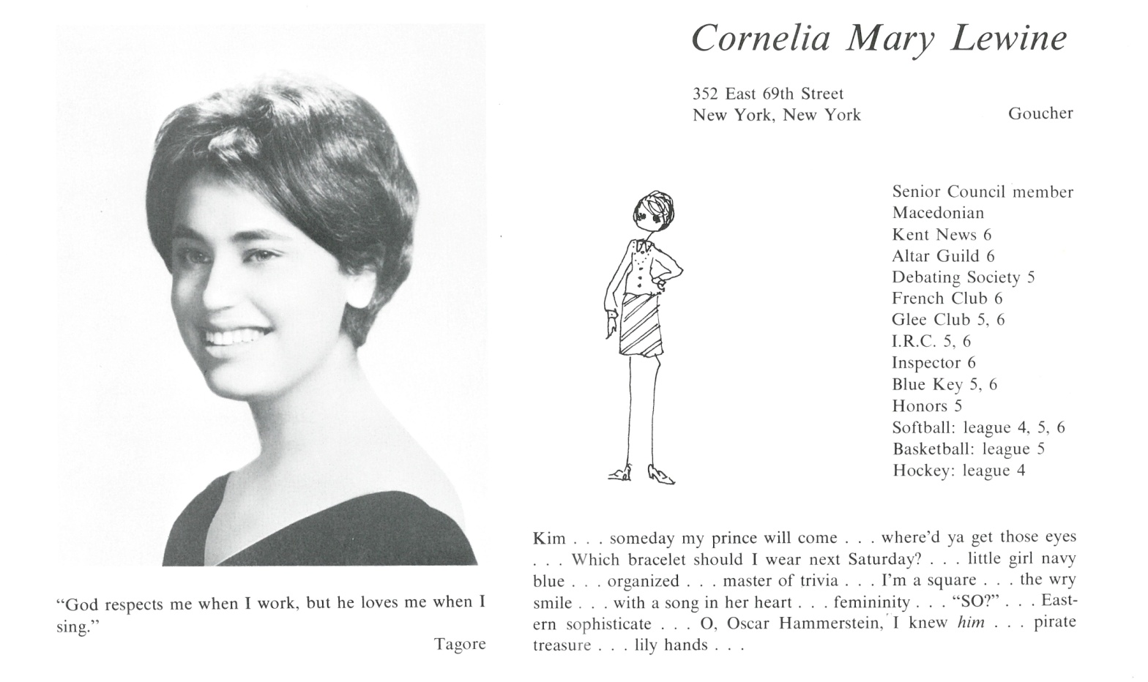

Cornelia M. Lewine Fortier

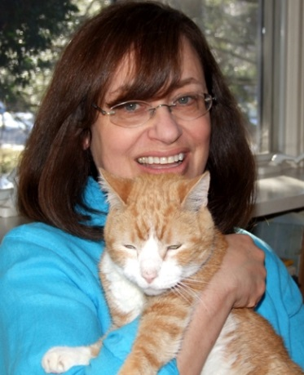After college (Goucher, in Baltimore and then NYU) I lived and worked in NYC (in radio and publishing) for a while before moving to Boston in 1979, starting a job at WGBH-TV, the public TV station there. I worked on many of the station’s shows during my seven year stint and also met my husband, Russ Fortier, who was a director there. We married in 1986 and, the same year, moved to Long Island, NY, when he began a job at the public TV station there before moving on to ABC in New York. Our son was born in 1992 and shortly after, we moved to Westport, CT.

Career-wise, I migrated from television production to TV writing, then was a print reporter for a while, wrote scripts and did PR until 2004 when I was offered an editing/writing job at a web startup. By the time I retired in 2016, I had worked for four web startups, an interesting and unexpected chapter in my professional life.



______________________________________________________________

______________________________________________________________ ______________________________________________________________ ______________________________________________________________ ______________________________________________________________ ______________________________________________________________ ______________________________________________________________ ______________________________________________________________ ______________________________________________________________

Attach Picture in .jpg Format

______________________________________________________________

______________________________________________________________

___________________________________________________________________________________ _________________________________________________________________________________________________________________________________________________________________________________________________________________________________________________________________________________________________________________________________________________________________________________________________________________________________________________________________________________________________________________________________________________________________________________________________________________________________________________________________________________________________________________________________________________________________________________________________________________________________________________________________________________________________________________________________________________________________________________________________________________________________________________________________________________________________________________________________________________________________________________________________________________________________________________________________________________________________________________________________________________________________________________________________________________________________________________________________________________________________________________________________________________________________________________________________________________________________________

___________________________________________________________________________________