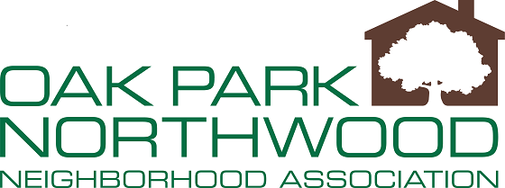

Board Meeting Agenda: August 17, 2021 ZOOM

- Call to Order
- Welcome Guests
- Approval of the Minutes of Meeting held July 20, 2021
- Treasurer Report
- Committee Reports
  - National Night Out Update
- President’s Comments
  - Fundraising
  - Bylaws
- Special Guest: Clayton Perry, D10 COSA Councilman
- New Business / Announcements
- Adjournment

