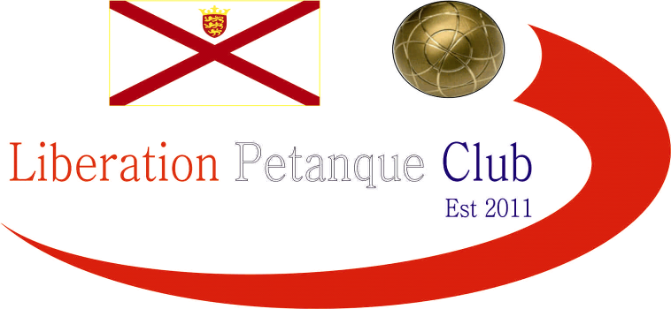

2024
International Doubles Open

A sell out 32 Doubles teams took part in day two of our International Open weekend.

Round one saw Eric & Julian leaving France for the first time, choosing Jersey for their first overseas competition. What a start beating club members Andrew & Lorna 13 – 0.

Last years runners up Andrew & Geoffroy started off well winning 13 – 5 over Colin & Lesley from the UK and last years winner Matt Ryan, playing with Toby also won 13 – 5 against Sandra & Grant from the UK.

European Fed Cup champions Benny & Gabriel Bel-Lafkih lost their first match against club members Gary & Wendy. Eli who was playing with Pauline from the UK though started off very well, 13 – 1 over Liz & Marietta from Ireland.

English veteran champions Ian & Simon started off well beating John & Tony and Adrian & Myra won against Brian & Colin.

Round two, saw Laurent & Jean make it back to back wins, but only just 11 – 10 as time ran out. Eli & Pauline made it two 13 – 1 wins for an amazing start.

Simon & Ian had a big win over Gary & Wendy and Adiran & Myra also won heavily for impressive starts and showing their experience.

Benny & Gabriel lost again to Graeme & Keith who had also lost in round one to Kevin & Paul from Carrefour.

Paula & Roger from the UK beat experienced club members Callum & Ross. Virgina & Michael from Irland beat Eliot & Paul from the UK for their first win.

Clive & Christine from the Petanque Events team in the UK beat players from the UK in Lesley & Colin and Julian & Eric just got over the line against Keith & Keith from Jersey.

Round three, saw two 13 – 0 results as Matt & Toby made it three wins in style beating Paula & Roger from the UK. Benny & Gabriel finally got their tournament underway over Brian & Mary from Ireland.

The lowest score of the tournament was a 9 – 6! win for Eric & Julian over Andrew & Geoffroy. Another one not going the distance saw Adrian & Myra just beat Eli & Pauline 11 – 10!

After their impressive round one win Gary & Wendy suffered their second loss 13 – 1 to Kevin & Paul.

Mo & Carolyn beat Grant & Sandra and John & Tony got their first win over Virgina & Michael. Ian & Simon handed Laurent & Jean their first defeat.

Round four, saw Matt & Toby make it four from four over tough opponents in Adrian & Myra and a surprise result, certainly score wise saw Ian & Simon beat Eric & Julian 13 – 1!

Margaret & Richard from Scotland beat Mary & Brian for a good win and Colin & Jim from Jersey playing in their first big competition beat Virgina & Michael.

Laurent & Jean got their third win by beating Eli & Pauline who suffered their second loss in a row.

James & Neil restored Liberations pride in beating Carrefour team Kevin & Paul. Wins also for Andrew & Geoffroy, Callum & Ross and Benny & Gabriel to name a few.

In the final Round to determine the top sixteen for the Main and the next sixteen players for the plate.

Matt Ryan & toby Northern topped the rankings with a dramatic win over Ian & Simon. After the two extra ends the match was tied at 12-12 with a great shot by Toby firing Ian & Simon holding boule out and also the Jack, which had to be replaced on its mark giving them the win. Ian & Simon dropping to third in the rankings.

Second place went to Paula & Roger who had been beaten 13 – 0 by the top ranked team in round three, but their 12 – 7 win over Andrew & Geoffroy gave them four wins and second place. Andrew & Geoffroy finishing eleventh with three wins.

Fourth place went to Adrian & Myra who recovered to win their last match for four wins over Laurent & Jean who finishing seventh and top of the teams with three wins.

Eric & Julian finished with four wins over James & Neil to take fifth place with James & Neil also qualifying for the main in eighth place.

Callum & Ross the last team with four wins, doing it in style 13 – 0 over Christine & Clive.

After a bad start Benny & Gabriel won their third place in a row to finish sixteenth and just make it to the main competition as the last team on three wins with Gary & Wendy missing out after losing 13 – 11 in their last match and John & Tony lost 13 – 12!

Final Swiss Rankings

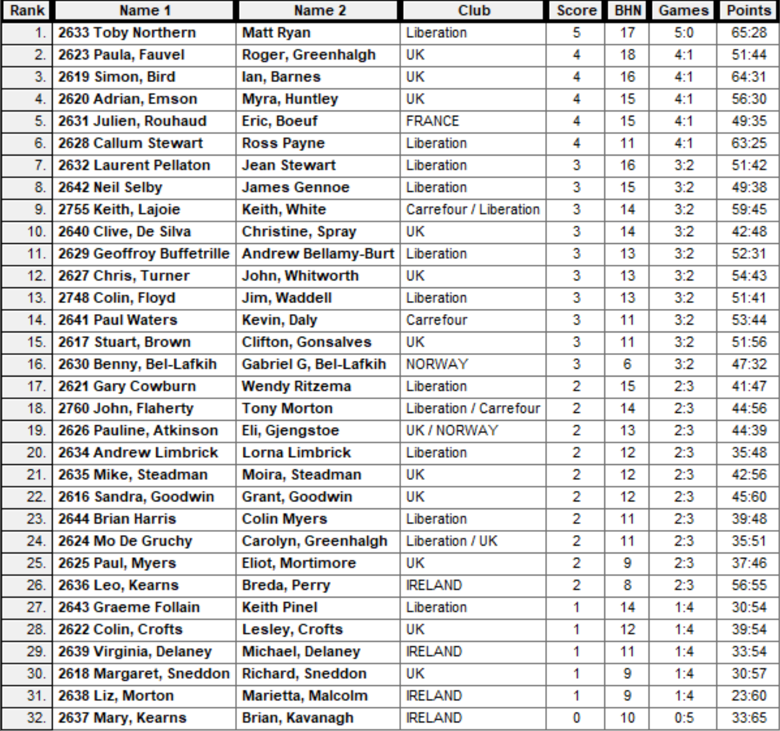

The Plate Competition

Last 16

Some teams in the Plate that had wins over the best teams as consistency was key in big competitions.

There was a 100% win rate for club members in the last 16 of the Plate as Gary & Wendy got back to winning ways 13 – 2 over Brian & Mary, John & Tony beat Liz & Marietta and Andrew & Lorna beat Michael & Virgina. Also wins for Graeme & Keith and Brian & Colin.

Eli & Pauline lost four straight matches as their went out to Margaret & Richard, Mike & Moira won a close match against Colin & Lesley and Paul & Eliot beat Mo & Carolyn.

Ranked 17th Gary & Wendy 13 v 02 Brian & Mary Ranked 32nd

Ranked 18th John & Tony 13 v 06 Liz & Marietta Ranked 31st

Ranked 19th Eli & Pauline 06 v 13 Margaret & Richard Ranked 30th

Ranked 20th Andrew & Lorna 13 v 04 Michael & Virgina Ranked 29th

Ranked 21st Mike & Moira 13 v 10 Colin & Lesley Ranked 28th

Ranked 22nd Grant & Sandra 08 v 13 Graeme & Keith Ranked 27th

Ranked 23rd Brian & Colin 13 v 08 Breda & Leo Ranked 26th

Ranked 24th Carolyn & Mo 07 v 11 Eliot & Paul Ranked 25th

The Plate Competition

Quarter Finals

A mixed bag from Gary & Wendy as either very good or not so good as they lost heavily to Eliot and Paul 13 – 3 to go out. Brian & Colin did though make the Semi-Finals of the Plate beat John & Tony 13 – 9, the closest score in this Quarter Finals.

Big wins for Graeme & Keith 13 – 2, and Andrew & Lorna 13 – 5.

Ranked 17th Gary & Wendy 03 v 13 Eliot & Paul Ranked 25th

Ranked 18th John & Tony 09 v 13 Brian & Colin Ranked 23rd

Ranked 30th Margaret & Richard 02 v 13 Graeme & Keith Ranked 27th

Ranked 20th Andrew & Lorna 13 v 05 Mike & Moira Ranked 21st

The Plate Competition

Semi Finals

A good win for Eliot & Paul, despite Paul not feeling too well, he managed to push through with Eliots help to make the Plate Final. Winning 13 – 9. A surprising easier win for Graem & Keith again winning big 13 – 5 over Brian & Colin.

Ranked 25th Eliot & Paul 13 v 09 Andrew & Lorna Ranked 20th

Ranked 23rd Brian & Colin 05 v 13 Graeme & Keith Ranked 27th

Brian & Colin took third place with a win over Andrew & Lorna 13 – 2! Despite being a long day a much closer final in the Plate but Eliot & Paul just made it over the line 13 – 10.

Fair play to Graeme having played nine full matches at over 80 years of age! Taking runners up with Keith.

2024 – Plate Winners – Eliot & Paul on the Right of the photo with Runners Up Graem & Keith on the left.

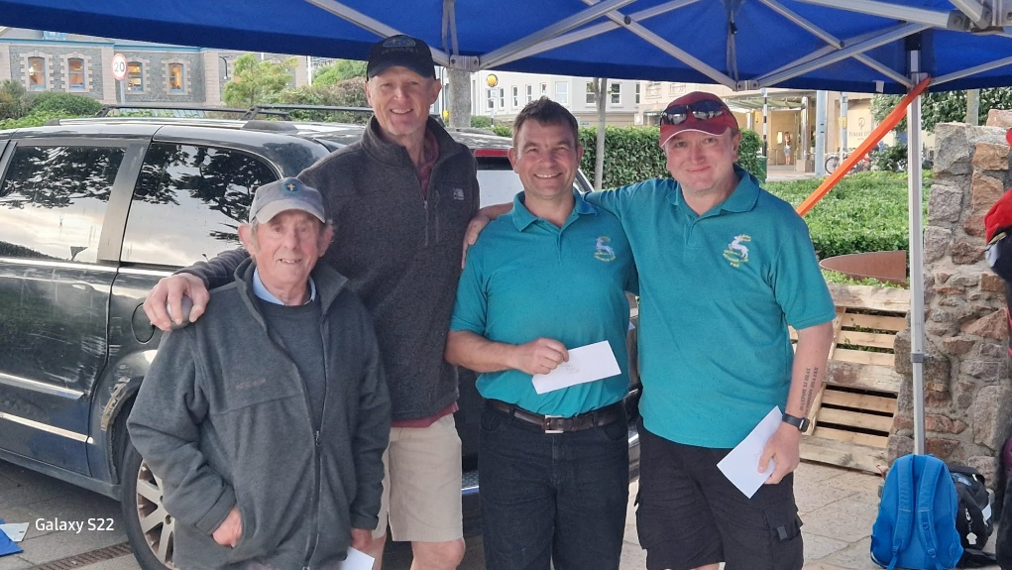

The Main Competition

Last 16

Well what a draw for the top ranked team in getting European champions who happen to finish 16th!

It was going well for Matt & Toby who were leading 10 – 7, before a nightmare end saw them lose a six and the match. Still topping the rankings some achievement and having beaten both teams who made the final.

Paula & Roger were having a great tournament and beat fellow players from England Clifton & Stuart.

Big wins saw Ian & Simon beat Kevin & Paul 13 – 0 and Andrew & Geoffroy beat Callum & Ross 13 – 1!

Wins also for Laurent & Jean and Neil & James. Big teams in Eric & Julian and Adrian & Myra also won as expected.

Ranked 1st Matt & Toby 13 v 10 Benny & Gabriel Ranked 16th

Ranked 2nd Paula & Roger 13 v 06 Clifton & Stuart Ranked 15th

Ranked 3rd Ian & Simon 13 v 00 Kevin & Paul Ranked 14th

Ranked 4th Adrian & Myra 13 v 08 Colin & Jim Ranked 13th

Ranked 5th Eric & Julian 13 v 06 Chris & John Ranked 12th

Ranked 6th Callum & Ross 01 v 13 Andrew & Geoffroy Ranked 11th

Ranked 7th Jean & Laurent 13 v 08 Clive & Christine Ranked 10th

Ranked 8th Neil & James 13 v 06 Keith & Keith Ranked 9th

The Main Competition

Quarter Finals

No matches in the quarter-finals went down to the wire. James & Neil had a very good tournament going out to top European pair in Benny & Gabriel is nothing to be ashamed of.

Jean & Laurent were a team at the last minute and worked well making the semi-finals with a big win over Paula & Roger.

Last years losing finalists Andrew & Geoffroy did not go as far this year as they lost to Ian & Simon. Adrian & Myra with a good win over Frenchmen Eric & Julian.

Ranked 8th Neil & James 08 v 13 Benny & Gabriel Ranked 16th

Ranked 2nd Paula & Roger 05 v 13 Jean & Laurent Ranked 7th

Ranked 3rd Ian & Simon 13 v 09 Andrew & Geoffroy Ranked 11th

Ranked 4th Adrian & Myra 13 v 07 Eric & Julian Ranked 5th

The Main Competition

Semi Finals

A very close first semi-final going down to wire but in favour of the English Veterans champions from 2022, with a 13 – 11 win.

Ian & Simon though won a bit more comfortably 13 – 6 over Jean & Laurent.

Ranked 4th Adrian & Myra 13 v 11 Benny & Gabriel Ranked 16th

Ranked 3rd Ian & Simon 13 v 06 Jean & Laurent Ranked 7th

Benny & Gabriel Bel-Lafkih took Third Place with a convincing win over Jean & Laurent for a good finish considering they started off the day with two defeats.

So a final of all the Veteran players from England and it looked to be in favour of Adrian & Myra but Ian & Simon took it at the end 13 – 11.

2024 – Winners – Simon Bird & Ian Barnes

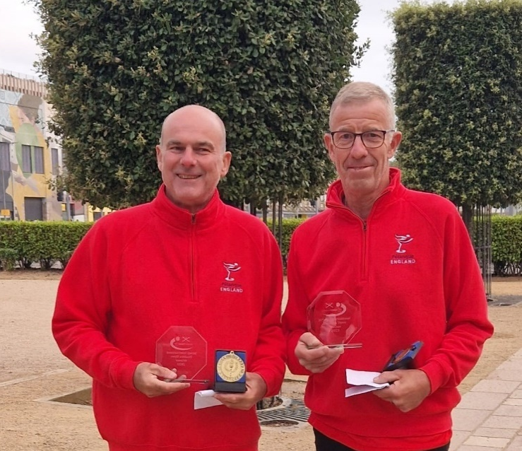

Thanks to all those who helped, especially Dawn Buckley and Elaine Paisnel for umpiring on the day to make it another great competition.

Club email address - liberationpc@gmail.com

Club Website - www.liberationpetanque.co.uk

Kind Regards

Toby Northern

Chairman

Liberation Petanque Club

