**Triple T Sports Center**



**Summer Sports Day Camp**

**2020 Registration**

**H= Half Day; F=Full Day**

|  |  |  |  |  |  |  |  |  |  |  |  |  |  |
| --- | --- | --- | --- | --- | --- | --- | --- | --- | --- | --- | --- | --- | --- |
|  | **SB** | **WK 1** | **WK 2** | **WK 3** | **WK 4** | **WK 5** | **WK 6** | **WK 7** | **WK 8** | **WK 9** | **WK 10** | **WK 11** | **WK 12** |
| **CAMP WEEKS** | **APRIL 13-17** | **June 15-19** | **June 22-26** | **June 29 -July 3** | **July 6-10** | **July 13-17** | **July 20-24** | **July 27-31** | **Aug 3-7** | **Aug 10-14** | **Aug 17-21** | **Aug 24-28** | **Aug 31-Sept 4** |
|  |  |  |  |  |  |  |  |  |  |  |  |  |  |
| **Mon** | H | H | H | H | H | H | H | H | H | H | H | H | H |
|  | F | F | F | F | F | F | F | F | F | F | F | F | F |
| **Tues** | H | H | H | H | H | H | H | H | H | H | H | H | H |
|  | F | F | F | F | F | F | F | F | F | F | F | F | F |
| **Wed** | H | H | H | H | H | H | H | H | H | H | H | H | H |
|  | F | F | F | F | F | F | F | F | F | F | F | F | F |
| **Thrs** | H | H | H | H | H | H | H | H | H | H | H | H | H |
|  | F | F | F | F | F | F | F | F | F | F | F | F | F |
| **Fri** | H | H | H | H | H | H | H | H | H | H | H | H | H |

**Triple T Sports Center Summer Sports Day Camp Open To Ages 3-12**

**\*Full Day Camp Hours 6:00am-6:00pm / Half Day Camp Hours 6:00am – 1:00pm**

**\*Late fee will be charged if campers are not picked up on time, $10, and $5 each additional 15 mins.**

**\*Half Day Campers Bring 1 Snack & Lunch / Full Day Campers Brings 2 Snacks & Lunch**

I hereby authorize the staff of Triple T Sports Center to act for me according to their best judgment in any emergency requiring medical attention and hereby waive & release owners, agents, volunteers, and staff of Triple T Sports Center from any and all liability for any injuries or illnesses incurred while at camp. I understand that participation in gymnastics and other sports/activities involves motion and as such carries with it the risk of injury or death. Triple T and camp staff are not responsible for personal items that are lost, stolen or damaged. All medical expenses as a result of injury or illness during all camp activities are the responsibility of the parent or guardian of registered camper. In lieu of medical certificate signed by a medical doctor, I have no knowledge of any physical or mental impairment that would be affected by the named camper’s participation in the camp program. I also understand and agree that camp retains the right to use any photographs, videotapes, motion picture recordings, or any other record of this event for publicity, advertising or any legitimate purpose.

________________________________ _______________

Signature Date

Child’s Name______________________________________ M/F Age___________ DOB_________________

Medical Conditions/Allergies __________________________________________________________________________

Primary Guardian Name ______________________________________________________________________________________

Home Phone (_____) _______-________ Cell Phone (_____) ______-________Work Phone (_____) ______-_________

EMAIL: ___________________________________________________________________________________________

***Camp Registration Fee and $25 Deposit (each week) Required at Registration-**No Refunds on Camp Registration or deposit\*\****

I authorize my credit card to be charged for balances due for Triple T Summer Sports Day Camp the Wed before camp week.

______________________________________________ ____________________

Signature Date

*This is a legal document and must be signed by parent or legal guardian only. By signing above you are stating that you fulfill this requirement.

Registration ___$35 / $50 Non Member_____Deposit_($25 x number of weeks)_$__________ Amount Due at Reg $ ___________

Total Paid ____________ Form of Payment ___________ Date ____________ Rec’d by __________ Forms Complete ______

Shirt Size______ Extra Shirts $(15x # shirts) $_____ Tshirt(s) rec’d **________ Fieldtrips $20: OB______, Dave&Busters______**

**Required Forms: Birth Certificate ________ Shot Record _______ Most Recent Physical ________**

**Triple T Sports Center**

**Day Camp Medical Release Form**

**(All Information Very Important-Please Fill Out Completely)**

Child’s Name

______________________________________ DOB ___________ Age __________

Medical Conditions / Restrictions / Allergies: (all medicines kept at TTT require med admin form – if prescription needs to be completed by physician) _____________________________________________________________________

_____________________________________________________________________

Medications: __________________________________________________________

Special Instructions: _____________________________________________________________________

_____________________________________________________________________

**Physician ___________________________________ Telephone # (_____) _______-_________**

**Dentist _____________________________________ Telephone # (_____) _______-_________**

**Primary Email: __________________________________________________________________**

Father:_______________________________________________________________

Address ______________________________________________________________

City _____________________________________State__________ Zip___________

Home (____) ______-______ Cell (____) _____-______ Work (____) _____-______

Mother: ______________________________________________________________

Address (if different) ________________________________________________________

City _____________________________________State__________ Zip___________

Home (____) ______-______ Cell (____) _____-______ Work (____) _____-______

**Code Word ______________________________________________________________**

(This word is used to verify your authorization for them to pick up your child when you cannot. Persons other than parent will be required to produce driver’s license as identification)

Insurance (Copy of Insurance Card—Front and Back Required)

I certify that my child is up to date on all state required immunizations.

I am fully aware of and appreciate the risks of catastrophic injury, paralysis and even death, as well as damages and losses, associated with participation in gymnastics and other sports. I further agree that Triple T Sports Center, corporations, employees, agents, officers and directors shall not be liable for any losses or damages occurring as a result of camper’s participation in the “Summer Sports Day Camp”.

I hereby give consent for Triple T to provide customary medical/athletic attentions, transportation and emergency medical services as warranty in the course of my child’s participation at Triple T. I will maintain and uphold up-to-date primary medical health insurance during the entire camp enrollment at Triple T Sports Center.

_____________________________________________________ ______________________________

Parent/Legal Guardian Signature Date

**Triple T Sports Center**

***Summer Sports Day Camp***

**Day Camp Registration Fee:** $35 / $25 add’l children (includes camp t-shirt required for field trips, additional shirts may be purchased at registration if available for $15 each)

**Non-Member Registration:** $50.00 / $40.00 Additional Children

**Day Camp Rates:** 5 Day Full Day $135 / $150 Non-Member

**3 Day Full Days** $95.00 / $110.00 Non-Member

**5 Day Half Day** $95.00 / $110.00 Non-Member, $10 add’l fee for fieldtrips

**5% Discount for each sibling**

**Cash, Check, Debit Cards, MasterCard, Visa, Discover Accepted**

**Camp Hours 6:00am – 6:00pm Half Day 6:00am – 1:00pm**

**Deposit:** A $25 deposit is due upon registration to hold your child’s space in each camp week. This is applied to the total due for the week. Balances must be paid on the Wednesday before each week they are attending. Your credit card will be charged for the balance for the week on Wednesday after 6pm if payment has not been received. If payment is not able to be made your child will not be able to attend camp until payment is received. ***Full week will be charged unless 2 week written notice is given to release the spot.***

**Licensed/Non Licensed Areas: I understand that there are licensed and non licensed areas of Triple T Sports Center. The licensed areas include the lobby, kitchen/party room, Preschool room, and back Tae Kwon Do room. I give Triple T staff my permission to sign my child in and out of licensed and non-licensed areas during camp based on the activities they are participating in.**

**Campers will not be allowed to participate if tuition is not current.**

**Payment must be received by the Wednesday before your child’s camp for each week. A guaranteed form of payment in the form of a credit card for day camp is required. If payment is not received Wednesday by 6pm your child’s camp week will be charged to your credit card on file. Without valid Credit Card on file – camper cannot be dropped off without payment in full for the week, no later than Wednesday. You will be responsible for payment of the time registered for.**

**Very Important: Signing your child IN and OUT of camp is very important. The child is not allowed to sign themselves in or out. Only the parent or authorized person is permitted to Sign in and Sign out. If an authorized person is picking up your child please note this on the sign in form and notify the front desk when you sign in. If a person is picking up that is not on the authorized persons list we will not release the child without written permission from the parent or correct code word is given.**

**Credit Card # ________- _______-________-_______Exp Date_________ (MC Visa Discover)**

**3 Digit code off the back (CV Code) ___ ___ ___**

**Authorized Signature _________________________________ ___________________________**

**Signature Print Name**

**I have read and understand the Triple T Camp policies and agree my credit card will be processed for the amount due for the current week of day camp if not paid. This will be processed on the   
Wednesday after 6pm before your child’s camp for the following week.**

**Signature Date**

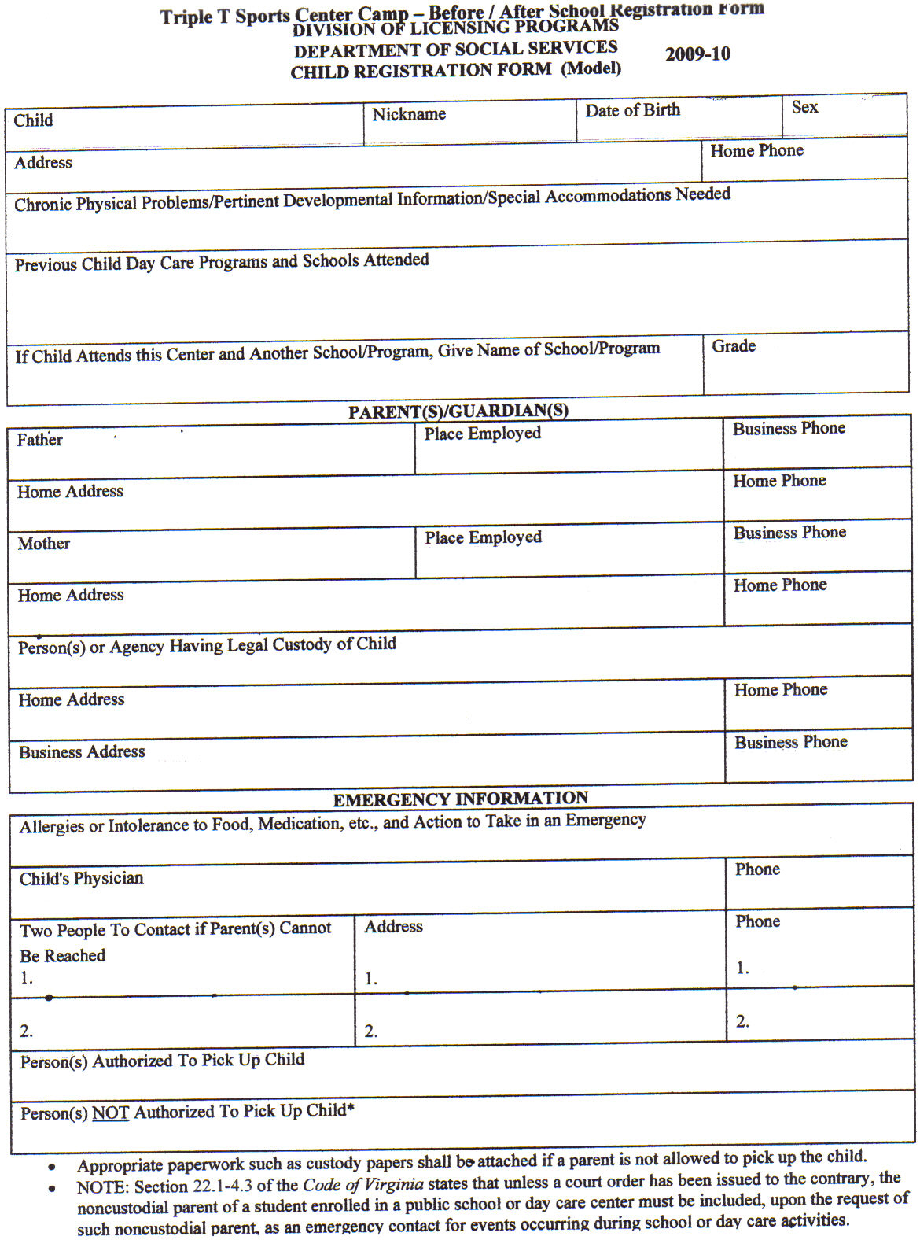

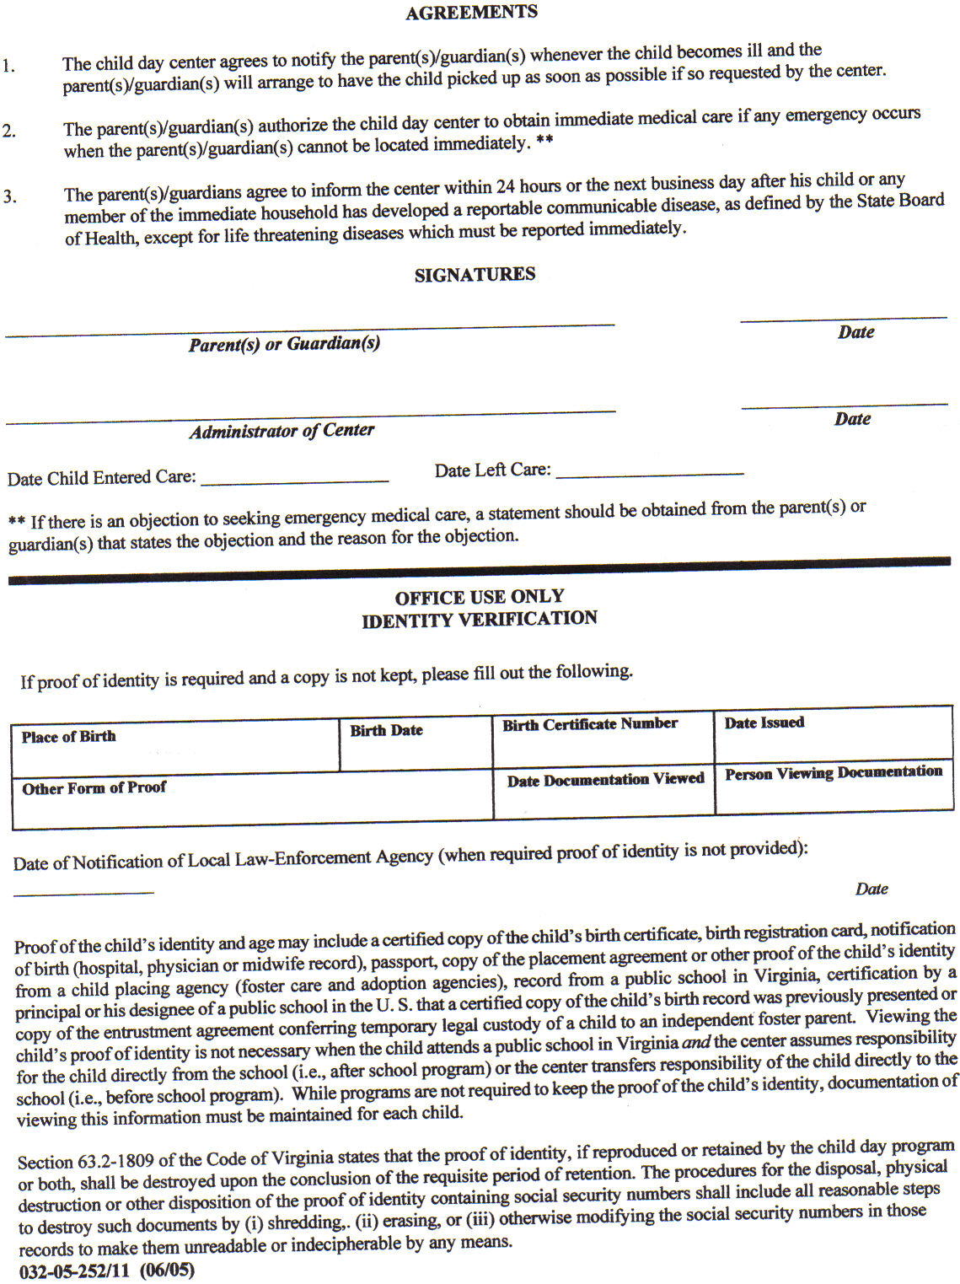

**Triple T Sports Center**

**Summer Sports Day Camp Policies & Procedures**

**1. Sign In-Sign Out**

Signing your child IN & OUT of day camp is very important. The child is not allowed to sign themselves in or out. Only the parent or authorized person is permitted to Sign In and Sign Out. If an authorized person is picking up your child please note this on the Sign In Form and notify the receptionist when you Sign In. If a person is picking up that is not on the authorized persons list we will not release the child without written permission of the parent or verification of code word by the person picking up.

**2. Structured Camp Activities 9:00am-5:00pm, extended care 6am-6pm is included**

**3. Parent Notices:**  For your convenience we post all childcare notices/reminders directly in front of the sign in and out sheet and/or post on the neon flashing sign on that table. Good communication requires both the giving and receiving of information. Please help us keep you informed by reading information posted for you. We will be creating a summer camp 2020 parent facebook page that info will be posted on as well pictures from throughout the week.

**4. Pick Up**

Pick up time for 1/2 day camper is 1:00pm

Pick up for full day is 6:00pm

**5. A Late Fee of $10.00 for late pick ups after 6:00pm, $5 each additional 15 mins.**

**6. Day Camp Forms**

Please make sure that all forms are fully completed upon registration for day camp. Partially completed forms will not be accepted. This includes shot record, physical, birth certificate, credit card release form, rules and policies sheet, and the camper information forms. Please be sure to fully complete all pages to insure your child’s space in the camp. Space in camp is reserved upon receipt of registration forms and payment of deposit. No spaces will be held

**7. What is a member**

Members are children enrolled in a class (gymnastics, tumbling, ninja, tkd, cheer, or dance) or enrolled in our before and after school program throughout the school year.

**8. What to wear**

Most activities require no shoes. Bare feet are recommended. Sport shorts and t-shirts are recommended. (Please no zippers or snaps) No Jean Shorts please.

If your child is younger and prone to bathroom accidents please make sure the child has an extra set of clothing with them each day or we may have to call you to pick up your child early if your child has a potty accident. We have lockers available to store the spare set of clothes if you prefer to leave them here at the gym.

Also girls with shoulder length hair or longer need to have hair tied back – NO balls ties please.

**9. Lunch & Snacks**

Full day campers bring lunch, 2 snacks and drinks. Mark all items clearly with campers name and date. Morning half day campers need lunch and 1 snack and drink, afternoon half day only need 1 snack and drink. Our camp consists of non-stop sports, games and activities, therefore each child needs to have a healthy lunch and snacks for the energy they need. Please refrain from junk food to help your child have the energy they need each day.

**10. Medication**

If your child is on medication you will be required to fill out medication forms that may require your doctor’s signature. All medication must be given to the office staff with directions and medication form. Leaving medication with the child is strictly forbidden and could be hazardous for other children. This includes cough drops, Tylenol, etc.

**11. Procedures for sick children**

The staff will have the child to sit out for a while to see if they start feeling better. Sometimes a child will say they do not feel well if they are unsure of the activity. After they watch for a while and feel comfortable they will join the activity. If they are truly sick we will contact the parent to pick the child up. It is recommended that arrangements be pre-set for your child to be picked up by someone else if it is impossible for you to leave work. We will not accept children that are visibly sick into camp. Children with a fever, diarrhea or vomiting need to be picked up within the hour. Child must be symptom free for 24 hours before returning to the care.

**12. Accidents**

Due to the nature of our day camp accidents do sometimes happen. Our staff is trained to handle accidents. We will contact you to advise you of any accidents. Younger children (3-6) you may want to keep a change of clothes at the gym to prevent having to make a trip to drop off clothes if needed.

**13. Celebrating Birthdays**

If you child would like to celebrate their birthday it is recommended you bring cake, cupcakes or cookies. Please also bring all the paper goods needed. Boxed drinks are permitted. You may contact us for the number of campers we expect on the day you wish to celebrate your child’s birthday. We will celebrate birthdays during snack time.

**14. Missed Days:**

Camp tuition covers the week registered for – due to limited space, campers are not allowed to make up missed days in a different camp week. ECC card users, you will be responsible for payment directly for missed days.

**15. Payment Policy**

A guaranteed form of payment in the form of a credit card for day camp is required. If payment is not received on the Wednesday before your child’s camp week balance will be charged to the card on file on Wednesday after 6pm. If requested your receipt will be put in an envelope with your child’s name on it and placed by the sign in sheet.

**16. Field Trips**

We will be scheduling field trips during camp this summer. The field trip schedule is posted in the lobby and on our website at TTTGym.com. Please keep the field trip schedule provided handy as a reminder of what days the fieldtrips will be so your child will be prepared. Children that do not go on the field trip will remain at the gym for regular scheduled activities. If your child is not going to be participating please notify the office staff in writing by end of the day on Monday of that week so we can staff appropriately. Parents are welcome to come on the field trips with the campers for an add’l fee. Transportation will not be provided for parents. Please let us know if you wish to attend so arrangements can be made. Campers will be assigned to a camp staff person and constant supervision will be given by the camp staff person, parents will not be responsible for supervision. You cannot take your child out of the group during the fieldtrip. Field trips are a privilege and will be taken away if child does not behave properly or comes without proper attire which includes camp T-shirt and closed toe shoes. This is for their safety and exceptions will not be made.

**17. Behavior Procedures**

In an effort to provide the best environment for the Triple T Summer Sports Day Camp, behavior procedures have been implemented to ensure that each and every child has the best possible experience at the Triple T Day Camp. Behaviors such as: using bad language repeatedly, not following instructions that will result in harm to themselves or others, fighting, continuous disrespect to staff, etc.

The following behavior procedures will be enforced.

1st Offense Time Out

2nd Offense Parent will be notified of the situation by camp staff at pickup or via phone call if necessary.

3rd Offense Meeting with the child, parent, and child care management.

4th Offense Dismissal from further participation in the Triple T Summer Sports Day Camp if staff and management feel harm will come to the child and or/others if participation in camp continues.

**18. Video / Quiet Play Time**

The full day camper will be watching an age appropriate theme related movie from approximately 1:30-2:30pm. With the amount of physical activity in camp this time provides a chance for the children to rest between AM and PM activities. Campers will also be allowed to play passive games; such as: board games, checkers, puzzles, etc if they do not want to watch the movie.

**19. Group Divisions**

We have 3 age groups that children are separated into. Ages 3-4, 5-7, and 8-12. This is to allow each group to participate in age appropriate games and activities. Please do NOT request for certain campers to be together or separated. The only exception that will be made is if an older child is not behaving correctly and may be temporarily moved to a younger group. Preschool group (ages 3-4) will have nap time from 12:30-2.

**20. Teacher/Student Ratios**

Teacher/Student ratios vary depending on the activity. Gymnastics classes are 8/9 students to teacher ratio. For sports, games and dance the ratio can be 15 and higher because the sports and games usually require a larger number of students and dance/karate/cheer class will range from 15-20 depending on the age. Ratios of staff to children during care: Preschool (ages 3-4) 1:10, School Age (5-12) 1:18 are the state mandated ratios however due to the structured activities that are done at Triple T our school age ratio is generally closer to 1:12.

**21. Triple T Contact Info**

619 E Constance Rd Suffolk, VA 23434

(757) 923-5150

(757) 923-5185 Fax

[tttgym@msn.com](mailto:tttgym@msn.com) Email

tttgym.com website

Cheryl Burks (757) 839-9108 Owner/Childcare Administrator

**Triple T Sports Center Summer Day Camp Policies**

Parent/ legal guardian must initial next to each statement verifying that they have been informed of the following policies.

__________ I understand that a $25 non- refundable deposit is due upon registration for each week I reserve.

__________ I understand a 2 week written notice is required to remove my child from summer camp. If notice is not given the balance in full will be charged to the credit card on file for the remaining weeks. I understand that if notification is not received I will be liable for the balance as well as payment of fees associated with collecting on the account. Deposits are non refundable.

__________ I give permission for my child to participate in all regularly scheduled fieldtrips. However, I understand that fieldtrips are a privilege and not a right, even if additional fee is charged. Campers will be kept from participating in the fieldtrip if they are not dressed appropriately (camp t-shirt and closed toe shoes) or not behaving appropriately. Triple T wants all campers to participate however if it presents a safety hazard to themselves others they will not be allowed to attend. The field trips that require an additional fee are purchased far in advance and we cannot get a refund if the child does not attend. (Water Country, Ocean Breeze, Spirit of Norfolk) If child does not bring an appropriate lunch (non - microwavable on fieldtrip days) and one has to be provided you will be charged a $10 fee.

__________ Registration includes 1 camp t-shirt. If you would like to order additional shirts upon registration the cost is $15 per shirt. T-shirts are ordered based on the students registered, a limited number of additional shirts are ordered. However we cannot guarantee that there will be any available for purchase if you forget yours on field trip day. Please plan ahead and be sure your child’s shirt is clean and available on fieldtrip day, days are listed on the fieldtrip schedule.

__________ Some fieldtrips are divided by age. I understand this is the age on the day of the fieldtrip. This is for the safety of the children and no exceptions will be made.

__________ Unfortunately when large numbers of children get together there may be times that arguments, fights, or hurt feelings will occur. Our staff is trained to handle these situations when they arise. You will be notified if your child is involved in any incident. We will not discuss the other children with you and you are strictly forbidden to approach any child (includes CITs) other than your own to address any issue directly. If your child is having a problem with another child or staff member please report the issue to Cheryl Burks, Administrator/Owner and the problem will be addressed in whatever manner needed. If issue cannot be resolved with the children then both sets of parents will be called in for a conference with Mrs Burks.

_________­­­­­­ Electronic devices such as ipods, DS, or other games can be brought to camp. The students have certain times of day to play with these, during quiet play times. The rest of the day the device is locked in a locker. I understand that bringing them is a privilege and if my child argues about putting them away or begging to play with them then they will no longer be allowed to bring them. I also understand that bringing any device is at my own risk and that Triple T is not responsible for any loss or damage done to the device. Cell phones are not permitted in camp. If you need to contact your child please call the gym at 923-5150 or Cheryl Burks directly at 839-9108.

__________ It is my responsibility to be sure and pack a full, healthy lunch, drinks, and 2 snacks for my child. Snack Accounts are optional for campers however office is not always open and cannot be counted on to purchase snacks. Any money left with the camper is not Triple T’s responsibility if lost, stolen, or misplaced. See the front desk for details on how to open an account for your child.

__________ I understand there are licensed and unlicensed areas of Triple T Sports Center and give my permission for the staff to sign my child(ren) in and out of these areas.

__________ Parents using ECC cards, you must swipe your child in and out daily and put your receipt in the black gym tuition box. If you do not clock your child in and out you will be responsible for payment of the prior day or receipt showing they were signed in/out before returning. Absences: you will be responsible for payment out of pocket.

I have read the above statements and fully understand the policies and procedures of Triple T.

___________________________________ __________________

Signature of Parents or Legal Guardian Date

***Triple T Sports Center***

***Summer Camp 2020***

**June 15-Sept 4th**

**Register now for the entire summer or for only the weeks you would like your child to attend.**

Our coaches will be teaching Gymnastics, TaeKwonDo, Dance, and Cheer along with several school teachers and counselors that will be helping with the educational activities, arts & crafts, computer skills, field trips, games, and more!! Space is limited to 60 campers per week (4 preschool spots for 3-4 yr. olds) so sign up early to save your child’s spot! Most fieldtrips are included with only a few exceptions. If you want to participate in those payment is due at registration. These tickets are purchased far in advance to insure our spot. 5% sibling discount.

**Week # Date Theme Fieldtrip**

1 June 15-19 School’s Out! Funville* (Preschool-7) $20 add’l fee

Dave & Buster’s* (8-12) $20 add’l fee

2 June 22-26 Symphony of the Five Senses Portsmouth Children’s Museum

3 June 29- July 3 All American Picnic & Games @ Ches City Park

4 July 6-10 Splashtopia Portsmouth Spray Park (5-7)

Williams Farm Rec Center (8-12)

5 July 13-17 Blast Off! VA Air & Space Museum

6 July 20-24 Artful Antics! TBA

7 July 27-31 Olympic Games AMF Bowling

8 Aug 3-7 Splash Down Ocean Breeze* (5-12) $20 add’l fee

9 Aug 10-14 Mad Scientist Subzero Ice Cream Shop

10 Aug 17-21 Reptiles & Amphibians VA Living Museum

11 Aug 24-28 Aloha Hawaiian Luau Luau @ Triple T

12 Aug 31- Sept 4 Triple T’s Got Talent TTT Talent Show (for parents) Fri 4:30pm

*$20 additional fee due at registration, these fees are non-refundable as tickets are pre-purchased.

Structured Camp Hours 9am-5pm, extended care included 6am-6pm

Registration Fee $50 Non-members, $35 Members (includes camp T-shirt for field trips)

5 full days $150 Non-members, $135 Members (enrolled in regular class at TTT)

3 days: $110 Non-Members, $95 Members, $10 add’l fee for field trips

½ day camp 9am-1 $110 Non-Members, $95 Members

Field trips are usually on Wednesdays unless otherwise posted.

TTT camp shirts & closed toe shoes are required for all fieldtrips!!

** All regular classes will be held as scheduled **

***Spring Break – Zoo-Cation April 13-17th***

Fieldtrip: Virginia Zoo (preschool-12)

619 E. Constance Rd. Suffolk, VA 23434

(757)923-5150; tttgym@msn.com