Have you seen the brick installation at the high school?

For $50.00 (2 or more for $45 ea.), you may have a brick engraved in honor of, or in memory of a loved one, or a member of the community. If you would like to buy a brick, please clearly write your message in the blocks below. Note that you are allowed 14 letters and spaces on each of three lines. The Marathon Community Scholarship Foundation will approve all inscriptions before the bricks are installed.

My name is __________________________________. I can be reached at

__________________(phone) or email______________________________
for clarification of the information below.

I would like an acknowledgment of this gift sent to:

Name_________________________________________

Address_________________________________________________________________
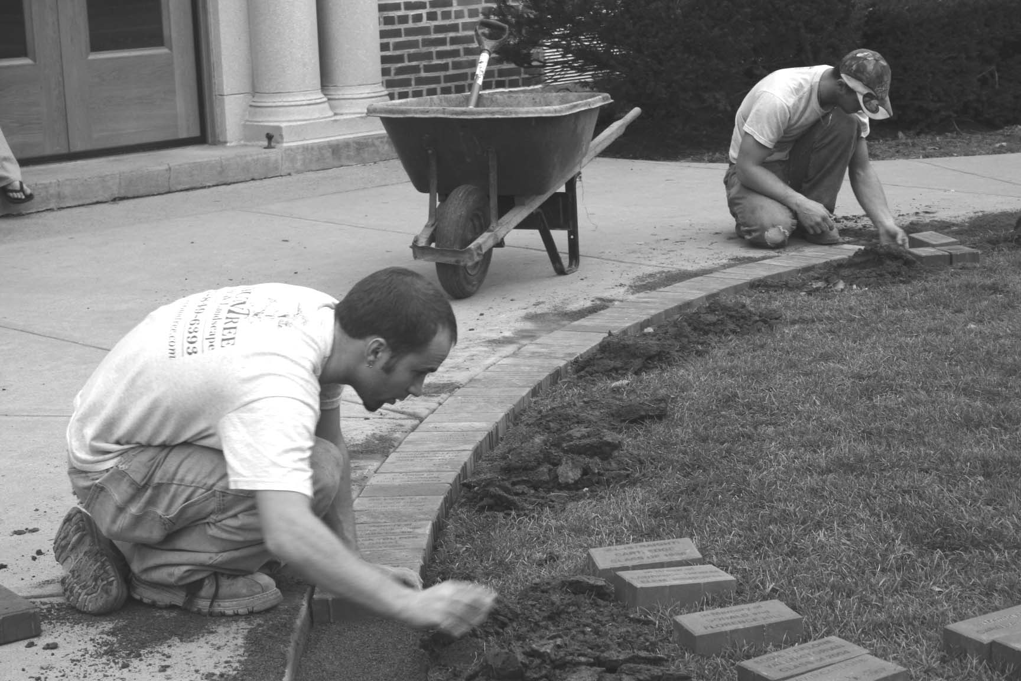
Checks should be made payable to: Marathon Community Scholarship Foundation and mailed to PO Box 1 Marathon, 13803.

Questions? Call Kathi Bush (607-345-4313) or email bush335@frontiernet.net

Profit from these sales directly supports the Marathon Community Scholarship Foundation, which supplements the financial awards at Marathon High School’s graduation each year.

