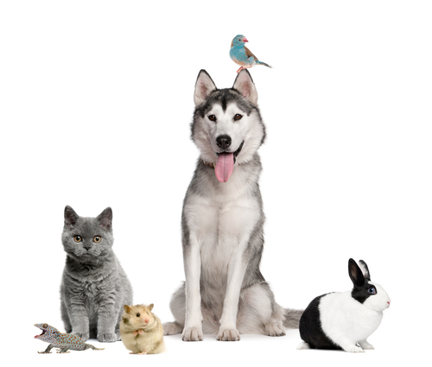
Tail Waggin Good Pet Services
“Happy Pets…One Tail at a Time”

Home Guide and Instruction

Owner: _________________________
Pet(s):__________________________

Locations of:
Crated Area

Leash/Collar

Grooming Brush/Comb

Litter Box

Poop Scoop

Kitchen Waste

Outside Waste

Recycle Bin

Paw Towels

Paper Towel

Spot Cleaner

Broom/Vacuum

Put Mail

Indoor Plants

Outdoor Plants

Birdfeeders

Usual Vehicles & Visitors At Home:

Possible Visitors:

Notes & Misc.:

Usual Visits:
Time Slot Length

KEY – MUST TEST □ Pet Sitter Has □ Use Code □ Will Mail □ Unlocked □ Drop off □ Client Present □ Will Leave □ Other

