

Name of Organization

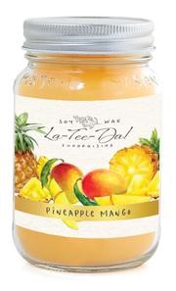  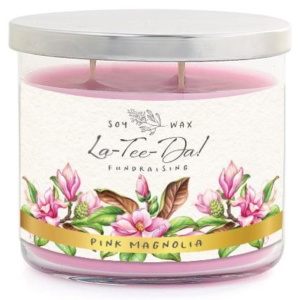  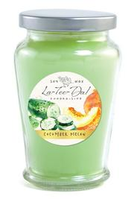

**WHAT & WHY**: We are raising money for….

Shop for Mason Jar Candles, Classic Jar Candles, 3-Wick Candles, Wax

Melts, Room Sprays, Aroma Diffuser Oils, and Bath Salts

**OUR GOAL**: We are requesting all students participate and sell 15 or more items.

**CHECKS PAYABLE TO:**

**END DATE**: Return order forms and money by , 2021

**CONTACT INFO**: For any questions, please contact (chairperson) at (email and/or phone #

**You can share our fundraising brochure with your friends in multiple ways! In addition to collecting orders in-person, you can share a website link for customers to open and view the brochure:**

[***Perfect Gifts for Family & Friends***](https://ad145d12-6b6b-430d-a3af-3cb187d6583c.filesusr.com/ugd/5fe0a6_a0104cad6fa74b7db88226b2328dd721.pdf)

***https://cdn.shopify.com/s/files/1/2569/6186/files/2019_Fundraising_Spring_Brochure-web.pdf?203***

**Use many resources including email, text, and social media!**

You can post on your Facebook page, create a Facebook Event, share the link by Messenger, Instagram, and Twitter! Your customers can contact you with the items they want to purchase, you can write their order onto your order form, and collect payment by cash app, PayPal, check, or cash.

**Important:** **Send messages 3 times to your supporters to achieve higher sales:**

1) To announce the start of our fundraiser. Please send your messages as soon as possible.

2) Half-way through as a reminder. Customers often intend to order but forget to do so!

3) A few days before our fundraiser ends as a last chance to order.

**Our organization will earn a 40% profit,**

**but when we all** **participate, we can earn up to a 50% profit!**

SAMPLE PARTICIPANT LETTER WE WILL CUSTOMIZE FOR YOUR ORGANIZATION

SPRING AND FALL VERSIONS ARE AVAILABLE