CONTENTS

LIST OF VENDORS, SPACE ASSIGNMENTS, CHECK-IN TIME AND CHECK-IN DOOR…………………………………………………………………..2

MAP OF FIELDHOUSE SHOWING ENTRANCE DOORS, VENDOR PARKING LOCATION AND UNLOADING INSTRUCTIONS……….5

RINK MAP…………………………………………………………….……………..6

NOTICE TO VENDORS WHO PURCHASED ELECTRICITY…..…………7

DOCUMENTS YOU WILL RECEIVE AT CHECK-IN……………….……8

TOWN OF PARKER TAX WORKSHEET SPECIFIC INFORMATION…………………………………………………………………….9

ADDITIONAL INFORMATION…………………………………………..….10

END OF EVENT INSTRUCTIONS…………………………………………. 11

# List of Vendors, Space Assignment, Check-In Time & Check-In Door

**DO NOT ARRIVE BEFORE YOUR CHECK-IN TIME  
*We must process all vendors in their specified time slot. If you arrive early you will be asked to leave and return at your assigned time.***

|  |  |  |  |  |  |  |  |  |  |  |  |  |  |
| --- | --- | --- | --- | --- | --- | --- | --- | --- | --- | --- | --- | --- | --- |
| **Company** | | | | | **Booth #** | | | **Check-In and out Door** | | **Check-In Time** | **# of Electrical Items Permitted** | | |
| **(Fire regulations will not permit use of power strips or extension cords)** | | |
|  | | | | |  | | |  | |  |  | | |
| Author *$ | | | | | 81 | | | 1 | | 6:30 |  | | |  |
| 310 Gordon Street * | | | | | 76 | | | 2 | | 7:30 |  | | |  |
| 41 Missing Pieces *$ | | | | | 41 | | | 2 | | 7:50 |  | | |  |
| 70 Linda Schroyer *$ | | | | | 70 | | | 2 | | 7:10 |  | | |  |
| Abigail Esther Designs * | | | | | 17 | | | 1 | | 7:10 |  | | |  |
| Annette's Art * | | | | | 40 | | | 2 | | 6:30 |  | | |  |
| Arra Noreen's Handmade soap * | | | | | 78 | | | 2 | | 6:30 |  | | |
| Boot Hill Bags & Joni Carr Srudio * | | | | | 98 | | | 2 | | 7:30 |  | | |
| Calm Creations by Quinn Harley *$ | | | | | 89 | | | 1 | | 7:50 |  | | |
| Mpwc Card Table * | | | | | 52 | | | 2 | | 6:30 |  | | |
| Civil Air Patrol, U.S. Air Force * Auxiliary | | | | | 80 | | | 2 | | 6:00 |  | | |
| Colorado Cards * | | | | | 99 | | | 2 | | 7:10 |  | | |
| Colorado Cocoa Pod LLC *$ | | | | | 45 | | | 2 | | 7:50 |  | | |
| Colorado Hammock * | | | | | 72 | | | 2 | | 7:10 |  | | |
| Dancing Horse Press *$ | | | | | 73 | | | 2 | | 7:50 |  | | |
| Cozy, By Jen LLC * | | | | | 60 | | | 1 | | 6:30 |  | | |
| Crafty Lizard Designs *$ | | | | | 16 | | | 1 | | 6:30 | **1** | | |
| Creative Helping Hands * | | | | | 39 | | | 2 | | 6:30 |  | | |
| Crystal Musings * | | | | | 100 | | | 2 | | 7:10 |  | | |
| **Company** | | | | | **Booth #** | | | **Check-in and out door** | | **Check in time** |  | | |
| Golden Spirit Kreations *$ | | | | | 14 | | | 1 | | 7:10 |  | | |
| Great Treasures - Zion Blankets * | | | | | 31 | | | 2 | | 7:10 |  | | |
| Purple Heart Creations *$ | | | | | 22 | | | 1 | | 6:30 | **1** | | |
| Rejuvenated Remnants *$ | | | | | 3 | | | 2 | | 7:10 | **1** | | |
| Information Booth* | | | | | By cafe | | | 2 | | 7:50 |  | | |
| J & J Creations * | | | | | 27 & 28 | | | 1 | | 6:30 |  | | |
| Joan's Creations * | | | | | 50 & 51 | | | 2 | | 6:30 |  | | |
| Katiebird Designs *$ | | | | | 48 | | | 2 | | 7:10 |  | | |
| Kay's Krazy Krafts *$ | | | | | 101 | | | 2 | | 7:10 |  | | |
| Khaos Krafters *$ | | | | | 87 & 88 | | | 1 | | 6:30 |  | | |
| Kogler's Bakery *$ | | | | | 36 | | | 2 | | 7:50 |  | | |
| K-Sauce *$ | | | | | 9 | | | 1 | | 7:30 |  | | |
| M & J Creations * | | | | | 77 | | | 2 | | 6:50 |  | | |
| Megan Gets Knotty *$ | | | | | 74 | | | 2 | | 6:50 |  | | |
| Moonstone *$ | | | | | 43 | | | 2 | | 6:30 |  | | |
| Moving Memories *$ | | | | | 37 | | | 2 | | 6:30 |  | | |
| My Urban Poncho * | | | | | 47 | | | 2 | | 6:30 |  | | |
| Nation Wide MediCare Help * | | | | | 54 | | | 1 | | 7:50 |  | | |
| Nikki 6 Designs *$ | | | | | 25 | | | 1 | | 7:10 |  | | |  | | | | | |  | | |  | |  | |  |
| Noonie & Pea *$ | | | | | 85 | | | 1 | | 7:30 |  | | |
| Normani Creations *$ | | | | | 34 | | | 2 | | 7:10 |  | | |
| Outreach Uganda * | | | | | 24 | | | 1 | | 6:30 |  | | |
| Pampered Chef * $ | | | | | 83 | | | 1 | | 7:50 |  | | |
| Phineas CBD * | | | | | 79 | | | 2 | | 7:30 |  | | |
| Pinkinparker Alcohol Ink *$ | | | | | 44 | | | 2 | | 7:50 |  | | |
| The Chickadee Tree LLC * | | | | | 55 | | | 1 | | 6:30 |  | | |
| **Company** | | | | | **Booth #** | | | **Check in and out**  **door** | | **Check n time** |  | | |
| Woolhouse Lane *$ | | | | | 6 | | | 2 | | 7:10 |  | | |
| The Pure Tea Company* | | | | | 86 | | | 1 | | 7:30 |  | | |
| LenaLex Co. * | | | | | 68 | | | 2 | | 7:30 |  | | |
| Discovery Toys * | | | | | 13 | | | 1 | | 6:30 |  | | |
| Ramblin' Ramos Creations * | | | | | 64 | | | 1 | | 7:50 |  | | |
| doTERRA Essential Oils *$ | | | | | 66 | | | 2 | | 7:30 |  | | |
| RJCrafted Designs *$ | | | | | 95 | | | 2 | | 6:30 |  | | |
| Rosabella *$ | | | | | 104 | | | 2 | | 7:50 | 1 | | |
| Scentsy *$ | | | | | 5 | | | 2 | | 7:10 | 1 | | |
| Whimsical Women *$ | | | | | 69 | | | 2 | | 7:10 |  | | |
| Song Ferri *$ | | | | | 67 | | | 2 | | 7:50 |  | | |  |  |  |  | |  |
| The Winter Theory * | | | | | 103 | | | 1 | | 6:50 | 1 | | |
| Dougs Wood Art * | | | | | 75 | | | 2 | | 7:30 |  | | |
| Druid Hill Designs, LLC * | | | | | 65 | | | 1 | | 7:30 |  | | |
| Fabric Originals *$ | | | | | 82 | | | 1 | | 7:30 |  | | |
| Fabulous Faces By Linda * | | | | | 97 | | | 2 | | 7:10 |  | | |
| Fluid Art Works * | | | | | 84 | | | 1 | | 7:30 |  | | |
| Flying Gal Jewelry *$ | | | | | 106 | | | 2 | | 7:10 | 1 | | |
| Forever Hearts and Crafts *$ | | | | | 102 | | | 2 | | 6:50 |  | | |
| GFWC Southwest Region V *$ | | | | | 107 | | | 2 | | 7:10 | 2 | | |
| Gift Expression *$ | | | | | 19 &20 | | | 1 | | 7:10 | 1 | | |
| GlassHill Studio *$ | | | | | 7 & 8 | | | 2 | | 6:30 |  | | |
| Hannah Spiegleman Illustrations *$ | | | | | 2 | | | 2 | | 7:50 |  | | |
| High Plains Creative Arts *$ | | | | | 33 | | | 2 | | 7:10 |  | | |
| Gem from Crystal * | | | | | 53 | | | 1 | | 6:50 |  | | |
| Unseen Wonders * | | | | | 38 | | | 2 | | 6:30 |  | | |
| Trail Magic Sauce *$ | | | | | 23 | | | 1 | | 6:30 |  | | |
| Unfolding Health Natural Science * | | | | | 59 | | | 1 | | 6:50 |  | | |
| Usborne Books & More *$ | | | | | 18 | | | 1 | | 6:50 |  | | |
| Samye Arts *$ | | | | | 21 | | | 1 | | 7:10 | 1 | | |
| Suzi Reaves Art *$ | | | | | 58 | | | 1 | | 6:60 |  | | |
| Steve McBride Fine Art *$ | | | | | 11 | | | 1 | | 7:10 |  | | |  | | | |  | | |  |  | |  | |
| The Traveling Tea Pot *$ | | | | | 15 | | | 1 | | 7:10 |  | | |  | | | |  | | |  |  | |  | |
| Thirty One Gifts (2) * | | | | | 63 | | | 1 | | 7:10 |  | | |  | | | |  | | |  |  | |  | |
| Ry Grace * | | | | | 46 | | | 2 | | 7:30 |  | | |  | | | |  | | |  |  | |  | |
| Skoob Books * | | | | | 62 | | | 1 | | 7:30 |  | | |  | | | |  | | |  |  | |  | |  |
| Smokey Hill Trail Chapter *$ | | | | | 12 | | | 1 | | 7:30 |  | | |  | | | |  | | |  |  | |  | |  |
| Think Big Custom Woodwork *$ | | | | | 93 | | | 1 | | 7:30 |  | | |  | | | |  | | |  |  | |  | |  |
| Thirty One Gifts *$ | | | | | 91 & 92 | | | 1 | | 7:30 |  | | |  | | | |  | | |  |  | |  | |  |
| Tupperware Exclusive *$ | | | | | 26 | | | 1 | | 7:30 |  | | |  | | | |  | | |  |  | |  | |  |
| Teddy Bear Mobile Rocky Mtn. *$ | | | | | 105 | | | 2 | | 7:30 | 1 | | |  | | | |  | | |  |  | |  | |  |
| MOD Wares * | | | | | 61 | | | 1 | | 7:50 |  | | |  | | | |  | | |  |  | |  | |  |
| Suzanne's Simple Knits *$ | | | | | 94 | | | 1 | | 7:50 |  | | |  | | | |  | | |  |  | |  | |  |
| Tanancious creations LLC *$ | | | | | 90 | | | 1 | | 7:50 |  | | |  | | | |  | | |  |  | |  | |  |
| Taspen's Organics *$ | | | | | 57 | | | 1 | | 7:50 |  | | |  | | | |  | | |  |  | |  | |  |
| Under the Bark * | | | | | 56 | | | 1 | | 7:50 |  | | |  | | | |  | | |  |  | |  | |  |
| Wilson Farms *$ | | | | | 49 | | | 2 | | 7:50 |  | | |  | | | |  | | |  |  | |  | |  |
| Tastefully Simple *$ | | | | | 71 | | | 2 | | 6:30 |  | | |  | | | |  | | |  |  | |  | |  |
| Storyteling Fun *$ | | | | | 29 & 30 | | | 2 | | 6:30 |  | | |  | | | |  | | |  |  | |  | |  |
| Sock Ink * | | | | | 4 | | | 2 | | 7:10 | 1 | | |  | | | |  | | |  |  | |  | |  |
| Weathered Hands * | | | | | 96 | | | 2 | | 7:30 |  | | |  | | | |  | | |  |  | |  | |  |
| The Adored Pet * | | | | | 32 | | | 2 | | 7:30 |  | | |  | | | |  | | |  |  | |  | |  |
| World in Pencil * | | | | | 35 | | | 2 | | 7:0 |  | | |  | | | |  | | |  |  | |  | |  |
| Younique $ | | | | | 42 | | | 2 | | 6:50 |  | | |  | | | |  | | |  |  | |  | |  |
| COS Woodworking$ | | | | | 10 | | | 1 | | 7:30 |  | | |  | | | |  | | |  |  | |  | |  |
| Wicksy Daisy Candle | | | | | 1 | | | 2 | | 7:50 | 1 | | |  | | | |  | | |  |  | |  | |  |
|  | | | | |  | | |  | |  |  | | |  | | | |  | | |  |  | |  | |  |
|  | | | | |  | | |  | |  |  | | |  | | | |  | | |  |  | |  | |  |
|  | | | | |  | | |  | |  |  | | |  | | | |  | | |  |  | |  | |  |
|  | | | | |  | | |  | |  |  | | |  | | | |  | | |  |  | |  | |  |
|  | | | | |  | | |  | |  |  | | |  | | | |  | | |  |  | |  | |  |
|  | | | | |  | | |  | |  |  | | |  | | | |  | | |  |  | |  | |  |
|  | | | | |  | | |  | |  |  | | |  | | | |  | | |  |  | |  | |  |
|  | | | | |  | | |  | |  |  | | |  | | | |  | | |  |  | |  | |  |
|  | | | | |  | | |  | |  |  | | |  | | | |  | | |  |  | |  | |  |
|  | | | | |  | | |  | |  |  | | |  | | | |  | | |  |  | |  | |  |
|  | | | | |  | | |  | |  |  | | |  | | | |  | | |  |  | |  | |  |
|  | | | | |  | | |  | |  |  | | |  | | | |  | | |  |  | |  | |  |
|  | |  | |  | |  | | |  | | | |
|  |  | |  | | | |  | | | | |

**Map of Fieldhouse showing entrance doors, vendor parking location and unloading instructions**

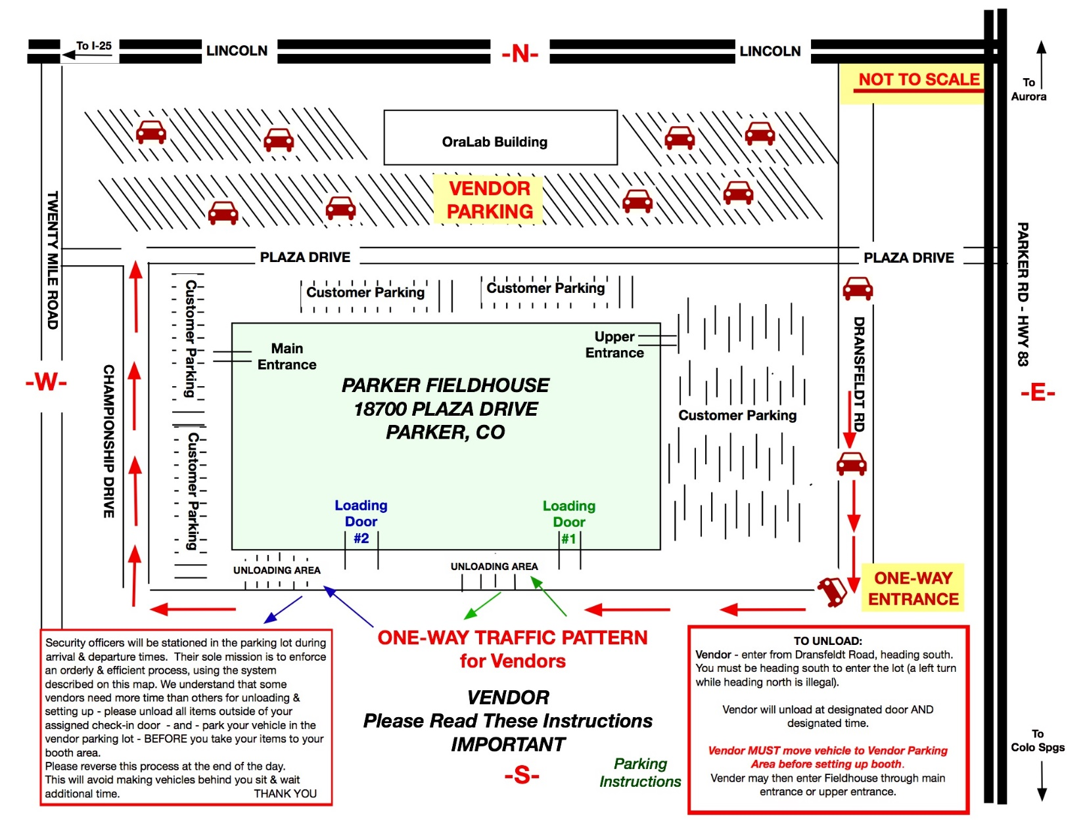

Rink Map

***These entrances will be closed once all vendors have checked in.***

***These entrances will be closed once all vendors have checked in.***

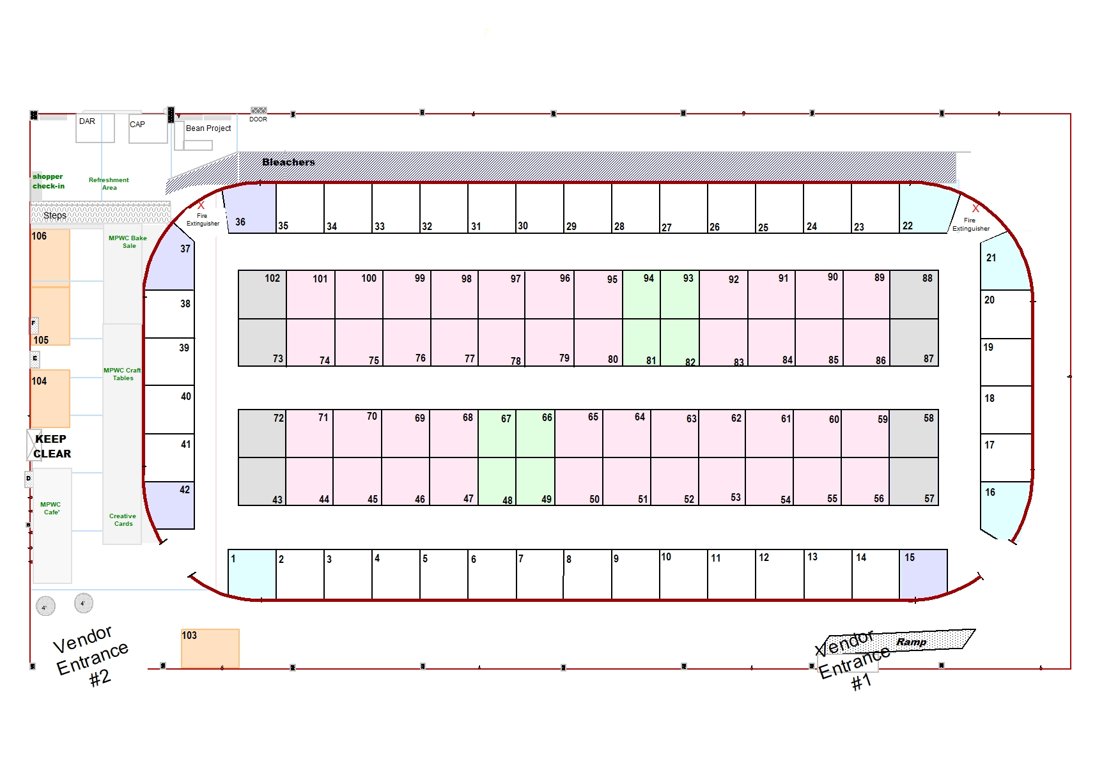

SPEC

# Notice to vendors who purchased electricity

Vendors who purchased electricity must strictly adhere to the following policy established by the Parker Public Safety Office.

1. ***all cords must comply with fire codes.*** You ***may not use*** a personal extension cord or power strip for any reason. Do not bring any with you. All unauthorized cords will be confiscated and NOT returned.
2. Approved cords and cord covers will be in place when you arrive. You **may not** plug any additional extension cords/power strips into the provided outlets which will be in place when you arrive.
3. You are limited to the number of electrical item outlets you purchased and that are supplied by MPWC (*as noted on pages 2-4*)
   1. You may be sharing an authorized electrical power strip with another vendor, so configure your space to allow for this.
   2. Review the layout map to determine which side of your booth has a vendor that might be sharing the electrical strip with you (those noted on pages 2-4). Then plan your layout to accommodate sharing if required.

The Town of Parker will conduct an inspection for adherence to this policy prior to 9 a.m. on the morning of the event. The event will not be allowed to open until this inspection has taken place and the Public Safety representative has checked each vendor’s connection, so please work with us on this so that we can ensure the safety of everyone and be in 100% compliance!

Thank you for your compliance with these regulations.

***MPWC and the Town of Parker***

# Documents you will receive at Check-In

You will receive the following documents at check-in:

1. PARKING PERMITS
   1. These allow you to park in the designated/restricted vendor parking areas. Only vendors with handicap permits are allowed to park in the upper level of the Fieldhouse parking lot. All other vendors must park across the street (Plaza Dr.) at the Ora Labs parking lot.
   2. Vendors must park in the designated/restricted vendor parking area.
   3. Permit must be displayed in your windshield to avoid being ticketed or towed.
   4. Vendors without handicap permits may not park in the Fieldhouse parking lots; no one can park in the spaces along the one-way traffic patterns.
2. THE TOWN OF PARKER TAX WORKSHEET
   1. This must be completed and turned in at the end of the day.
      1. Put this form plus cash or check made out to MPWC for taxes due inside the plastic bag you receive at check-in and give it to the MPWC representative when she comes around between 3:30 and 4:00 PM
      2. If you make any sales after the tax has been collected, you are responsible to provide that information directly to the Town of Parker and make appropriate payment to them.
      3. Specific guidelines for completing the tax worksheet can be found on Page 9.

# Town of Parker Sales Tax Worksheet Specific Information

***all vendors must complete this form – no exceptions***

This form can be found in your registration packet and **must be completed, signed and turned in at the end of the day by all vendors including:**

* **Vendors with a Town of Parker tax ID** will turn in the completed form only.
* **All other vendors who make any sales** will turn in the completed form and the taxes due. (See exception for Direct Sales vendors below.)
* **Direct sales vendors who live inside the Town of Parker** city limits will turn in the completed form only if Parker taxes are paid by your company. Otherwise the completed form and the taxes due will be collected.
* **Direct sales vendors who do not live inside Town of Parker** city limits will turn in the completed form and any taxes due.
* **Vendors who do not have any sales** will turn in the form only.

Put your completed and signed form plus the amount due for the 3% Town of Parker sales tax inside the plastic bag you receive at check-in and give it to the MPWC representative when she comes around between 3:30 & 4:00. Checks must be made out to MPWC.

All sales (including food items) are considered taxable and are subject to the Town of Parker’s 3% sales tax. Any overpayment made to MPWC will not be returned; it will be considered a charitable contribution to MPWC’s donation funds.

If you have a State Tax License Number and you know it, you may also include this on the form. If you do not have a State Tax License Number, leave this line blank.

**All vendors** **must turn in the worksheet with sales information to MPWC at the end of the day even if no taxes are due. Failure to do so will result in your not being invited back again and may result in fines imposed by the Town of Parker. This applies to ALL vendors. THERE ARE NO EXCEPTIONS.**

# Additional Information

1. Your booth area will be identified with masking tape
   * 1. *There is* ***NO*** *added space between booths.* Please be considerate & don’t encroach right up to or into your neighbors’ booth area.
     2. PLEASE allow yourself and your customers walking space within your area.
2. MPWC does not provide tables or chairs for vendors. Please bring your own.
3. The Fieldhouse has only a small snack bar with limited selections, and there are no restaurants nearby. Please plan accordingly and bring your own water, snacks and lunch.
4. There are soda/snack machines located in the main lobby area.
5. The Fieldhouse is an active sports complex with activities going on in the rink area Friday night, so vendors may NOT set up the night before.
6. All vendors are expected to wear a name-tag to identify yourself as a vendor at all times. Your name-tag should also include the name of your booth/company.
7. Vendors are expected to display some type of identification showing the name of their booth. You may remove and use the paper we have taped to the floor, but it should be prominently displayed where shoppers can see it.
8. We will be offering you the opportunity to pre-register for the 2022 event. *The registration form will be posted on the MPWC Bazaar Vendors page of our website no later than November 30, 2021.* We do not know yet what fees will be in 2022, but we will guarantee 2021 booth fees only if the form has been completed and submitted by Dec. 30, 2021.
9. This is a sports complex and is kept rather cool. We cannot control the temperature in the space and cannot turn off the fans. Consider dressing in layers to ensure your comfort.
10. There is an **ATM** located in the front lobby next to the Snack Bar if you or your customer need cash.
11. Free WiFi is provided by the Fieldhouse; no password is required. However, please remember there will be a lot of people using it, so response time may be very slow or you may have trouble connecting. We have no control over this. Please take your concerns to the front desk of the Fieldhouse.

# End of Event Instructions

1. Please ***WAIT UNTIL 4:00pm*** to start breaking down your booth. This is when the event officially ends.
2. After 4:00pm the loading doors will be opened. Please load/leave only through ***the door you came in***. You ***may not use*** the front entrance of the Fieldhouse or any other doors of the Fieldhouse for loading/leaving.
3. **Do not move your vehicle to the loading area until AFTER you have packed up** all your items and are ready to load. Moving it beforehand causes undue burdens for those who are packed and ready to load their vehicles.
4. You will be receiving a survey electronically within two weeks after the event. Please take a moment to complete it.

***Thank you again for your support of our event.***

Mountain Pine Woman’s Club is a 501(c)(3) not for profit organization

*MPWC is a member of the Colorado Federation of Women’s Clubs (CFWC) - & - the General Federation of Women’s Clubs (GFWC).*