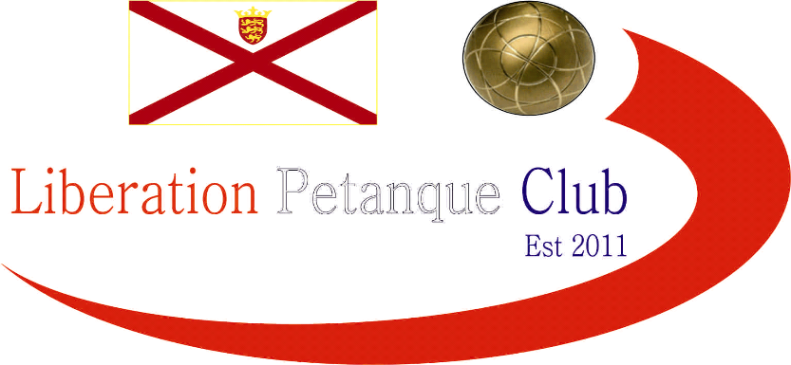

2018

Ladies Singles Open

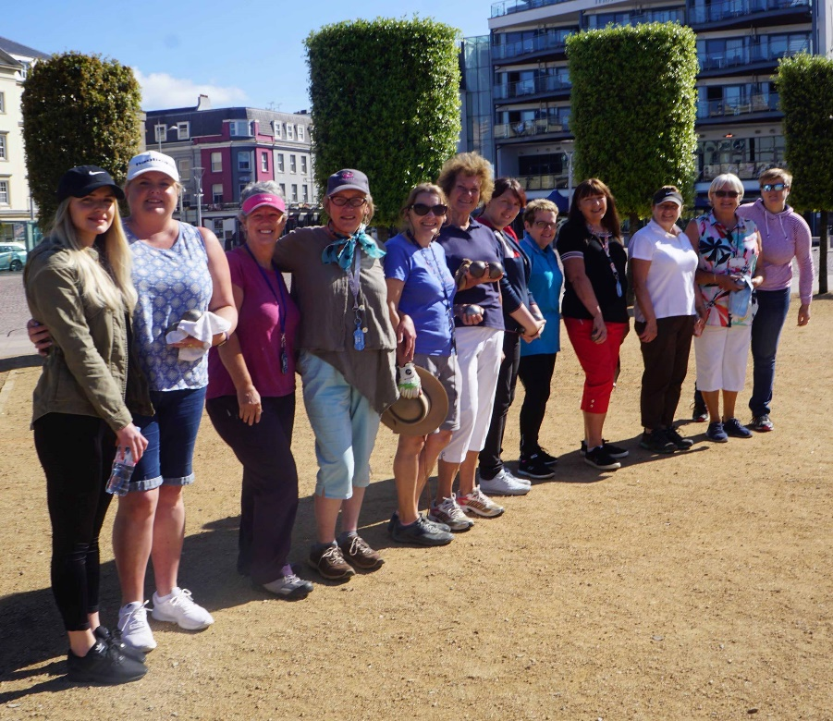

12 Ladies (pictured above) took part in the Clubs (and Island’s) first ever Ladies Singles Open held on the 2nd June 2018.

Tournament favourite Joy Hart started off with a big win over a tough opponent in Susan Le Gresley winning 13 – 2, this was the same score for Ella-Jay Limbrick who beat a more experienced Jean Stewart.

Wendy Ritzema conceded one more point than Ella-Jay and Joy beating Lorna Limbrick, 13 – 3. Unfortunately for Jeannine Carey though as suffered a 13 – 0 defeat to Cassie Stewart. There were some close matches though as Fay Scholefield just beat Mo De Gruchy 13 – 10, with the same score in favour of Brigitte Ibitson over Christine Eccles.

Round two saw a narrow victory for Joy over Christine, Ella-Jay over Jeannine and Fay over Brigitte as these players all made it two wins in a row. Cassie Stewart beat mum Jean 13 – 8 to also make it two wins.

Susan overcame Wendy 13 – 11 and Lorna beat Mo 13 – 5 as both players gained their first wins.

Round three saw Lorna beat her daughter Ella-Jay 13 – 3, with both players on two wins after three rounds. Susan also moved to two wins with a 13 – 8 win over Jean.

Three players though ended with a 100% record after three rounds. Joy who beat Jeannine, Cassie who beat Mo and Fay who ended Christine’s title hopes with a 13 – 5 win.

Round Four saw Christine win her first match over Susan, 13 – 6 making it nearly impossible for Susan to make the top four and progress to the Semi-Finals.

Two players on a 100% record saw Joy overcome Cassie, 13 – 4 and with Fay also losing to Lorna, Joy was the only player after four rounds on a 100% record.

With Lorna, Cassie, Wendy and Fay all on three wins and Susan and Brigitte on two wins there was plenty to play for in the final qualifying round.

Joy finished the qualifying rounds in style handing Ella-Jay her second 13 – 0 defeat of the tournament, but this was against the top two players after the qualifying rounds and much more experience of competition play.

Fay lost by the narrowest margin 13 – 12 to Wendy Ritzema and with 4 wins + 36 Wendy ended in 2nd place. Third place went to Lorna Limbrick who made it four straight wins with a 13 – 6 win over Cassie Stewart. This combined with Brigitte’s 13 – 2 win over Mo mean’t that Brigitte finished fourth with 3 wins +12 to Cassie’s 3 wins +11.

FINAL STANDINGS

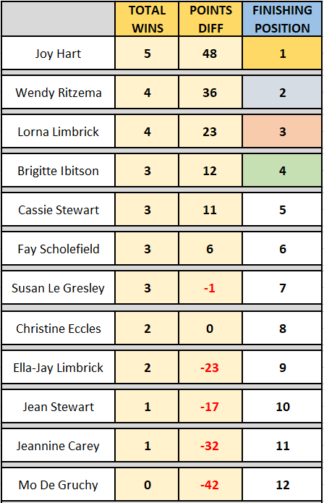

With the benefit of finishing first Joy Hart had the benefit of playing fourth placed Brigitte in the first semi-final. It was a fairly close affair, but Joy ran out eventual winner 13 – 7.

In the second semi-final Wendy played Lorna whom she beat 13 – 3 in round one. Unfortunately for Lorna that was two more points than the semi-final as Wendy ran out a comfortable winner 13 – 1.

Brigitte however had the satisfaction of winning the third place play-off, 13-4 over Lorna for a bronze medal.

The final on the Weighbridge terrains of Liberation Pétanque Club saw best friends Joy and Wendy play each other. Joy raced to an 11-3 lead but Wendy mounted a comeback to take the game to 9-11 before Joy closed out the game 13-9.

So Joy Hart is the first Jersey women’s open singles champion.
(Pictured Below centre, on the left Brigitte and on the right Wendy)

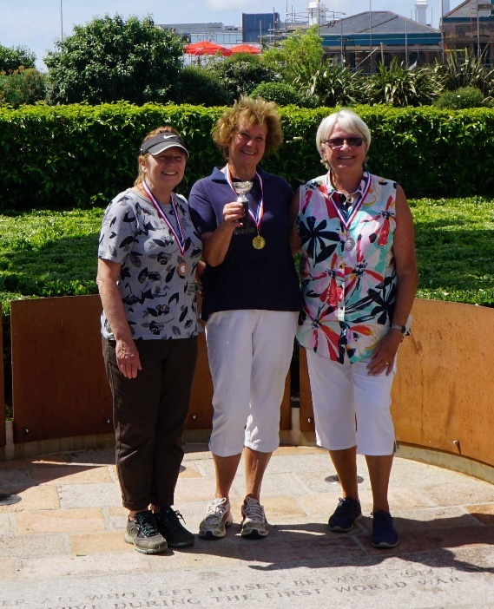

All the participants were agreed the new competition had been a big success and the winner made a point of thanking Callum Stewart and the Liberation Petanque Club for coming up with such a brilliant idea and Ross Payne for organising the event so well.

We hope you will all be back next year and hope you can help make it bigger and better.

Liberation Charity Triples Open
In Aid of Jersey Children’s Charity
Saturday 28th July 2018
Still Time to Enter

WEBSITE www.liberationpetanque.co.uk
EMAIL liberationpc@gmail.com

Kind Regards
Toby Northern
Chairman
Liberation Petanque Club

SPONSORED BY

