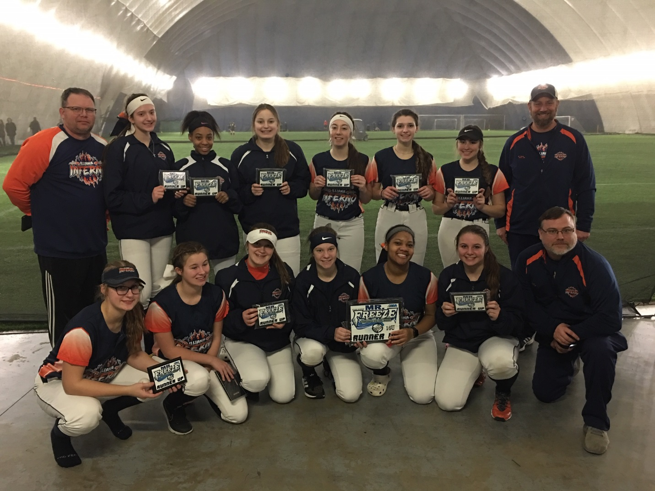
16u Runner Up Illiana Inferno (Reitsma)

