Morgan County Animal Hospital
MASS REMOVAL RELEASE FORM

Owner Name ___________________________________________________________________ ID_____________
Pet Name ______________________________________________________________________ ID_____________
Additional Services:
Vaccines ______________________________________________________________________________________
Heartworm Prevention _________ Flea/Tick Prevention _________ Fecal Analysis (intestinal worm) ___________
Other _________________________________________________________________________________________
PRE‐ANESTHETIC BLOOD SCREEN: Your pet is scheduled for a mass removal which will require anesthesia. The safety of anesthesia has greatly increased with new technology and anesthetic agents. However, there is always some risk with anesthesia. We will perform a complete physical examination before your pet is anesthetized. Some conditions such as liver, kidney, and certain blood disorders may not be detected without blood analysis. For these reasons, we strongly recommend a preoperative blood screening including a complete blood count be performed. This may help us detect an underlying problem that could lead to anesthetic complications. With our in‐house blood analysis capabilities, we can have the results within minutes, which enables us to evaluate potential surgical risks.

I would like to have the pre‐operative blood screen that is recommended for my pet and understand there will be an additional charge of $75. Yes _______ No _______ Senior pre-operative blood screen $100 (7+) Yes ______ No ______

Would you like your pet to go home with additional pain medication? Yes______ No______

If fleas/ticks are seen, the pet will be treated with Frontline spray for an additional charge of $10 _______ (initial)

Would you like your pet microchipped today? There will be an additional charge of $34. Yes ______ No ______

Number of masses to be removed ______
Submit mass for histopathology? ($135) Yes _____ No ______

My pet HAS NOT eaten for the past 8 hrs. ___________ (initial)
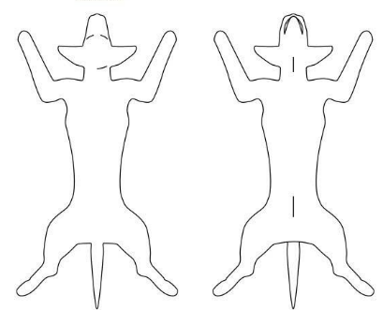
I understand, although all reasonable precautions and due care will be taken during treatment of my pet(s), there is always a potential risk in anesthesia surgery, up to and including death. I accept these risks and authorize Morgan County Animal Hospital to perform such treatment as deemed necessary. I also understand that during the performance of the procedure(s), unforeseen conditions may be revealed that necessitate an extension of the foregoing procedures, or even different procedure(s). I further realize that I am responsible for payment in full for the procedures and treatments performed on my pet at the time he/she is discharged.

Best Phone Number to be Reached At Today ______________________________________________________

Owner/agent:____________________________________________________________Date:________________

