***EBENEZER UNITED METHODIST CHURCH***

***Welcome and Announcements -- Barry Sudduth***

Announcement – please read and pin a copy to the refrigerator.

Welcome The Light of Christ

*Praise Songs “***Come, Now’s the Time to Worship”, “Mighty to Save”***

Children’s Time Bridget Gillions

Offering

*Doxology ***“Praise God from Whom all Blessings Flow”*** # 95

Joys and Concerns

Morning Prayer

*Praise Song ***“Lord I Need You”***

Scripture: Matt. 5:43-45, Lk. 6:27-28, 3 Jn. 11-b, Gal. 5:15 & 22-26,

Ro. 12:9-10 &13 Beth Sherm

Message  **“Do No Harm, Do Good”** Pastor Loretta

*Praise Song ***“They Will Know we are Christians by Our Love”***

*Benediction

*Please stand as you are able.

**THE LORD’S PRAYER**

*Our Father, who Art in Heaven, hallowed be Thy name. Thy Kingdom come, Thy will be done on earth as it is in Heaven. Give us this day our daily bread and forgive us our trespasses as we forgive those who trespass against us. And lead us not into temptation but deliver us from evil. For Thine is the Kingdom, the power, and the glory forever. Amen*

***We extend a very warm welcome to all who are worshiping with us today.***

**ATTENDANCE: June 2nd = 44**

**Calendar**

June 9th – Worship Committee – brief meeting following worship

Friday: Pantry set up & Saturday = food distribution

**Thank you, Barry, Bridget, Beth**

**for your help in today’s service!**

**Next week the children have change for change and it is going to go to the “Ronald McDonald House” to help those who need to be close to the hospital during a time of crises and surgery. And special for Father’s Day**

**Thank you, to all who participated in this mission project.**

**Bible Study starts this evening at 4:00**

**The Chosen**

What: The topic–Jesus and His Disciples as portrayed in the film series

of THE CHOSEN.

When: It will be twice a month on Sunday afternoons – 4:00 PM

**Starting June 9th and June 23rd.**

Where: Warsaw United Methodist Church

Who: All are invited, families are welcome

Participating: Warsaw, Carmel, and Ebenezer United Methodist churches.

Content: Starting with Season 1, episode 1 we will watch an episode,

do a brief study on what we have viewed.

Homework will be assigned – such as reading, the scripture

which will identify the episode we will watch.

DO NO HARM

DO GOOD

STAY IN LOVE WITH GOD



**PRAYER LIST**

*I have not stopped giving thanks for you, remembering* you in my prayers.

Ephesians 1:16 (NIV)

Prayers for the family of Barbara Jean LeFon {joined the church triumphant on May 31st; also for the Kohari family.  Prayers for the Jr. Beta Club as they leave for coemption in Georgia on the 9th. Ginny & Lina Hahn (Cindy’s niece & great niece), Jennifer Clarke, Rachel Nice & Daphne, Linda & Ralph Fallin, Joan Balderson, Kacky Sanford, Kathy Davis, Betty Bailey, David Allison, Ian Duprey in the Coast Guard; for those battling cancer; for those battling sickness. Israel & Gaza, Russia & Ukraine; for the healing of the nations! For our country and its leaders, our Church, and the United Methodist Church.

We always thank God for all of you when we mention you constantly in our prayers

**Please** review the Prayer List and let us know of any people whose prayers have been answered. We will glean the list and start again on the first Sunday of every month. If you would like to keep a loved one on please advise pastor Loretta.

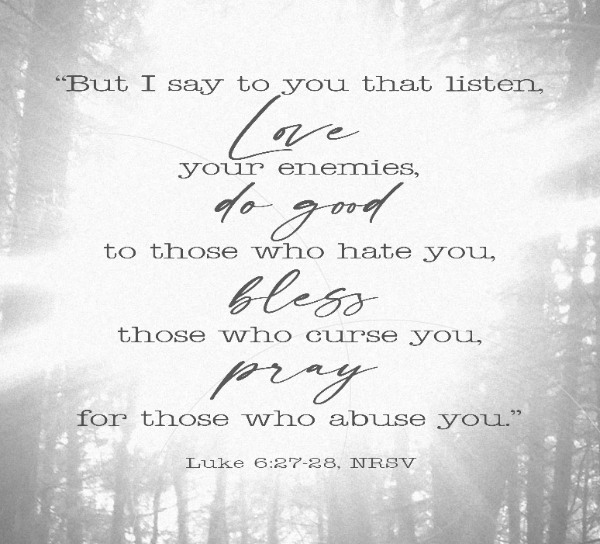

**Ebenezer United Methodist Church**

144 Ebenezer Church Road

P. O. Box 70

Oldhams, Virginia 22529

***Website:*** [*www.eumcoldhams.org*](http://www.eumcoldhams.org)

Reverend Loretta Benninghove

Pastor

Office (804) 472-4642; Cell (434) 480-9992

**Email:** [pastorlorettaumc@gmail.com](mailto:pastorlorettaumc@gmail.com) {preferred email}

[lorettabenninghove@vaumc.org](mailto:lorettabenninghove@vaumc.org)

**June 9th, 2024**