Sea Turtle’s JULY 2024
SUNDAY |  |  | MONDAY | TUESDAY | WEDNESDAY | THURSDAY | FRIDAY | SATURDAY
 |  | 30 | 1 | 2 | 3 | 4 | 5 | 6
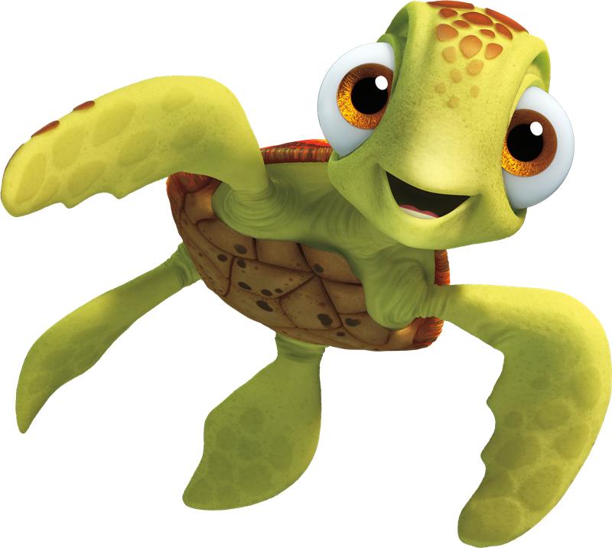  This Photo by Unknown Author is licensed under CC BY-NC |  |  | Closed  Canada Day | Esquimalt Lagoon | Langford Water Park | Royal Bay Beach | Glen lake Water Park | 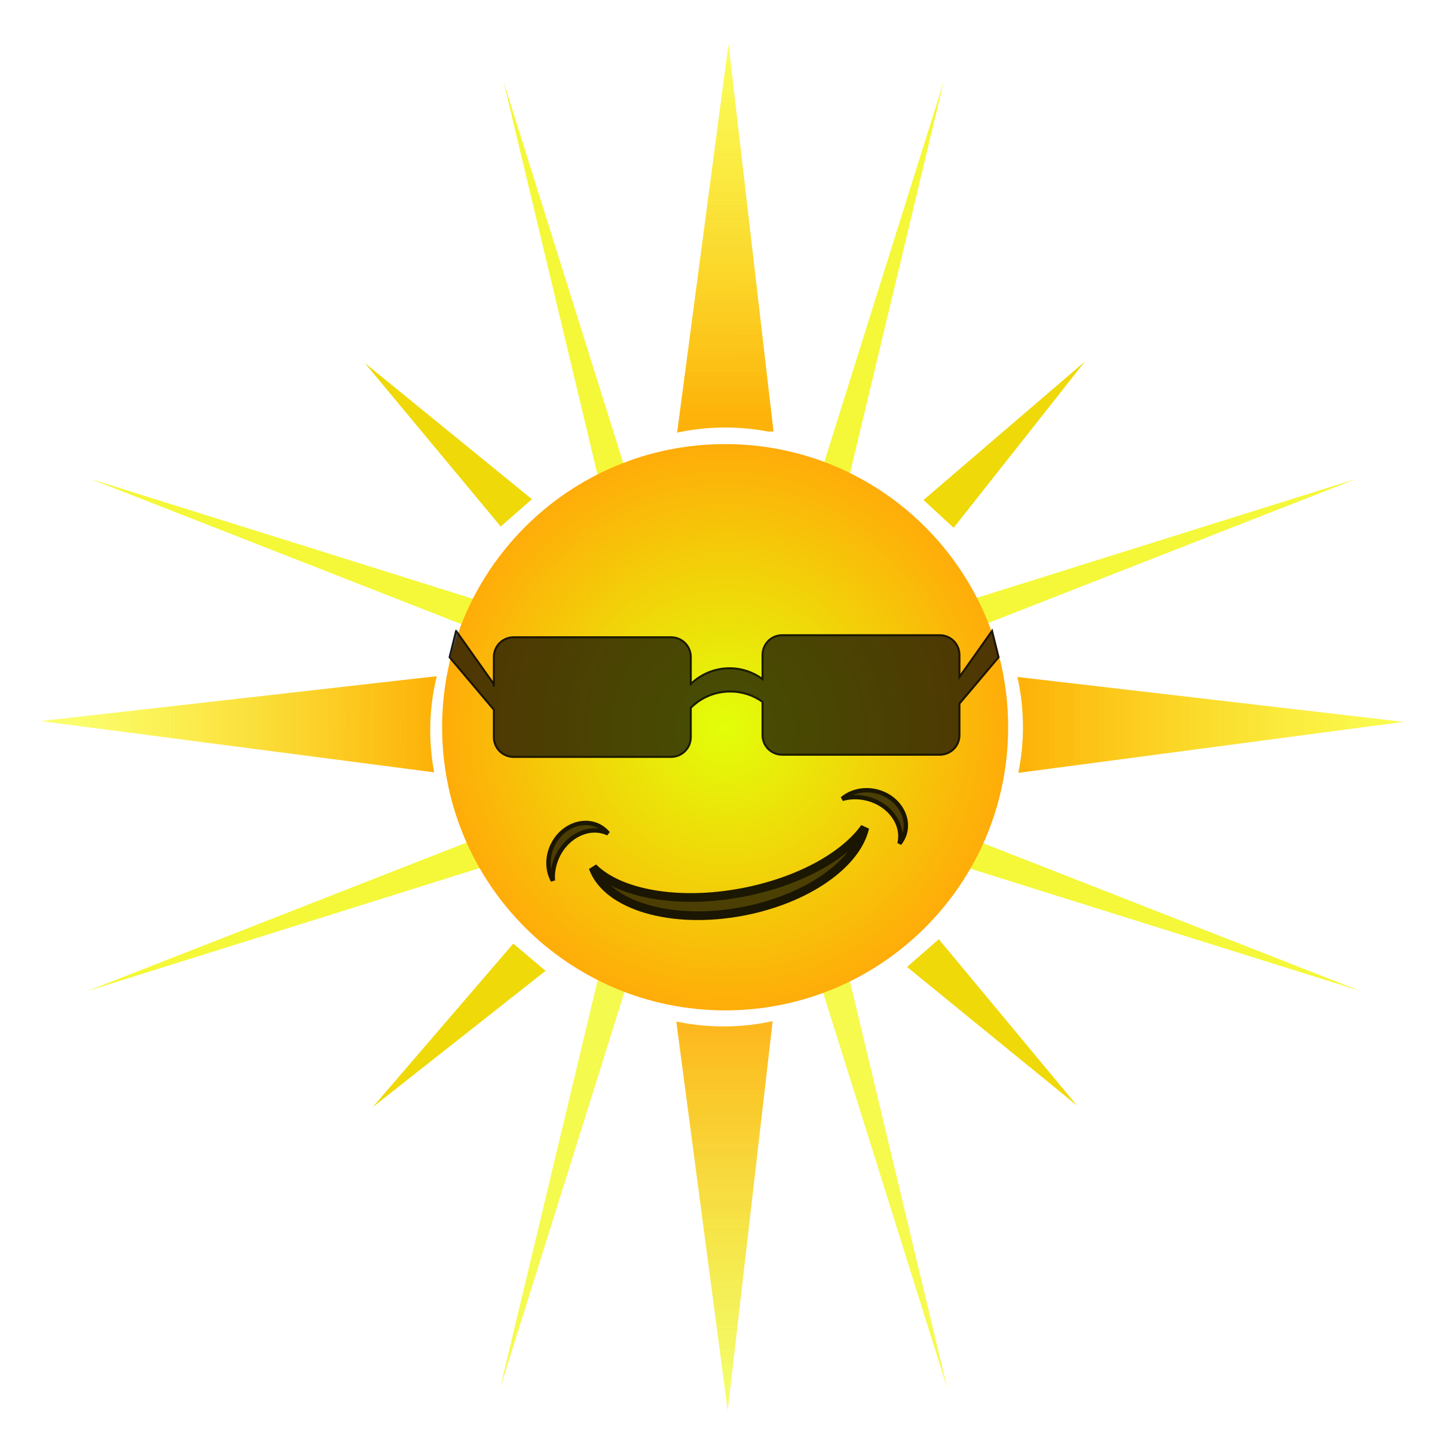
 | 7 |  | 8 | 9 | 10 | 11 | 12 | 13
 |  |  | Lookout  Lake | Esquimalt Water Park | Aylard  Farm | Bamberton Beach | Cloverdale Water Park
 | 14 |  | 15 | 16 | 17 | 18 | 19 | 20
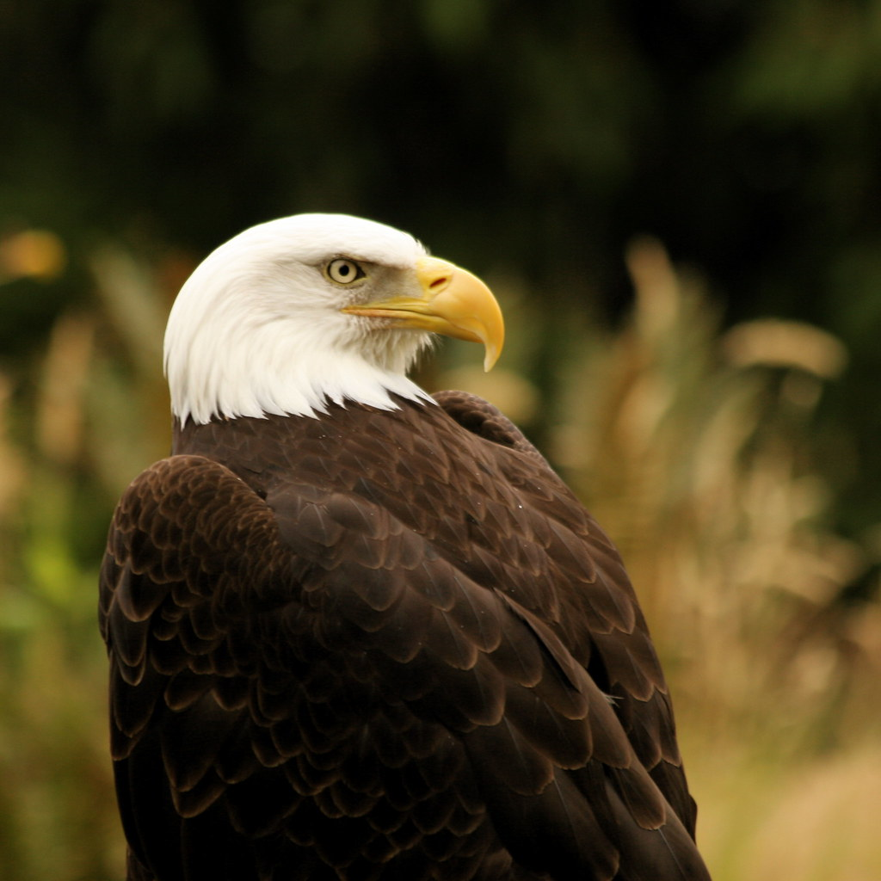  This Photo by Unknown Author is licensed under CC BY-NC |  |  | Island View Beach | Sooke Pothole’s Stairs | Gyro  Park | Sydney Water Park | Langford Lake Dock
 | 21 |  | 22 | 23 | 24 | 25 | 26 | 27
 |  |  | Sooke Pothole’s  Top | Witty’s Lagoon | Raptor’s  $13.50 | Langford Lake Dock | Sooke Water Park
 | 28 |  | 29 | 30 | 31 | 1 | 2 | 3
 |  |  | Beckwith Water Park | Shawnigan Lake | Sydney Water Park |  |   This Photo by Unknown Author is licensed under CC BY

