RSAI 2021 Position Paper:
School Choice and the Priority of Public Schools

Current Reality: Iowa has a wide range of school choice for parents and students, including:
- Within District Transfer: A neighborhood public school or a public school in another neighborhood within the school district (transfers regulated by local school board).
- Open enrollment to public school in another district. 33,833 students exercised this option in 2019-20. This total includes: 1) Open enrollment to another school district if an application is made by March 1 of the preceding school year, 2) Open enrollment into another school district for a good cause after the March 1 deadline, 3) Open enrollment to another school district if the request meets the criteria set by the local school board in the five districts with voluntary diversity plans (total of 2,407 students open enrolled out of those five districts in the 2019-20 school year), and 4) Open enrollment to an Iowa public virtual academy and other online programs.
- Strong nonpublic schools, with 32,887 students enrolled in 2019-20. Private schools and parents are supported by millions of state tax dollars for school tuition organization scholarships, tuition and textbook tax credits, transportation/textbook funds to private schools, public school and AEA support for special education in private schools, and public/private partnerships for private preschool tuition in the statewide voluntary preschool program. According to State Tax Subsidies for Private K-12 Education by the Institute for Taxation and Economic Policy, Oct. 2016, of the 17 states with either private school scholarships or private school tuition/expenses tax credit, Iowa is one of only five that have both (AL, IA, IN, LA, SC).
- Home School Options: competent private instruction or independent private instruction.
- All told, over $66 million in state tax dollars support the education of Iowa students in private and home school settings according to the Iowa Fiscal Policy Project analysis, Nov. 2018, found here http://www.iowapolicyproject.org/2018docs/181105-IFP-pvtschools-bgd.pdf
Vouchers or Education Savings Accounts Costs Outweigh Benefits: Increasing Iowa public investment in private schools will not add benefits and will negatively impact public school students:
- Iowa already has competition to pressure schools to perform, if competition provides positive pressure. But according to the Economic Policy Institute Report, February 28, 2017, “Research does not show that vouchers significantly improve student achievement.”
- That report concludes there are more effective ways to increase graduation and college attendance rates, that vouchers programs have hidden costs, including shrinking the pipeline into teaching, and that supports for privatization detract from more proven methods of improving student learning.
- Diverting funds to private education further stresses public school resources. From State Tax Subsidies for Private K-12 Education, Oct. 2016; “30 neovouchers across 20 states are draining over $1 billion in public revenues from state coffers every year. Every dollar of revenue diverted toward private schools is revenue that cannot be invested in the public education system.”

- Recent Iowa Expansion of Private School Support: In the 2020 session, Tax Reform Legislation, HF 2641, increased the annual cap for School Tuition Organization (STO) Tax Credits to $20.0 million (double-digit percentage increases in 2018, 2019 and 2020). In 2019, the income threshold for grant eligibility was increased from 300 to 400% of the federal poverty level and 529 Savings Plans were created to allow tax-free income to pay for K-12 private school tuition.
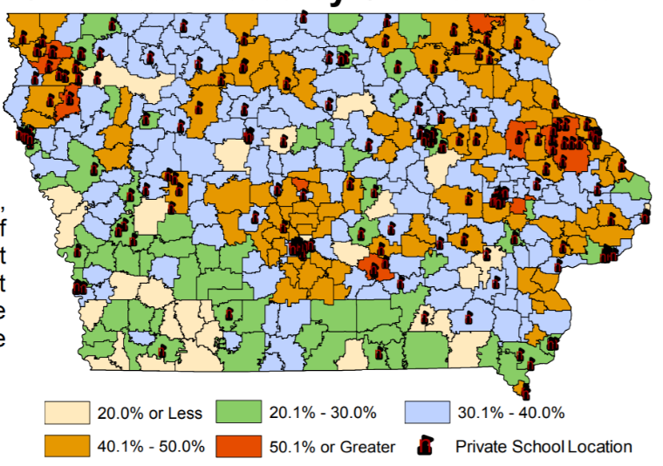
- Few Rural Private Schools: the survival of rural schools depends on adequate state funding, yet there are few private schools available for rural parents to exercise choice. This map from the Department of Revenue presentation to the Tax Expenditure Committee measuring participation in STO tax credits, January 2019, shows the gaps in private school geography. According to the National Rural Education Association, investing in vouchers reduces resources to rural schools and saves money for parents in urban centers. Meanwhile, student poverty and minority concentration in the inner cities is exacerbated when families with means are encouraged to leave the public school for a private program, increasing the challenge of public school districts while decreasing resources.
- No Oversight: The Institute also finds insufficient budgetary oversight of voucher programs. There is no publicly elected school board or Department of Education regulating and reporting allowable expenditures. The public does not have access to records or public meetings. Good stewardship of tax dollars requires transparency and clearly articulated expectations.
- Level the Playing field: Public schools are accountable to taxpayers, parents, communities, i.e., the public, and serve all students. Public schools cannot refuse to enroll or expel students that are not meeting expectations or refuse enrollment based on specific student needs, such as students with disabilities, who are non-English-speaking, minority or low income. If additional state dollars are used to fund vouchers, it is only fair that the private schools receiving those tax dollars also comply with testing, reporting, enrollment and service requirements.

The Rural School Advocates of Iowa calls on legislators and our governor to invest in Iowa’s public schools, which educate 94% of Iowa students, before expanding private school and home school options unnecessary in Iowa’s already competitive education environment.

