RSAI Regional Meeting Minutes
RSAI SE District 3-year term expires Sept. 2020
Laurie Noll
RSAI SW District 3-year term expires Sept. 2019
RSAI NW District 3-year term expires Sept. 2020
RSAI NE District 3-year term expires Sept. 2021
One At-large position expires Sept 2019 (Dennis McClain, Clay Central Everly CSD)

Southeast Region

Fairfield Central Office ACT Building
403 S 20th Street, Fairfield
July 18, 2019 – 4:30 pm

Attendees:
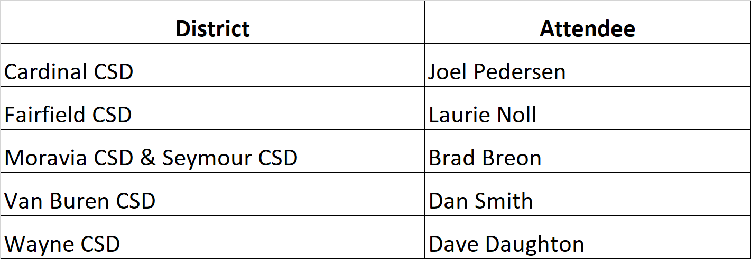
Call to order:
Laurie Noll convened the meeting at 4:33 p.m.
- Approval of Agenda:
Joel Pedersen, Superintendent at Cardinal, moved approval of the agenda.
Dan Smith, Board Member, Van Buren County, seconded.
Approved unanimously.
- Election of RSAI District Representative to the Leadership Group. Terms are specified in bylaws. Ongoing office is a 3-year term. No election this year.
- Election of RSAI District Liaison representing District SE to the RSAI Legislative Group (Annual Election). Thanks to Sandy Dockendorff, Danville School Board, for serving in 2018-19! Rep. attends Legislative Group meeting in Des Moines at ISFIS, Aug. 9, 2019, and supports legislative advocacy during the 2020 Session.
  - Nominations:
Brad Breon, Superintendent, Moravia/Seymour, nominated Joel Pedersen. Dave Daughton, Wayne CSD seconded the nomination.
No other nominations.
  - Election: Vote: Pedersen was unanimously approved.
- Consideration of Proposed Amendments to RSAI Bylaws if any (Requires 2/3 majority) None were proposed.
- Review of the 2019 Legislative Session and Data Supporting Key Issues Critical to RSAI member districts: Margaret Buckton, ISFIS, reviewed the legislative action of
the 2019 Session on RSAI priorities from pages 4-5 of the RSAI Legislative Digest and answered questions about RSAI Priorities and other legislative action.
- Establish RSAI District legislative priorities for the upcoming Iowa Legislative Session to forward to the RSAI Legislative Group
- Remove State Penny
- Keep working on formula equity but move lower in the list
- Teacher Shortage and Quality Instruction is #1 issue. Licensure barriers (need more flexibility for special education staff to work across all grades), wage gap with private sector jobs, more work on concurrent enrollment (for example, students that drop a concurrent enrollment course anytime after 9 days into the start of the course, the district still has to pay the community college, perhaps we could charge parents if students sign up for concurrent enrollment but don’t complete the course (or fail it?). IPERS issues with rehiring retired staff should be considered – Check out Missouri law and reach out to SAI Exec and Donna Mueller at IPERS and see if rules change can accomplish it without legislation.
- SSA is still a top priority. Relates to staff shortages. It’s not just educators. Bus drivers ( in WA state they collect unemployment insurance in the summer), paras, secretaries, food service, etc.
- Student Mental Health is still a priority and they haven’t solved it by creating a structure. The funding to AEAs must be ongoing. Must guard against the mandates that are likely to come, requiring schools to do certain things to meet mental health needs of students – likely not funded.
- Move sharing incentives/efficiencies lower in the list, but keep it around to remind folks renewal is coming. Consider adding positions of director of security or technology director to the positions that can generate weighting.
- School safety – see above with position in sharing, remove penny reference and keep funds for security personnel and training on the list.
- Funding Equity for at-risk Students: this is also a top priority. Must address the difference between 2.5% and 5.0%. Perhaps consider a local vote to increase the cap if at the lower level.
- Quality PK – discussed adding 3-year-olds. Issues with day care, convenience and eligibility all barriers to expansion in rural areas.
- New: Consider working on election changes – more special election dates and processes to make it easier for school communities to approve resources for educating students rather than harder.
- Any other business IPERS issues with rehiring retired staff should be considered – Check out Missouri law and reach out to SAI Exec and Donna Mueller at IPERS and see if rules change can accomplish it without legislation. Also mentioned Rep. Joel Fry and Rep. Timi Brown-Powers as good legislators to connect with, in the areas of mental health services. Also discussed membership recruitment and the need to connect with other school leaders in this area to help them understand the value of RSAI.
- Adjourn:
Brad Breon motioned for adjournment, Dan Smith seconded.
Vote: unanimous to adjourn, 5:41 P.M.
Save the date: 2019 RSAI Annual Meeting
Oct. 16, 2019 4:30-7:30PM (includes working dinner)
FFA Enrichment Center (DMACC Campus)
1055 SW Prairie Trail Parkway, Ankeny, Iowa 50023
Conduct annual business, set Legislative Priorities, and plan for successful advocacy

