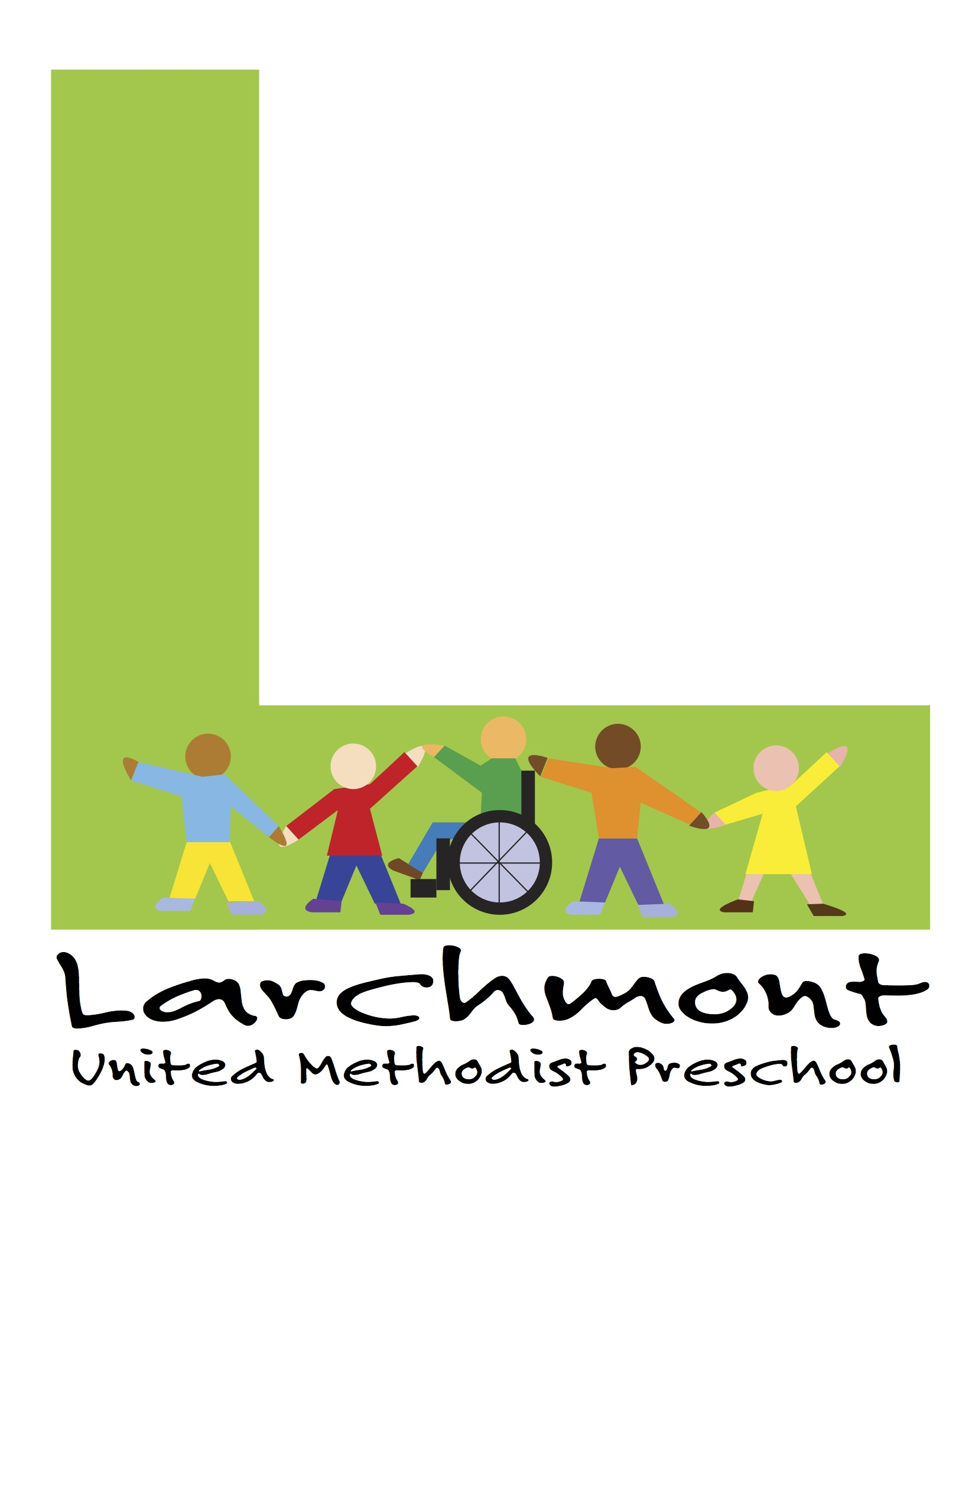

COVID-19 Policies & Procedures

The following procedures are in compliance with Phase II guidelines (issued on June 2, 2020) by the Commonwealth of Virginia for childcare providers.

Drop-Off & Pick-Up Procedures

- To help prevent further spread of illness, parents/caregivers will refrain from coming into the building.

- Preschool families will be meeting preschool staff outside. Parents and childcare givers will wear a mask when dropping off/picking up their child/children.

- Please maintain good social distancing practices with staff, other families and students while dropping off and picking up. Consider waiting in your car if you have more than one drop off time.

- A hand sanitizing station will be positioned at the preschool entrance. All parties will hand sanitize upon entrance and exit of the building.

- Upon arrival, designated preschool administration/staff will take the student’s temperature (no-contact/temporal). At this point your child’s teacher will record their temperature and they will line up for entry to school. Additionally, parents will take their child’s temperature at home, prior to bringing their child to school, to reduce risk of exposure to illness. At drop off, expect the following:

  - The parent/guardian will confirm that the child does not have fever, shortness of breath or cough.

  - A visual inspection of the child for signs of illness, which could include flushed cheeks, rapid breathing or difficulty breathing (without recent physical activity), fatigue, or extreme fussiness.

- The preschool will have a similar plan for pick-up time. Your child’s teacher will bring their class to your designated location for pick-up.

Class/Teacher Front Door |  | Pick Up Location
Two Year Olds/Jen & Gabby | 9:20am | 12:10pm Double Doors
Younger 3’s/Tracy & DeDe | 9:10am | 12:00pm Parking Lot
Older 3’s/Kristy | 9:00am | 12:00pm Double Doors
PreK4 Rosemary | 8:50am | 12:50pm Double Doors
PreK4 Becca | 8:40am | 12:40pm Parking Lot
Kindergarten/Amy | 8:30am | 12:30pm Atrium Exit

If parents/caregivers are late or unable to drop off students at the assigned time, I will remain outside until 9:40am for late arrivals. I will check in one student at a time for late arrivals. Please wait until all classes have entered the school before you approach for late drop off. After 9:40am you may ring the doorbell and I will get you checked in. You may also call the preschool office.

Preschool Office Phone Number: (757) 489-7823

Daily Health Check & Sick Policy
- All staff and students will receive a temporal/no-contact temperature check upon arriving and possibly throughout the day.

- We will keep daily logs for each classroom of children and retain records.
  - Child name and temperature
  - Drop/off pick up time
  - Adult completing both drop/off pick up
  - Staff that assist children to their class

Children or staff will not come to school if he/she has:
    - fever of 100.0 F or higher, now or in the preceding 72 hours (or would have, but have used fever reducing medicine)
    - cough
    - sore throat
    - muscle aches
    - difficulty breathing
    - new loss of taste or smell

- It is the responsibility of the staff to let the preschool office know if a child is showing symptoms of being sick. Office administration will then determine whether or not a child needs to be picked up due to illness.

- The preschool office’s regulated thermometer will be used to determine
whether or not a child has a fever.

- If a child becomes sick at school, office staff will call the parents.
  - In the event the parent(s) cannot be reached, the emergency
contacts will be called.
  - If a child needs to picked up from school due to illness, it is the expectation that he/she will be pick up from the preschool within 30 minutes.

PPE (Personal Protective Equipment) Procedures
- The combination of wearing both a mask and protective eyewear have proven effective in both preventing and spreading infection. All childcare staff must wear both protective eyewear and a mask while working with children.

- All individuals and staff are required to wear a mask while in the church/preschool building.

- Coworkers will take turns having breaks from their PPE, where they can remove their masks (outside of the classroom) to get fresh air and/or to eat and drink beverages.

- In accordance with state and CDC guidelines, children over the age of two, when feasible, should wear cloth face coverings when inside the facility and when unable to maintain social distancing of at least six feet. Children should wear masks if they can reliably wear, remove, and handle
them. Parents will make this determination for their children and, should they wish for masks to be used, they will provide them.

Handwashing & General Health Guidelines
Good handwashing hygiene is expected of both our staff members and our students. Staff members will be washing their hands regularly and facilitate a classroom environment where the students will do so as well.

- All children and staff will engage in hand hygiene at the following times:
  - Arrival to the facility and after breaks
  - Before and after preparing food or drinks
  - Before and after eating or handling food
  - Before and after administering medication or medical ointment
  - Before and after diapering
  - After using the toilet or helping a child use the bathroom
  - After coming in contact with bodily fluid
  - After handling animals or cleaning up animal waste
  - After playing outdoors or in sand
  - After handling garbage

- Wash hands with soap and water for at least 20 seconds. If hands are not visibly dirty, alcohol-based hand sanitizers with at least 60% alcohol can be used if soap and water are not readily available.

- Except for diapering or when eating, or serving food, hand- sanitizing products with 60-95% alcohol content may be used as an alternative method to handwashing. Hand sanitizer must be stored out of reach of children when not in use.

- Avoid touching his/her face.

- Cover coughs and sneezes with a tissue; throw the tissue away immediately.

- Staff will be expected to sanitize items in the classroom regularly. Prior to the end of shift, staff will sanitize: frequent touch points, counters, tables, chairs, toys, etc. The preschool will provide supplies for each classroom to have a bleach/water solution; staff members will prepare this daily.

- Items that have been used by a student or put in his/her mouth will be placed in a provided “dump bucket” and sanitized by staff prior to the end of their shift.

- All cleaning materials will be kept secure and out of reach of children. Cleaning products will not be used near children, and staff will ensure that there is adequate ventilation when using these products to prevent children from inhaling toxic fumes.

Limiting Physical Interaction & Providing Adequate Space
- Classrooms will not blend or physically interact with other classrooms. This will create “Stable Unit” classes. Classes will not share playground time, indoor playtime, and (outdoor or indoor) walks and activities with other classrooms, for any reason until further notice.

- Staff will practice physical distancing of a minimum of six (6) feet with other staff who are not within the same classroom.

- Young children are likely unable to practice physical distancing. Please understand that children within a classroom will not be able to maintain social distancing practices, such as being six feet apart from another student or staff member.

What if someone tests positive for COVID-19 or shows symptoms?
- If a staff member and/or a student is showing symptoms or tests positive for COVID-19, the office will be notified immediately.

- If/when positive results are confirmed, preschool administration will be required to notify the local health department. The preschool will be required to follow directives from the health department.

- If/when anyone who has entered the facility (including household members within a child’s family) is diagnosed with COVID-19, they and the preschool will report to and consult with the local public health authority regarding cleaning and closure. All teachers will have at least two weeks of prepared virtual learning material should we need to close a Stable Unit classroom.

- Report to the local public health authority any COVID-19 illness among the facility’s staff or attendees.

- Communicate, in coordination with the local public health department, with all families and other individuals who have been in the facility in the past two weeks.

Policies for Classes, Staff & Substitutes

- Students and teachers will not be socializing or visiting other classrooms/areas in the preschool.

- The church side of the building will be closed down during the week and will not be used by the preschool.

- Utilize the same teachers/substitutes for the same group(s) of children whenever possible.

- Ensure all substitutes and temporary staff are trained in COVID-19 related protocols prior to beginning work.

Diapering
When diapering a child, staff will wash their hands and wash the child’s hands before they begin, and wear gloves. Staff will follow safe diaper changing procedures. Steps include:

- Prepare (includes putting on gloves)
- Clean the child
- Remove trash (soiled diaper and wipes)

  - Replace diaper
  - Wash child’s hands
  - Clean up diapering station
  - Wash hands

After diapering, wash hands and disinfect the diapering area with bleach/water solution. If the surface is dirty, it will be cleaned with detergent or soap and water prior to disinfection.

COVID-19 Policies & Procedures Form
2020/2021

I have received and read Larchmont United Methodist Preschool’s 2020 COVID-19 Procedures & Policies. I am aware of all the procedures that are outlined and agree to comply with everything outlined in this manual.

Assumption of the Risk Relating to Coronavirus/COVID-19
The novel coronavirus, COVID-19, has been declared a worldwide pandemic by the World Health Organization. COVID-19 is extremely contagious and can lead to severe illness and death and it is believed to spread mainly from person-to- person contact. It may also spread by touching a surface or object that has the virus on it, then touching your mouth, nose or eyes. As a result, federal, state, and local governments and federal and state health agencies recommend social distancing and have, in many locations, prohibited the congregation of groups of people.
Larchmont United Methodist Preschool, Norfolk, Virginia has put into place extensive preventative measures to reduce the spread of COVID-19. The measures described, however, do not constitute medical advice. Our primary goal is to keep our staff and our children safe and healthy. But please understand, the preschool cannot and does not guarantee that you or your child(ren) will not become infected with COVID-19. Larchmont United Methodist Church and Preschool will not assume any liability for any employee, child, or individual that may become infected with COVID-19 while working for attending or visiting our preschool. By coming, you will voluntarily assume all risks related to the exposure to COVID- 19.

Child’s Name

Parent or Staff Name (Printed)

Parent or Staff Signature

Date

