Johnson & Hill County
Spring Volleyball League

Register Teams @ jcjvclub.org
Games Played @ Rio Vista HS
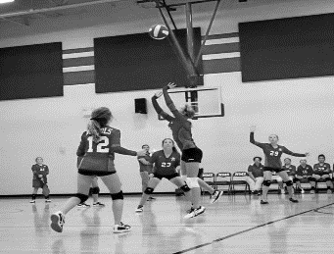
. 8 match pool play 16 sets
. End of season Tournament
. Games on Saturdays
. League starts April 4th 18th
. 25th May 2nd - May 9th
. 4th 5th 6th 7th 8th FR & HS
. Registration Starts January 2020
. Bringing Club Style Volleyball to Johnson & Hill Counties
. For information on League contact J.R. Martinez 817-915-2059
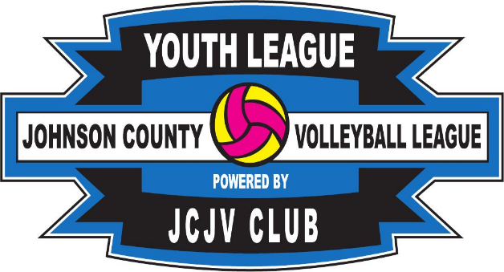
Powered by

