Pre-filter Benefits
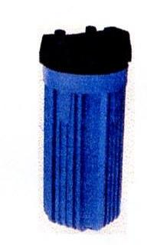

A pre-filter that is plumbed in before the Bill Miller and Family water softener and/or iron filter helps to protect the systems from damage (sand or scale) that your well might be producing. This standard pre-filter housing is manufactured of reinforced polypropylene. The leak proof seal is accomplished by the cap compression against the top seated O-Ring in the sump. The thread closure allows for years of cartridge change outs without failure. The thick walls and multiple rib design make these pre-filter housings ideal for any application. The clean look and light weight design also makes them preferred in residential and commercial uses. The pre-filter polypropylene construction has excellent chemical resistance for use with most acids, alcohols, ammonias, oils, plating solutions, beverages and water. This unit has a pressure relief bleed button on the inlet side of the cap. The pressure relief mechanism is constructed of a stainless steel spring and screw, gasket and polypropylene red button.

NOTE: Actual maximum flow rates vs. pressure drop will be determined based on the cartridge selections and fluid viscosity. We recommend the S-1 paper accordion filter.

* Each installed pre-filter comes with two ball valves for easy changing of the pre-filter, plus one wrench and two S-1 paper accordion filters.

Biller Miller and Family
Water Softener Sales and Service
www.BillMillerWaterSoftener.weebly.com
248.693.8233

