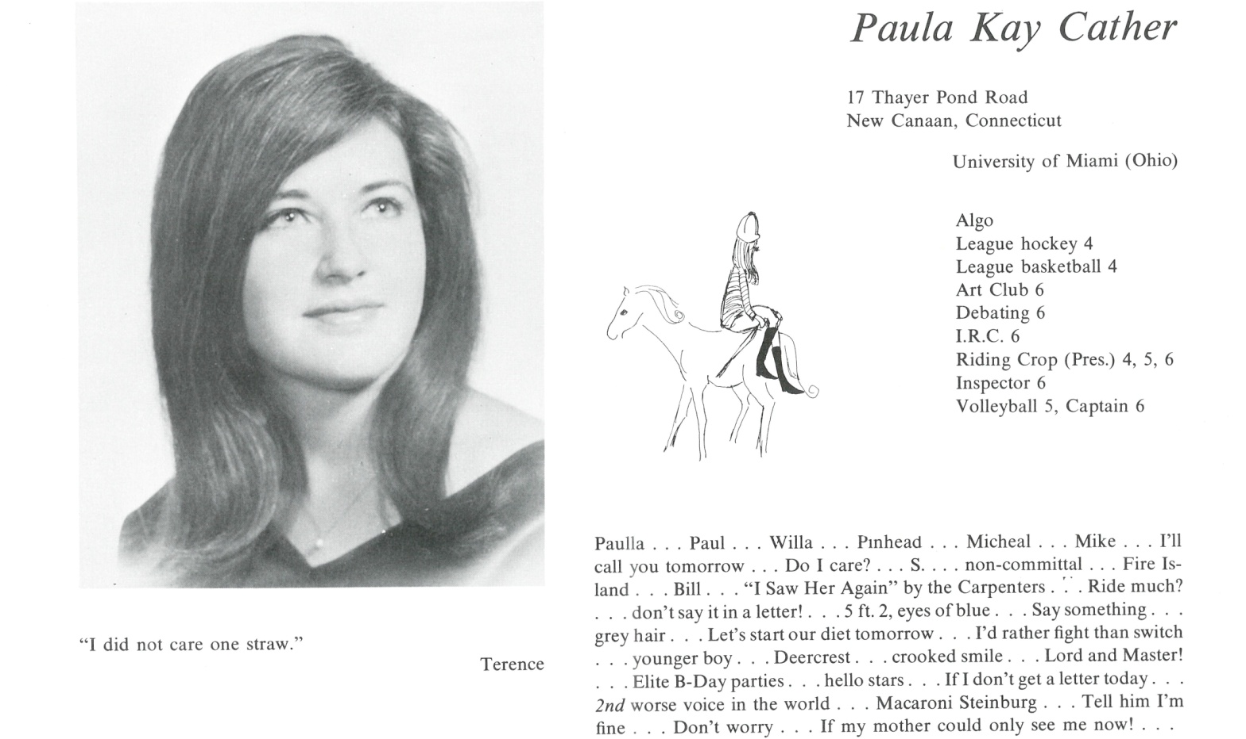

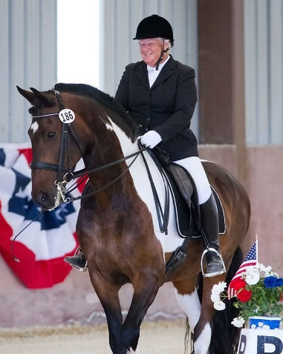K. Paula Cather Langan

After graduating from Kent I spent a few college years in Ohio but finally found myself in California attending Art Center College of Design in Los Angeles. California is where I was meant to live and I also met my husband Bill at Art Center. We were married in 1974 and moved up to Carmel Valley, California where we still live today.

I worked in the newspaper and graphic design industry and then was finally able to marry my two passions – horses and art by becoming the manager / executive secretary of the California Dressage Society and editor of the monthly newsletter to over 4,000 dressage enthusiasts. I have been lucky enough to be able to train and show my horses and work and promote CDS for over 28 years.

One of the early inspirations for me at Kent was the riding program and the introduction of Hubert Rohrer as the instructor. That truly helped form my path with the horses. I had a few friends at Kent, but mostly I was always about the horses.



______________________________________________________________

______________________________________________________________ ______________________________________________________________ ______________________________________________________________ ______________________________________________________________ ______________________________________________________________ ______________________________________________________________ ______________________________________________________________ ______________________________________________________________

Attach Picture in .jpg Format

______________________________________________________________

______________________________________________________________

___________________________________________________________________________________ _________________________________________________________________________________________________________________________________________________________________________________________________________________________________________________________________________________________________________________________________________________________________________________________________________________________________________________________________________________________________________________________________________________________________________________________________________________________________________________________________________________________________________________________________________________________________________________________________________________________________________________________________________________________________________________________________________________________________________________________________________________________________________________________________________________________________________________________________________________________________________________________________________________________________________________________________________________________________________________________________________________________________________________________________________________________________________________________________________________________________________________________________________________________________________________________________________________________________________

___________________________________________________________________________________