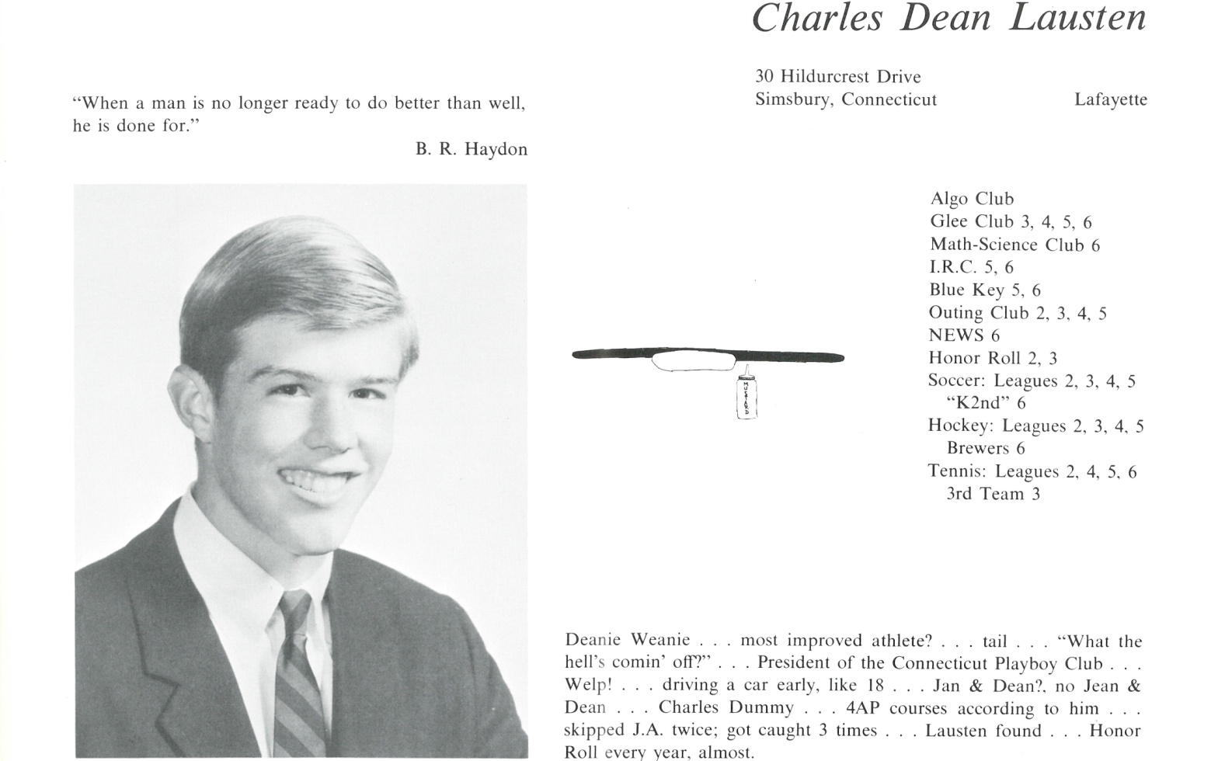

C. Dean Lausten

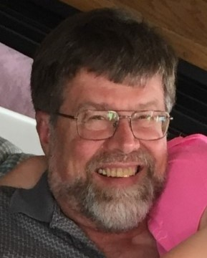Grew up in Simsbury, CT. Dad grew up CA; Mom, NJ; and Mom’s parents, Louise Wold and Arthur Anderson, lived with us from mid-1950's until their deaths in mid-1960's. Attended Kent School grades 8-12, graduating 1967. In 1969 attended summer geologic field camp in Red Lodge, MT. Was hired on after as field geologist for Johns-Manville, working Stillwater Complex, MT; worked total of 4 summers for them prospecting near Mt Baker, WA; Baker, La Grande, OR, for copper deposits; Stillwater for platinum. Graduated in 1971 from Lafayette College, Easton, PA, BA Geology; Graduated 2/1974 with MS Geology from ASU, Tempe, AZ.

Went to work as geophysicist in Oil Exploration in Denver, CO for Amoco Production Co, 1974-1980; met native Denverite Susan Abbott there, and we were married March 22, 1975.

Moved to Littleton, CO, where we lived from 1975 to 2008; Susan taught in primary education for Jefferson County schools for 16 years while we raised two boys, Matt, born 1977, and Ben, born 1980; Ben married Stefanie Planck in 2006, both now working in Dillon, CO as teachers; Matt married Allison Pottinger in 2009, both CPAs; Matt is working as forensic accountant in Denver; and Allison is working part time while raising two children, Cody, born in 2011; Ellie, born in 2013.

Susan and I bought home at 4575 W Lakeridge Rd, Denver; remodeled and moved in March of 2008. Sister Thora Lausten (Fernquist) passed 2012.

Worked for Williams Exploration Co., until 1984; consulting geophysicist from May of 1984 through September of 1984; worked for Petrel Exploration Co., Denver, CO from September of 1984 through May of 1989; and then formed Lausten-Holton, Inc with partner Jack Holton in May of 1989. Self-employed from 1990 to present, Consulting Geophysicist, Denver, CO; and then formed Lausten Energy, LLC in 2002 for working interest position in oil and gas exploration, mainly in KS, CO, WY.

Hobbies include travelling with Susan, being with grandchildren, sailing, hiking, fishing, raising orchids, antique clock repair and sailboat restoration, genealogist for 25 years, artist for 5.



______________________________________________________________

______________________________________________________________ ______________________________________________________________ ______________________________________________________________ ______________________________________________________________ ______________________________________________________________ ______________________________________________________________ ______________________________________________________________ ______________________________________________________________

Attach Picture in .jpg Format

______________________________________________________________

______________________________________________________________

___________________________________________________________________________________ _________________________________________________________________________________________________________________________________________________________________________________________________________________________________________________________________________________________________________________________________________________________________________________________________________________________________________________________________________________________________________________________________________________________________________________________________________________________________________________________________________________________________________________________________________________________________________________________________________________________________________________________________________________________________________________________________________________________________________________________________________________________________________________________________________________________________________________________________________________________________________________________________________________________________________________________________________________________________________________________________________________________________________________________________________________________________________________________________________________________________________________________________________________________________________________________________________________________________________